**FOR IMMEDIATE RELEASE**

**September 2020**

**Christina Kann, Publicist**

[pr@brandylanepublishers.com](mailto:pr@brandylanepublishers.com) or 804.644.3090

**In the Wake of Trauma: *Safe***

**by Elspeth Roake**

**on sale November 5, 2020**

“A completely unrestrained, intimate, and triumphant account of one brave woman’s battle with depression."

—Karen V. Robertson, co-writer of George Morris’s *Unrelenting*

[Brandylane Publishers, Inc.](https://www.brandylanepublishers.com/) of Richmond, Virginia, is proud to announce the upcoming release of *Safe* by Elspeth Roake. The book is a memoir of brutal and intense honesty, exploring the depths of despair, determination, and self-discovery, and the vital bonds—both human and animal—that make life possible. *Safe* is slated for release on November 5, 2020.

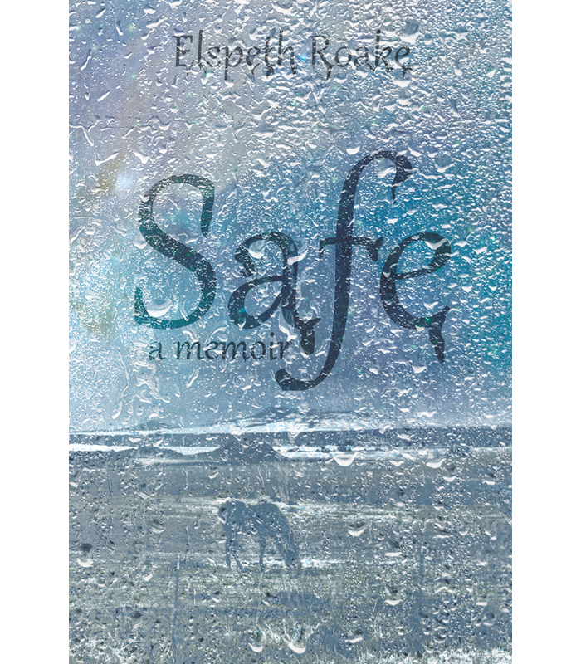

Elspeth Roake lives in the competitive world of showing horses, aspiring to perfect technique in the ring against a backdrop of long hours, hard work, and frequent travel. On the surface, she is poised and goal-oriented. Only her boss, Leslie, is witness to her depression. Leslie never shies away from Elspeth’s dark moods or tendency to self-harm, and eventually her strength and compassion inspire Elspeth to explore the shadows of childhood trauma which lurk at the back of her mind. But memories slip away even as she reaches for them, and behind closed doors Elspeth’s mental state continues to deteriorate. Over the course of two harrowing years, Elspeth sets increasingly radical goals for herself, determined not to let her illness get the better of her. Yet despite outward success, no ribbon or medal can help her outpace her depression. Finally, at a horse show far from home, Elspeth’s battle descends into a matter of life and death, and not even Leslie can help her. Finding herself trapped and sobbing into the sticky floor of a psychiatric ward, she realizes that something has to change.

**About the Author**

Elspeth Roake spent her childhood on the move, between Canada, Germany, and California, before settling on the East Coast to receive a B.S. in psychology from Vassar College. She has twenty years of experience in the horse show industry, and currently lives with her bunnies in New York State. This is her first book.

**Interviews available upon request.**

[Brandylane Publishers, Inc.](https://brandylanepublishers.com/), an independent press located in Richmond, Virginia, has published books since 1985.

_____

*Safe* (256 pages / paperback $16.95 / e-book $4.99) is available for pre-order from [Amazon](https://www.amazon.com/Safe-Elspeth-Roake/dp/1947860860/ref=sr_1_30?crid=G95R2NTQW58&dchild=1&keywords=elspeth+roake+safe&qid=1599162145&sprefix=elspe%2Caps%2C144&sr=8-30), [Barnes and Noble](https://www.barnesandnoble.com/w/safe-elspeth-roake/1137476318?ean=9781947860865), [IndieBound](https://www.indiebound.org/book/9781947860865), and other fine booksellers.