

**FOR IMMEDIATE RELEASE**

**May 2019**

**Christina Kann, Publicist**

brandylanepr@gmail.com or 804.644.3090

**Robert Pruett, Publisher**

brandylanerhpruett@gmail.com or 804.644.3090

**Home Can Mean Many Things:**

***Back Home***

**written by Shaista Kaba Fatehali**

**illustrated by Michelle Simpson**

**on sale July 8, 2019**

“Through the lens of a Muslim child named Asha, we see the challenges she faces as a newcomer, but realize that we are truly all the same . . . The message behind *Back Home* is that peace is everywhere and can be found within oneself. ”

— The Honourable Mobina S.B. Jaffer, Q.C. Senator for British Columbia

[Brandylane Publishers, Inc.](http://brandylanepublishers.com/) of Richmond, Virginia is excited to announce the upcoming release of the new children’s book, [*Back Home*](https://www.amazon.com/Back-Home-Shaista-Kaba-Fatehali/dp/1947860445/ref=sr_1_1?crid=QQF5PV44IFCM&keywords=back+home+shaista+fatehali&qid=1558466049&s=gateway&sprefix=back+home+fatehali+%2Caps%2C150&sr=8-1-spell), written by Shaista Kaba Fatehali and illustrated by Michelle Simpson. A thoughtful, timely story about friendship, the power of universal kindness, and being yourself, *Back Home* is scheduled for release on July 8, 2019.

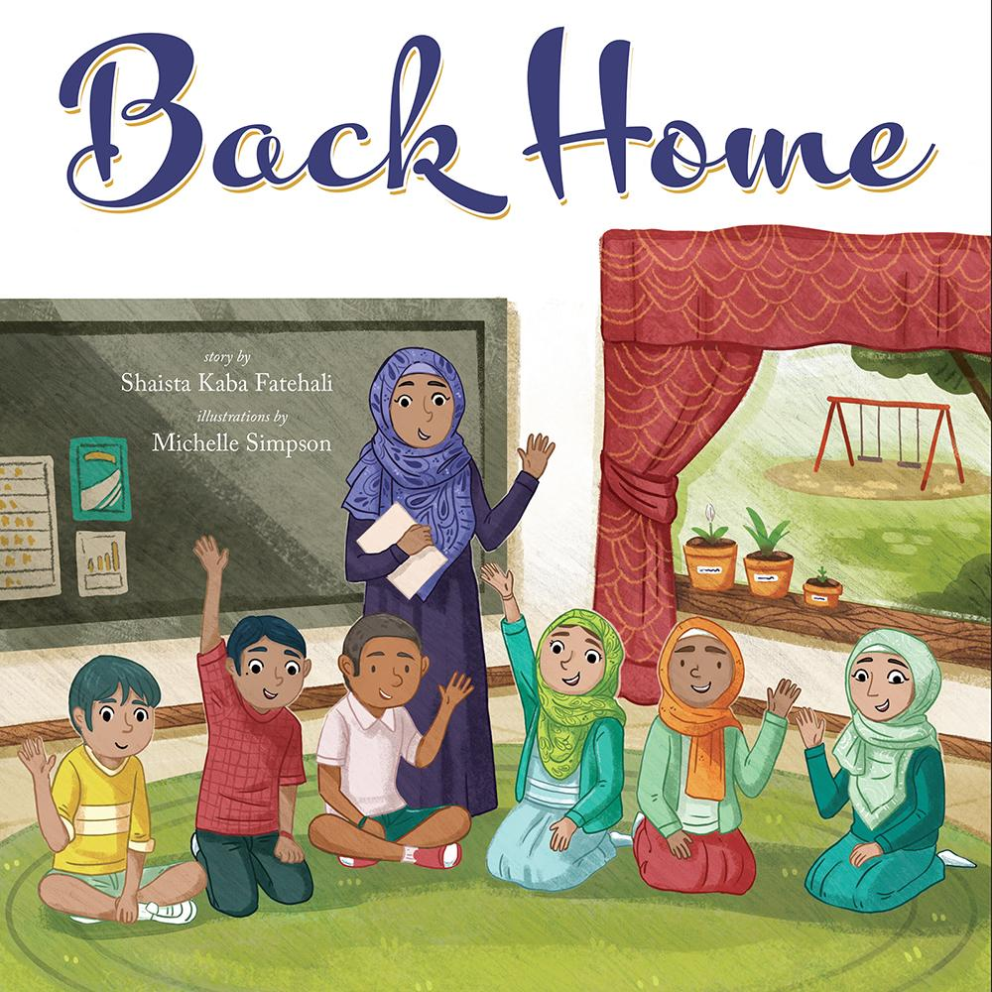

It’s Asha’s first day of school in her new country, and she’s a little overwhelmed. Everything seems so different, and on top of everything else, she can’t understand what the teacher is saying! But with a little help from her classmates, Asha soon learns that life in her new school might not be so different from back home after all.

**About the Author**

Shaista Kaba Fatehali is a Canadian Ismaili Muslim, a kindergarten teacher, and the founder of [THRIVE KIDS!](https://thrivekidsbc.ca), an organization that helps children discover their inner strengths, their identity, and their sense of purpose. She is currently completing her PhD in early childhood education, and lives with her husband and daughter in Burnaby, British Columbia.

**About the Illustrator**

[Michelle Simpson](http://www.michellescribbles.com/) is a professional illustrator based out of the Niagara Region of Canada. Michelle graduated with a BAA in illustration from Sheridan College, and now works as a freelance illustrator. Michelle has worked on concept artwork and final backgrounds for season two of the children’s TV show *Ollie: The Boy Who Became What He Ate*. She also worked on season one of Tee and Mo. Although she takes on many different projects, Michelle’s passion is children’s book illustration.

**Interviews are available upon request.**

Brandylane Publishers, Inc. is an independent press located in Richmond, Virginia that has published books since 1985.

____________

*Back Home*  (hardcover, 36 pages, retail $22.95) is available for pre-order from [Brandylane Publishers](http://brandylanepublishers.com/wp/book/back-home/), [Amazon](https://www.amazon.com/Back-Home-Shaista-Kaba-Fatehali/dp/1947860445/ref=sr_1_1?crid=QQF5PV44IFCM&keywords=back+home+shaista+fatehali&qid=1558466049&s=gateway&sprefix=back+home+fatehali+%2Caps%2C150&sr=8-1-spell), [Barnes & Noble](https://www.barnesandnoble.com/w/back-home-shaista-kaba-fatehali/1131504523?ean=9781947860445), and other fine booksellers. Kindle ebook (retail $2.99) forthcoming.