FOR IMMEDIATE RELEASE
APRIL 2019

Christina Kann, Publicist
brandylanepr@gmail.com or 804.644.3090
Robert Pruett, Publisher
brandylanerhpruett@gmail.com or 804.644.3090

This Bubble Duck Doesn’t Give a Quack!
written by Teresa Pistole
illustrated by Alex Pistole
On sale April 22, 2019

Brandylane Publishers is proud to announce the upcoming release of the second edition of children’s book, Bubble Duck and Bubble Duck Does Hockey, written by Teresa Pistole and illustrated by Alex Pistole. Have you seen the Bubble Duck? Follow this quacky duck through some sticky situations and learn about littering, making friends, and ice hockey! This book goes on sale on April 22, 2019.
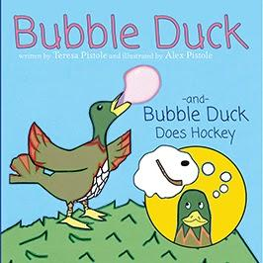

About the Author:
Teresa Bennett Pistole is a former nurse currently self-employed in Walkerton, Virginia.

About the Illustrator:
Alex Bennett Pistole is a veteran of the Afghanistan War, a decorated soldier, and a graduate of Radford University with a major in journalism. He lives in Christiansburg, Virginia.

Teresa and Alex often visit relatives in nearby West Point who shared the true life story of Bubble Duck. Teresa fashioned the text, Alex brought Bubble Duck to life with computer animation, and Bubble Duck has been “quacking” ever since. Teresa and Alex hope readers of all ages will enjoy the humble humor and candid lessons Bubble Duck has to share.

Interviews available upon request.

Brandylane Publishers, Inc. is an independent press located in Richmond, Virginia that has published books since 1985.
____________

Bubble Duck and Bubble Duck Does Hockey (casebound, 48 pages, retail $15.95) is available for preorder from Brandylane Publishers, Amazon, Barnes & Noble, and from other fine booksellers.

