**FOR IMMEDIATE RELEASE**

**January 2021**

**Christina Kann, Publicist**

[pr@brandylanepublishers.com](mailto:pr@brandylanepublishers.com)

804.644.3090

**Untold Heroes of the Civil War: *The Clothesline Code***

**written by Janet Halfmann**

**illustrated by Trisha Mason**

**on sale February 1, 2021**

“Lucy Ann and Dabney Walker are American heroes. Their covert operations at the heart of the Civil War in Virginia should inspire all of us to do what is right instead of easy, find our courage when surrounded by danger, and spring into action when the way forward becomes clear. *The Clothesline Code: The Story of Civil War Spies Lucy Ann and Dabney Walker* sends that message, loud and clear.”

—Mary Belcher, historian

[Brandylane Publishers, Inc.](http://www.brandylanepublishers.com) of Richmond, Virginia, is proud to announce the upcoming release of [*The Clothesline Code: The Story of Civil War Spies Lucy Ann and Dabney Walker*](https://www.amazon.com/Clothesline-Code-Story-Dabney-Walker/dp/1951565576/ref=sr_1_1?dchild=1&keywords=clothesline+code&qid=1608575519&sr=8-1) written by [Janet Halfmann](https://www.janethalfmannauthor.com/), illustrated by [Trisha Mason.](http://www.trishamasonart.com) One year after escaping slavery, Lucy Ann and Dabney Walker used a clothesline code to steal Confederate military secrets and send them back to the Union army at great risk to themselves. This true story of sacrifice and bravery shows us that when we have courage and compassion for the world around us, even the simplest items can become powerful tools for change. *Clothesline Code* is scheduled for release on February 1, 2021.

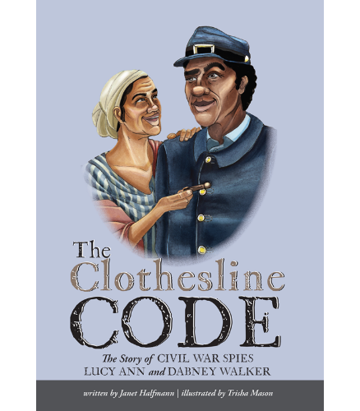

**About the Author**

[Janet Halfmann](https://www.janethalfmannauthor.com/) is a multi-award-winning children’s author who strives to make her books come alive for young readers and listeners. Many of her picture books are about animals and nature. She also writes picture book biographies about little-known people of achievement. Janet has written more than forty fiction and nonfiction books for children. Before becoming a children’s author, Janet was a daily newspaper reporter, children’s magazine managing editor, and a creator of coloring and activity books for Golden Books. She is the mother of four and the grandmother of six. When Janet isn’t writing, she enjoys gardening, exploring nature, visiting living-history museums, and spending time with her family. She grew up on a farm in Michigan and now lives in South Milwaukee, WI. You can find out more about Janet and her books [on her website](http://www.janethalfmannauthor.com).

**About the Illustrator**

[Trisha Mason](http://www.trishamasonart.com) attended the Herron School of Art + Design (IUPUI) where she graduated with honors and a BFA in drawing and illustration. She has illustrated the children’s book *Be Brave, Be Brave, Be Brave* by F. Anthony Falcon and has art featured in the book *She Votes* by Bridget Quinn. Mason currently resides in Plainfield, IN, where she enjoys creating watercolor pet portraits and taking walks with her fiancé, Jack, and her dog, Gilly. You can view more of Trisha’s work on her website www.trishamasonart.com or her Instagram @trishabmason.

**Interviews available upon request.**

[Brandylane Publishers, Inc.](https://brandylanepublishers.com/) is an independent press located in Richmond, Virginia, that has published books since 1985.

_____

*Clothesline Code* (36 pages, hardback $22.95 / paperback $12.95 / e-book $2.99) is available for pre-order through [Amazon](https://www.amazon.com/Clothesline-Code-Story-Dabney-Walker/dp/1951565576/ref=sr_1_1?dchild=1&keywords=clothesline+code&qid=1608575519&sr=8-1), [Barnes and Noble](https://www.barnesandnoble.com/w/the-clothesline-code-janet-halfmann/1138445731?ean=9781951565572), [Bookshop](https://bookshop.org/books/the-clothesline-code-the-story-of-civil-war-spies-lucy-ann-and-dabney-walker/9781951565572), and other fine booksellers.