FOR IMMEDIATE RELEASE
February 2021
Christina Kann, Publicist
christina@brandylanepublishers.com or 804.644.3090

Acceptance at All Ages: Collette in Kindergarten
written by Collette Divitto
illustrated by Katie Mazeika
on sale January 19, 2021

“This book is a victory for inclusion. Collette’s resilient kindness is a guiding light for how we fix stereotypes about disability in our world. Whether you’re a parent of a child with a disability or someone wanting to learn from Collette’s experience, this book is an invitation to be a part of exciting cultural change that starts in our own hearts. Incredible. Challenging. Hope-giving.”

—Andrea Friedman, co-founder, Voices for the Voiceless

Brandylane Publishers, Inc. of Richmond, Virginia, is proud to announce the release of Collette in Kindergarten, written by Collette Divitto and illustrated by Katie Mazeika. Based on the real-life experiences of entrepreneur and activist Collette Divitto, Collette in Kindergarten shows how important it is to practice acceptance throughout our lives, just as children do so freely every day.

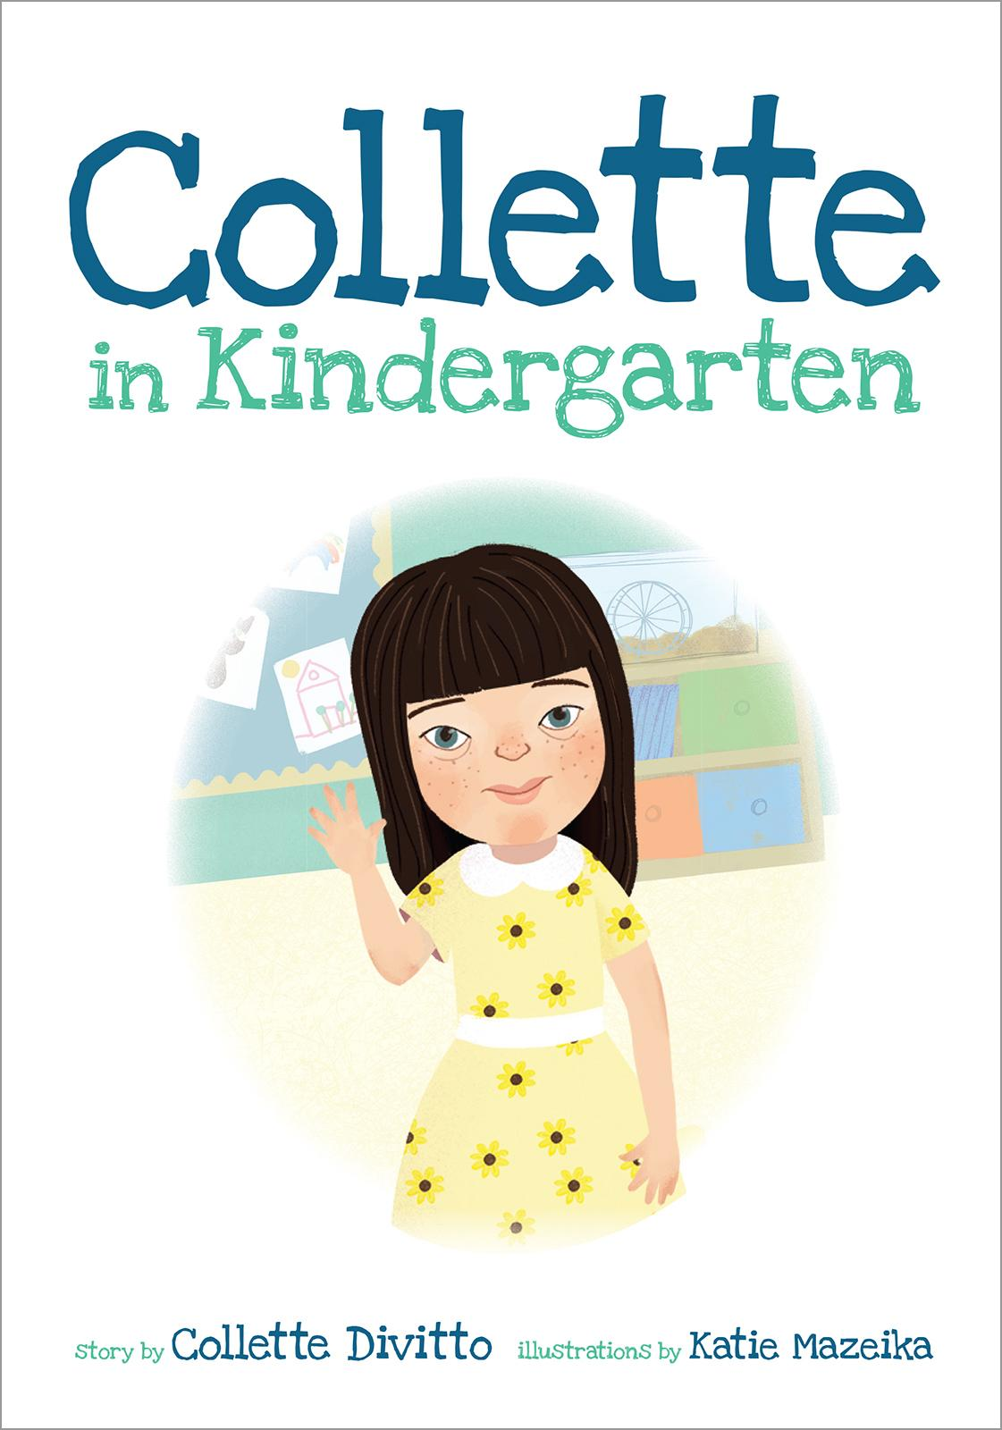

When Collette, a young girl with Down syndrome, begins her first year of school, her bubbly personality helps her make friends right away. Soon, Collette notices these new friends are not inviting her to playdates—but it’s not because they don’t want to invite her. Collette comes up with a great idea to show her classmates’ parents a new way of thinking. Based on the real-life experiences of entrepreneur and activist Collette Divitto, Collette in Kindergarten shows us how important it is to practice acceptance throughout our lives, just as children do so freely every day.

About the Author
Collette Divitto was born in 1990 with Down syndrome. She grew up in Ridgefield, Connecticut, where she developed a passion for baking. After high school, Collette attended Clemson University and finished a three-year LIFE program in just two years. With a strong drive to work hard and succeed, Collette moved to Boston, Massachusetts, and founded Collettey’s Cookies.

Collette teaches classes on empowerment, leadership, self-awareness, career pathways, and entrepreneurship, and when she's not at Collettey’s Cookies in Boston, you can find her traveling across the US, sharing her inspiring story and empowering those with labeled disabilities. Collette has been featured on CNN, Good Morning America, MSNBC, Inside Edition, BBC, and many other print and television media outlets around the world.

About the Illustrator
Once upon a time, in Mrs. Hershner’s kindergarten art class, Katie Mazeika painted the perfect butterfly. Then she accidentally stuck her thumb in the middle of its right wing. To fix the problem, she stuck her other thumb in the other wing. Mrs. Hershner announced that Katie was a “Little Artist.” She decided to go with it.

Many years after kindergarten, Katie went on to the Columbus College of Art and Design, where she graduated with a BFA in illustration. She moved to northeast Ohio, where she eventually settled down with her husband, two kids (Lillian and Jack), and two dogs. Katie still likes to paint butterflies, but now she works primarily in Photoshop on a Wacom Cintiq. When she isn’t in the studio, Katie spends time at the theater or in her garden, getting lost in a good book.

Interviews available upon request.

Brandylane Publishers, Inc. is an independent press located in Richmond, Virginia, that has published books since 1985.
_____
Collette in Kindergarten (36 pages, hardcover $22.95 / paperback $12.95 / e-book $2.99 ) is available from Bookshop.org, Amazon, Barnes and Noble, and other fine booksellers.

