FOR IMMEDIATE RELEASE
January 2021
Christina Kann, Publicist
christina@brandylanepublishers.com

Using Fashion Fun to Explore Gender: Toby Wears a Tutu
written by Lori Starling
on sale January 12, 2021

“Toby Wears a Tutu sends a powerful message to children: acceptance.”
—Jeremy Flagg, MFA, author, and SNHU creative writing professor

Brandylane Publishers, Inc. of Richmond, Virginia, is proud to announce the upcoming release of Toby Wears a Tutu written by Lori Starling and illustrated by Anita DuFalla. After being bullied at school, gender-non-conforming Toby has a declaration to make: They can eat, wear, do, or be anything they want! Toby Wears a Tutu is scheduled for release on January 12, 2021.

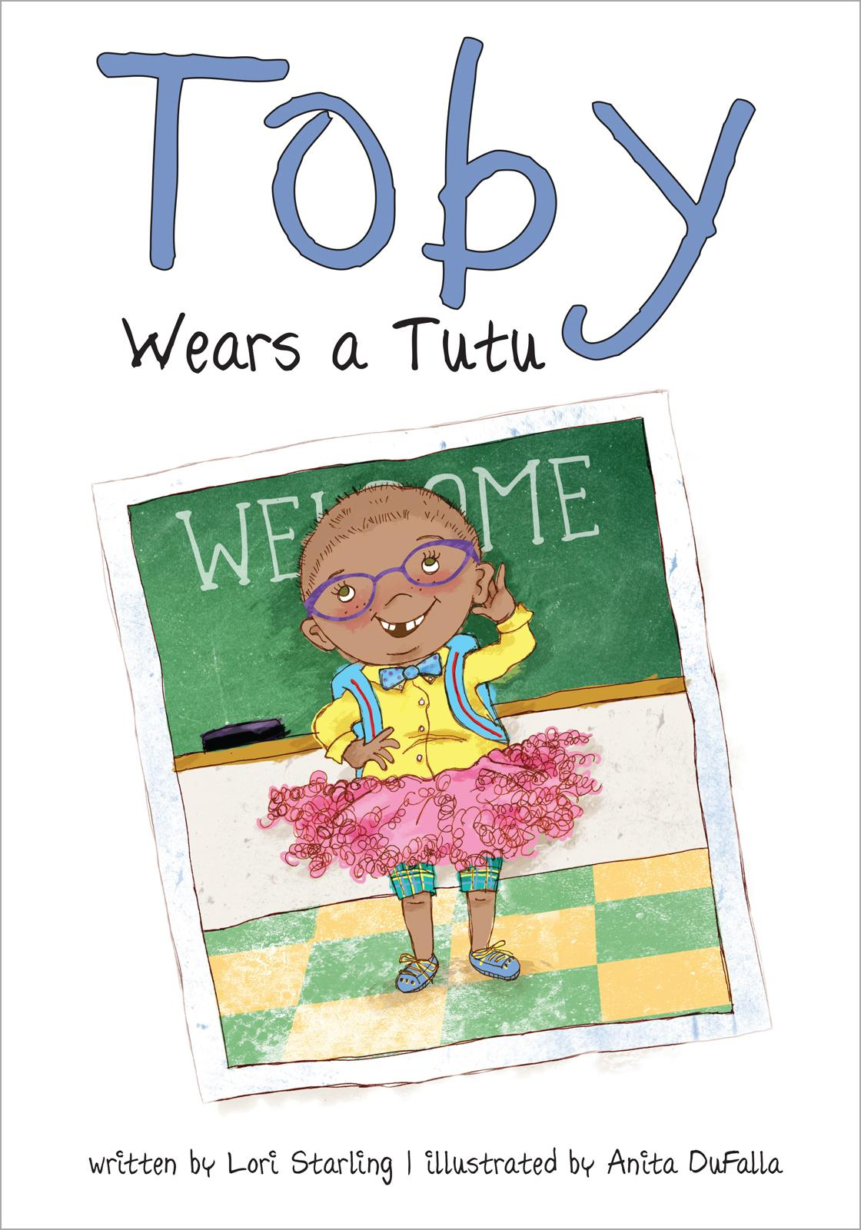

It's the first day of school, and Toby is dressed in their best and ready to make new friends! But first, Toby’s new classmates want to know: Is Toby a boy or a girl? Toby isn’t sure how to answer. Toby likes to wear basketball shorts and tutus. Toby plays ninjas and dances ballet. Finally, after a little thought and some encouragement from Mom, Toby has a declaration to make: they can eat, wear, do, or be anything they want! Toby isn’t a boy or a girl—Toby is just Toby!

About the Author
Lori Starling is a writer, poet, amateur ukulele player, and lover of all things Edgar Allan Poe, Emily Dickinson, and Sylvia Plath. Through their writing, they strive to create realistic worlds for their readers to explore, where marginalized voices are heard and empowered. Starling holds an MFA in creative writing, as well as a BA in English & creative writing with various associate degrees. In addition to their writing shenanigans on loristarlingwrites.com, their writing can be seen in places like One Green Planet, Life in 10 Minutes Lit Magazine, and Beyond Queer Words: A Collection of Poems. Recently, they have co-founded Clay Literary, which houses two weekly online publications: FLEDGLING and RAVEN. Toby Wears a Tutu is their first children’s book.

About the Illustrator
Anita DuFalla is both an award-winning illustrator and designer with fifteen years of experience in children’s book illustration. She sports a collection of more than five hundred patterned pantyhose, and lives in the Friendship neighborhood of Pittsburgh with her son, Lucas.

Interviews available upon request.

Brandylane Publishers, Inc. is an independent press located in Richmond, Virginia, that has published books since 1985.
_____

Toby Wears a Tutu (36 pages, hardcover $22.95 / paperback $12.95 / e-book $2.99) is available for pre-order from Bookshop, Amazon, Barnes and Noble, and other fine booksellers.

