FOR IMMEDIATE RELEASE
May 2021
Christina Kann, Publicist
pr@brandylanepublishers.com
804.644.3090

Real-Life Renegade: A Rebellious Woman
by Claire J. Griffin
on sale June 8, 2021

“Griffin captures Belle’s indomitable, energetic, and forward-thinking spirit. She places Belle within the context of the culture and history of her era, particularly portraying everyday life during the Civil War in Martinsburg and Front Royal in a way one can see, hear, smell and feel.”
—Carol J. Appenzellar, curator, Berkeley Co. Museum, Belle Boyd House

Brandylane Publishers, Inc. of Richmond, Virginia, is proud to announce the upcoming release of A Rebellious Woman by Claire J. Griffin. Born a century too soon, Belle Boyd defied every rule that dictated what a woman was permitted to do.

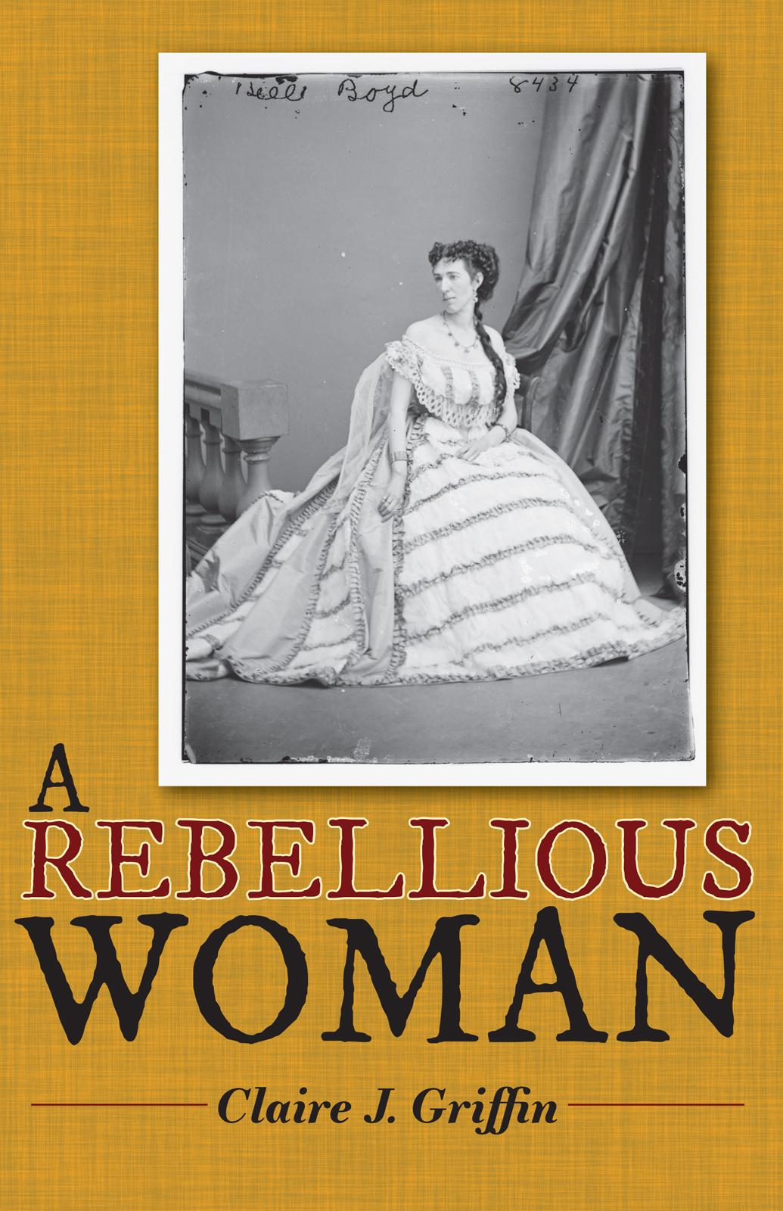

A Rebellious Woman is based on the life story of Belle Boyd (1844-1900), whose coming of age coincided with the opening shots of the Civil War. Debutante, teenaged spy, seductress, actress, divorcee, cross-dresser, and self-promoter, she carried a pistol and wasn’t afraid to use it. In a century when a woman was meant to be nothing more than a well-behaved wife and mother, Belle Boyd stands out as a scandalous woman of history defying all the rules.

About the Author
Claire J. Griffin has rowed competitively, traveled to seven continents, kayaked below the Antarctic Circle, camped in Africa, driven across the Sahara, eaten bugs, and been stung by scorpions two separate times. She has always said “yes” rather than “no” to adventure; this is likely why she identifies so strongly with Belle Boyd. Claire and her husband live in Brooklyn, New York. Claire is a fan of ethnic food, street art, riding the subway, and overheard conversations.

Interviews available upon request.

Brandylane Publishers, Inc. is an independent press located in Richmond, Virginia, that has published books since 1985.
_____
A Rebellious Woman (384 pages, paperback $20.95 / e-book $4.99) is available for pre-order through Bookshop, Amazon, Barnes & Noble, and other fine booksellers.

