**FOR IMMEDIATE RELEASE**

**August 2025**

**Publicity Team**

pr@brandylanepublishers.com

804-644-3090

**New Poetry Book *Steel Slides and Yellow Walls* Invites Readers to Question: What Makes a Woman Today?**

written by Alicia Swain

on sale August 12, 2025

“‘The harbored rage is a necessity.’ These six words from Swain’s ‘Breaking Silence’ . . . will be one of the many phrases that cling to your brain after reading . . . *Steel Slides and Yellow Walls*. . . . a liberating, empowering and inspiring read in these dark, uncertain times.”

- Amy David, journalist featured in *RVA* magazine, the *Henrico Citizen, Midlothian Lifestyle*, GayRVA.com, and OutRVA

[Belle Isle Books](http://www.belleislebooks.com/) of Richmond, Virginia, is pleased to announce the release of a new book of poetry, [*Steel Slides and Yellow Walls*](https://www.belleislebooks.com/store/p261/Steel_Slides_and_Yellow_Walls.html), written by Alicia Swain.

Alicia Swain’s debut poetry collection, *Steel Slides and Yellow Walls,* explores personal evolution in four parts: Ask, Experience, Recover, and Grow. Through Swain’s experimental form, religious allusions, and cultural commentary, her speaker questions the hetero-patriarchy of modern America and reconciles with finding a place within it and among those who intend to control, belittle, and abuse. Her speaker asks: what is the root cause of pain, why does society shield children’s eyes from reality, what is the cost of self-preservation, will our voices be heard, and how will it be okay? Her speaker experiences: drunken stories, door creaks, unwelcome touch, loss, sorrow, and a leap of faith. Her speaker recovers: purpose, voice, peace of mind, strength in community, and forgiveness. Finally, her speaker grows: in womanhood, from darkness, and toward self-love.

In exploring the beauty of resilience in the face of trauma, Swain creates a collection that allows readers to explore how they, too, have grown from their circumstances, and takes hereader with her to a place of healing and strength, where she dreams of a more just and inclusive future for us all.

A brutally, beautifully honest chapbook for women of all ages, *Steel Slides and Yellow Walls* releases August 12, 2025.

[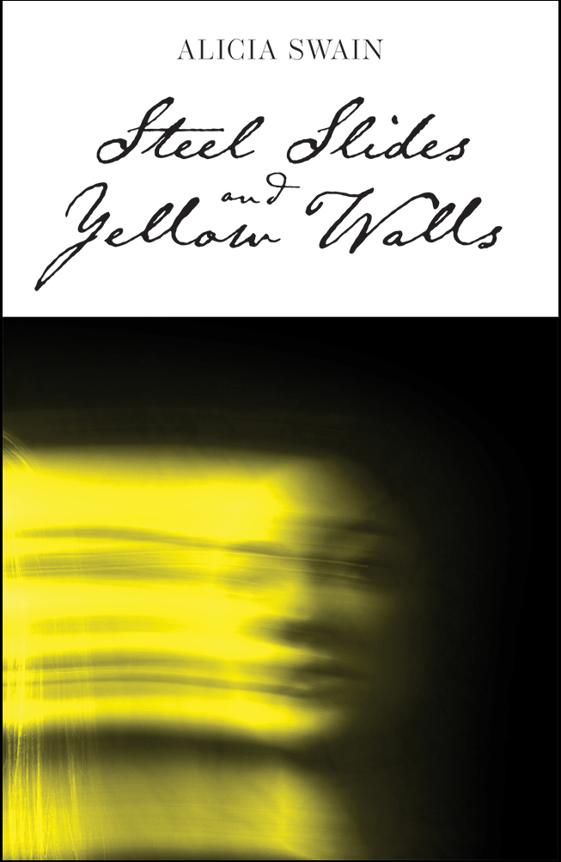](https://www.belleislebooks.com/store/p261/Steel_Slides_and_Yellow_Walls.html)

In *Steel Slides and Yellow Walls*, Alicia Swain navigates the labyrinthine journey women undergo to form their identities. Through a feminist lens and distinctive voice, her collection veraciously portrays the trials that forge women into sagacious, resilient adults. From contemplation of how to balance mental health despite knowing what tribulations are sure to come, to the title poem’s exploration of how traumatic memories can continue to haunt in the most unexpected situations, Swain offers a look at the diverse experiences that mold women into the tenacious beings they are.

**About the Author**

[Alicia Swain](https://www.brandylanepublishers.com/product/steel-slides-and-yellow-walls/) grew up along Lake Wallenpaupack in Pennsylvania and now resides in Richmond, Virginia, so her poetry is infused with images of both rural and urban life. Her work incorporates feminist themes that aim to highlight the complicated lives of women and members of the queer community. Swain studied English at Penn State University and Eastern Illinois University. Her work has been featured in several online publications, including the *Vehicle* and *Cathexis Northwest Press.*

**Interviews available upon request.**

[Belle Isle Books](http://www.belleislebooks.com/), an imprint of [Brandylane Publishers, Inc.](https://brandylanepublishers.com/), is an independent press located in Richmond, Virginia that has published books since 1985.

___________

*Steel Slides and Yellow Walls* (paperback, 72 pages, $13.95) is available for sale from [Amazon](https://www.amazon.com/Steel-Slides-Yellow-Walls-Alicia/dp/1966369042), [Barnes & Noble](https://www.barnesandnoble.com/w/steel-slides-and-yellow-walls-alicia-swain/1147376778?ean=9781966369042), and other fine booksellers.