**FOR IMMEDIATE RELEASE**

**April 2020**

**Christina Kann, Publicist**

brandylanepr@gmail.com or 804.644.3090

**“An Interactive Guide to Mindfulness and Meditation”:**

***Grow with Me Poetry***

**written by Bridgette Fowler**

**on sale April 30, 2020**

“What a special gift! With her creative and unique combination of mindfulness and poetry, Bridgette Fowler’s *Grow with Me Poetry* offers an easy-to-use, heartwarming, and fun way to move beyond the sense of separation increasingly experienced by today’s young people.” 

—Richard TenEyck, former superintendent, former Assistant Commissioner of Education (NJ)

[Belle Isle Books](http://www.belleislebooks.com/) of Richmond, Virginia is excited to announce the upcoming release of [*Grow with Me Poetry*](https://www.amazon.com/Grow-Me-Poetry-Bridgette-Fowler/dp/195156524X/ref=sr_1_1?keywords=grow+with+me+poetry&qid=1580915392&sr=8-1). This interactive children’s book is designed to teach the practice of mindfulness through poetry reading and journaling exercises for children and parents to complete together. *Grow with Me Poetry* isscheduled for release on April 30, 2020.

[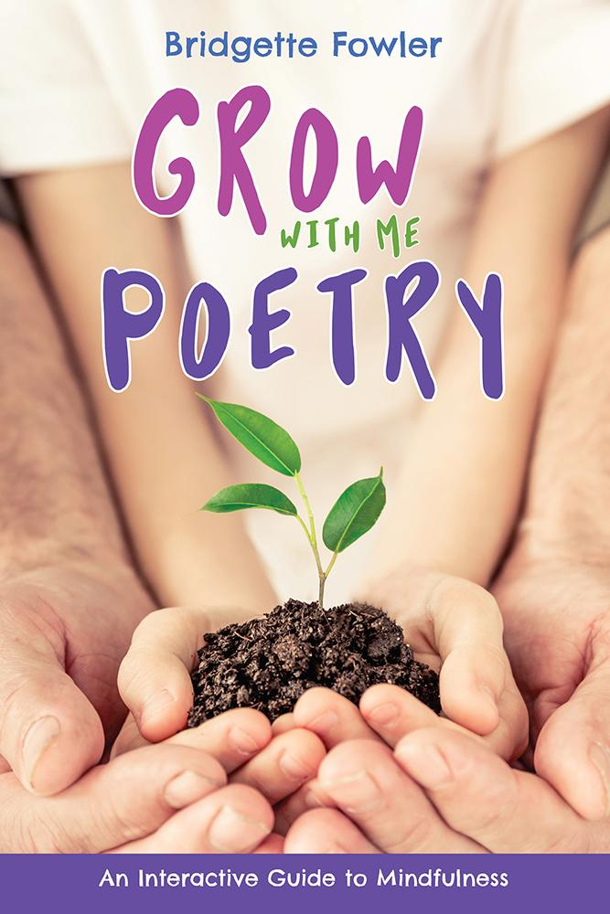](https://www.amazon.com/Grow-Me-Poetry-Bridgette-Fowler/dp/195156524X/ref=sr_1_1?keywords=grow+with+me+poetry&qid=1582570892&sr=8-1)

*Grow with Me Poetry* uses poetry as a means of introducing children and early teens to the practice of mindfulness. In *Grow with Me Poetry*, you will find both a primer on mindfulness and basic meditation techniques, as well as a guide to incorporating that practice into your daily life. Through unique interactive exercises and discussion prompts, adults and children alike will have the opportunity to engage, to converse, to learn about each other, and ultimately, to grow. This book is sure to become a treasured keepsake on any family’s bookshelf!

**About the Author**

[Bridgette Fowler](https://www.bridgettefowlerpoetry.com/) worked in the field of healthcare for thirty years. She began her career in audiology helping the youngest ears hear, and ended it making sure elderly ears could continue to hear the words of their younger counterparts. Today, she is reaching out to all those same ears through her poetry. Writing poems that are both poignant and whimsical, her words speak directly to the issues faced by our youth. She is an avid proponent of mindfulness meditation and touts the practice as a means to keep both mind and body healthy. Additionally, seeing an ever more present disconnect between adults and children, she seeks to bring the generations together by melding her two loves: poetry and mindfulness.

**Interviews are available upon request.**

[Belle Isle Books](http://www.belleislebooks.com/) is an imprint of [Brandylane Publishers, Inc.](https://brandylanepublishers.com/), an independent press located in Richmond, Virginia, that has published books since 1985.

*Grow with Me Poetry* (250 pages, paperback $17.95 / Kindle ebook $3.99 forthcoming) is available for preorder from [Amazon](https://www.amazon.com/Grow-Me-Poetry-Bridgette-Fowler/dp/195156524X/ref=sr_1_1?keywords=grow+with+me+poetry&qid=1580915392&sr=8-1), [Barnes & Noble](https://www.barnesandnoble.com/w/grow-with-me-poetry-bridgette-fowler/1136276954;jsessionid=D5D4DDDE5E52ED886210DAB3C7CA3150.prodny_store01-atgap15?ean=9781951565244), and other fine booksellers.