**FOR IMMEDIATE RELEASE**

**September 2024**

**Publicity Team**

804-644-3090  
pr@brandylanepublishers.com

**New Children’s Book *Henry and the Magical Words* Sets Foster Kids and Parents Up for Success**

written by Cathy Newbanks-Hawks

illustrated by Susannah Wagner Merritt

on sale September 10, 2024

“. . . sure to charm every child and be beloved by every family hoping to build a sense of belonging for their children. A must-read for foster, adoptive, and kinship families everywhere.”

- Arnie Eby, Executive Director, National Foster Parent Association

[Belle Isle Books](http://www.belleislebooks.com/) of Richmond, Virginia, is pleased to announce the upcoming release of a new children’s picture book, [*Henry and the Magical Words*](https://www.belleislebooks.com/store/p246/Henry_and_the_Magical_Words.html)*,* written by Cathy Newbanks-Hawks and

illustrated by Susannah Wagner Merritt.

There are almost four hundred thousand children in foster care in the US. Still more— numbering in the millions, 3 percent of American children—are living in kinship care, with grandparents, aunts, uncles, or other relatives than their parents, when those parents are unwilling or unable to care for them. Debuting during National Kinship Care Month, this book, which illustrates the importance of kinship and foster care in helping children find their sense of belonging, offers understanding as it tells the story of these children and their families, through the eyes of a little bird named Henry.  
 Henry is a little bobwhite who feels alone—as alone as you might feel on a deserted island where it is just you and a coconut tree! Although he is surrounded by other forest animals, he wonders whether there is anyone else in the world like him, and longs to hear the magical words: *You belong.*

When two children who have themselves been adopted from foster care find Henry, he feels a strange new sense of happiness—but although the children try to provide a loving home for him, they soon realize they haven’t quite managed to give Henry everything a bobwhite needs. With the help of their own foster parents, the children reflect on their own feelings on the day they arrived at their foster home, and learn how they can work together with Henry to make sure they make their house a place where he feels he can belong just as he is.

At the same time, Henry is searching for his own answer to the question of where his heart belongs. When he finally admits that he feels connected to the children who have taken him in, he allows his heart to open—and, with the help of his new loving and accepting family, realizes can do many things and belong in many places, and find his own sense of self and home.

A tender story for foster and adopted children, their loving foster and adoptive families, and anyone who has ever felt they didn’t belong,*Henry and the Magical Words* releases today, September 10, 2024.

[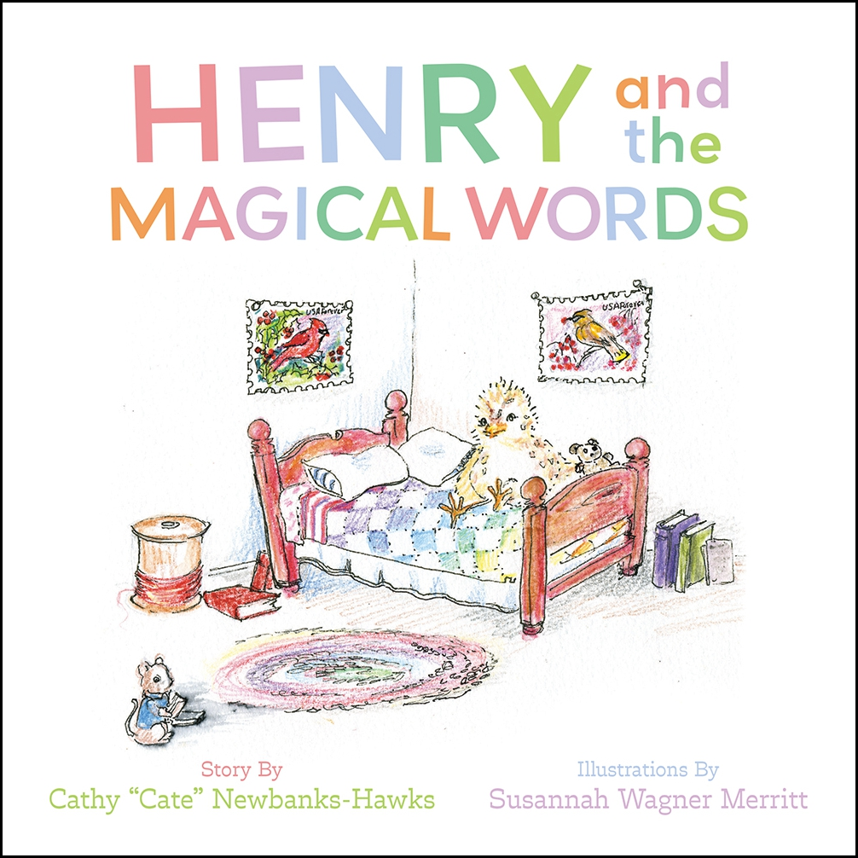](https://www.belleislebooks.com/store/p246/Henry_and_the_Magical_Words.html)

*Separated from his parents, Henry is discovered by two children who once lived in the foster care system. By taking Henry in, the family discovers how important it is to take time to listen to the similarities and differences of each and every member of a family. Later, when Henry and his aunt and uncle are reunited, Henry learns that he can happily belong to more than one family!*

*Kinship care is a federally supported child welfare initiative in which children come to live with their extended families.* Henry and the Magical Words *was inspired by one such child. In her words, she wanted to “belong somewhere—anywhere.” Moved by that conversation, and by Margery Williams’s classic story “The Velveteen Rabbit,” Cate Newbanks-Hawks offers a story that is sure to touch the hearts of anyone who has ever longed to belong.*

*Profits from sales of this book will be donated in support of young people with lived experience in foster care.*

**About the Author**

[Cathy Newbanks-Hawks](https://www.belleislebooks.com/cathynewbankshawks.html) has worked as a public administrator in child welfare in Illinois, Virginia, and Florida. She spent seventeen years developing and running a statewide family support organization in Virginia and served on the board of the National Foster Parent Association. Cathy remains engaged in the national child welfare conversations.

**About the Illustrator**

[Susannah Wagner Merritt](https://www.belleislebooks.com/susannahwagnermerritt.html) is a Virginia native. She modeled the illustrations of children for *Henry and the Magical Words* in honor of her niece and nephew, who were adopted from foster care.

**Interviews available upon request.**

[Belle Isle Books](http://www.belleislebooks.com/), an imprint of [Brandylane Publishers, Inc.](https://brandylanepublishers.com/), is an independent press located in Richmond, Virginia that has published books since 1985.

___________

*Henry and the Magical Words* (hardcover, 36 pages, $26.95 / paperback, 36 pages, $15.95) is available from [Amazon](https://www.amazon.com/Henry-Magical-Words-Cathy-Newbanks-Hawks/dp/1958754994), [Barnes & Noble](https://www.barnesandnoble.com/w/henry-and-the-magical-words-cathy-cate-newbanks-hawks/1145692337?ean=9781958754993), and other fine booksellers.