**FOR IMMEDIATE RELEASE**

**September 2024**

**Publicity Team**

804-644-3090  
pr@brandylanepublishers.com

***I’d Rather Be Me* Encourages Children to Foster Self-Confidence**

written by Emily Peace Harrison

illustrated by Dacil Curbelos

on sale September 24, 2024

“. . . a wonderful celebration of individuality and self-expression. . . . An essential addition for any young reader’s bookshelf, inspiring them to shine bright in the world!”

- Nima Patel, founder of Mindful Champs, parenting coach, and author of the picture book *The Best You*

[Belle Isle Books](http://www.belleislebooks.com/) of Richmond, Virginia, is pleased to announce the upcoming release of a new children’s picture book, [*I’d Rather Be Me*](https://www.belleislebooks.com/store/p244/I%27d_Rather_Be_Me.html)*,* written by Emily Peace Harrison and illustrated by Dacil Curbelos.

Hank is a pup who is happy as can be—except for the fact that he has a little flea in his ear, who can’t seem to quit nagging him with questions about what it might be like to be some other creature entirely! But even though the flea’s fantasies are entrancing, Hank knows he’d rather be himself. With that knowledge, Hank shows kids that they too can be confident in standing up to peer pressure and embracing who they are—and find the courage to shake off their own insistent little fleas!

Fully illustrated in beautiful textures and colors, and told in a fun rhyming patter that will inspire young readers to “listen up!” and build their self-esteem to be “the very best me” they can be,*I’d Rather Be Me* is scheduled for release on September 24, 2024.

[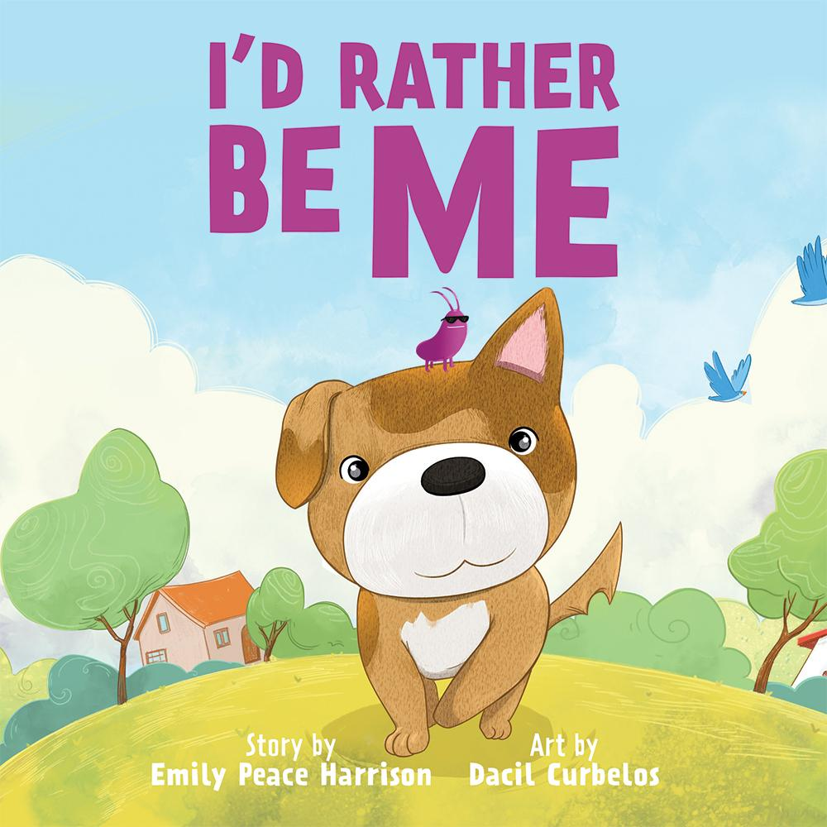](https://www.belleislebooks.com/store/p244/I%27d_Rather_Be_Me.html)

*If you were not you, who would you be? Maybe a whale in the deep blue sea? Hank the pup is happy just being himself, except for one little problem—a tiny flea buzzing in his ear, telling him that he’s not good enough. What if he were a monkey? Or a bird? Or even a lion? Wouldn’t that be better than just being himself?*

*Sometimes it is hard to avoid the pressures to change who you are just to fit in. Will the flea convince Hank to be someone he’s not, or will Hank stay true to himself?*

**About the Author**

[Emily Peace Harrison](https://www.belleislebooks.com/emilypeaceharrison-915462.html) was the youngest of five children in a house full of glorious chaos. It is no surprise that she established a career as the ultimate organizer of chaos, serving as an executive assistant in higher education for over fifteen years. Having had a front-row seat to the emotional journeys of her four siblings, her two sons, and countless college students (not to mention her own personal journey), Emily knows the importance of character building in the early stages of a child’s life as a way to prepare them for the emotional struggles they are sure to face. Beginning with her debut, I’d Rather Be Me, Emily’s picture books, filled with beautiful illustrations and heartfelt characters, aim to inspire confidence, foster empathy, and promote self-esteem in young readers. When she’s not at her day job or crafting rhymes for her stories, Emily enjoys stirring up a little chaos of her own with family and friends.

**Interviews available upon request.**

[Belle Isle Books](http://www.belleislebooks.com/), an imprint of [Brandylane Publishers, Inc.](https://brandylanepublishers.com/), is an independent press located in Richmond, Virginia that has published books since 1985.

___________

*I’d Rather Be Me* (hardcover, 36 pages, $26.95 / paperback, 36 pages, $15.95) is available for pre-order from [Amazon](https://www.amazon.com/Id-Rather-Emily-Peace-Harrison/dp/1962416240), [Barnes & Noble](https://www.barnesandnoble.com/w/id-rather-be-me-emily-peace-harrison/1145238567?ean=9781962416245), and other fine booksellers.