**FOR IMMEDIATE RELEASE**

**July 2025**

**Publicity Team**

pr@brandylanepublishers.com

804-644-3090

**New Children’s Book Explains Why *Lady Needed Space—*and Teaches Child Readers to Empathize with Others’ Needs**

written by Audrey Weatherstone

illustrated by Natalia Logvanova

on sale May 20, 2025

**“Audrey Weatherstone’s tender and reassuring picture book is a genuine reminder that we all need acceptance to thrive. We can never have enough books about belonging.”**

**- Judy Pedersen, author of *When Night Time Comes Near***

[Belle Isle Books](http://www.belleislebooks.com/) of Richmond, Virginia, is proud to announce the release of a new picture book for children aged 3 to 7, [*Lady Needed Space*](https://www.brandylanepublishers.com/product/lady-needed-space/)*,* written by Audrey Weatherstone and illustrated by Natalia Logvanova.

When a kind woman named Lily finds a frightened dog all alone on Nine Mile Road, she’s determined to make that dog one lucky lady—by bringing her to the animal shelter, where she might find a person to bring her to her forever home. But the shelter is loud and bright, and frightens Lady almost as much as the road!  
 Fortunately, Lily’s hopes are realized when Lady is adopted by April, a young girl with an equally big heart. With April, Lady finally feels safe at home—but the outside world remains a frightening place, and Lady reacts fearfully when confronted by new dogs, people, and noises, often barking or growling. Even though she doesn’t mean to, her nerves get the better of her—and she sometimes worries her reactions push away potential friends.

Despite April’s kindhearted efforts to help by offering treats and teaching Lady tricks to help her deal with her fears, the outside world and walks remain nerve-wracking for Lady, who alternates between brave days and more difficult ones. Nevertheless, April’s patience, and ultimately, a new friend—and an unexpected old one—help Lady feel better—but even then, April respects that Lady still needs space sometimes.

Bright, expressive watercolors capture the characters’ big emotions—animal and human alike—in this tale of a dog who needs to find her confidence in the face of past traumas and current pressures. “As Lady navigates her emotional journey, we witness the transformative power of friendship and support from her dedicated caretaker and a newfound companion. This touching tale reminds us that sometimes we all need space, help to discover our bravery, and support to be our true selves,” comments Amy Learn, VMD, Diplomate of the American College of Veterinary Behaviorists and owner of the Animal Behavior Wellness Center in Richmond, Virginia.

A heartwarming story about empathy, friendship, and managing big emotions,*Lady Needed Space* released May 20, 2025.

[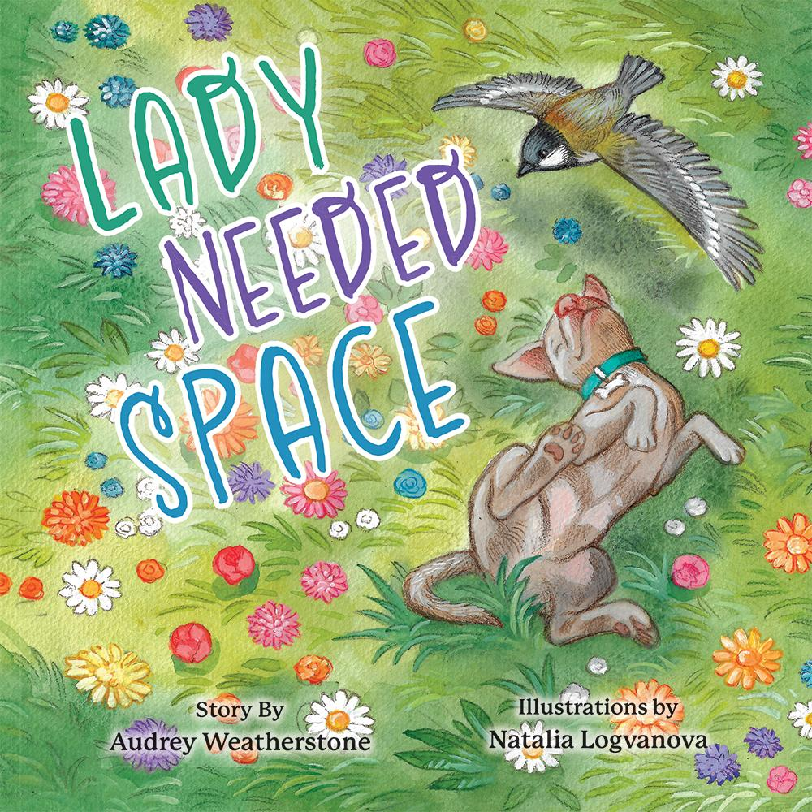](https://www.brandylanepublishers.com/product/lady-needed-space/)

*When Lady is brought home from the animal shelter, she feels overwhelmed by the busy world around her, full of unfamiliar dogs, people, sounds, and smells. She doesn't know what to do with her big feelings! But with love and patience from her human, April, Lady learns tricks to help her feel safe, and even makes a new friend. Some days she feels brave, and some days she just needs space.*

**About the Author**

[Audrey Weatherstone](https://www.brandylanepublishers.com/product/lady-needed-space/) is a singer-songwriter, author, and dog lover based in Richmond, Virginia. After graduating from Shenandoah University, she now works as a music therapist in neurologic rehabilitation and hospice care, as well as advocating for rescue animals, reactive dogs, and positive reinforcement dog training. Her music and writing are inspired by her work as a music therapist and her reactive rescue dog, Lady. *Lady Needed Space* is her first book.

**About the Illustrator**

[Natalia Logvanova](https://www.brandylanepublishers.com/product/lady-needed-space/) was born in the village of Zarechnoye, Ukraine. Natalia's father worked as a math teacher and was a self-taught artist. As a child, Natalia loved to draw and studied fine art with other children. After graduating from high school, Natalia went to the University of Manuilsky in Rivne, Ukraine. She graduated from the faculty of fine arts and design basics. Today, Natalia lives and works in Nizhny Novgorod, Russia. She has worked as an Illustrator for about twenty years, illustrating more than fifty books for publishers in the United States, England, Jordan, Australia, South Korea, Poland, and Belarus. Natalia specializes in children's illustration; she uses watercolors and digital graphics.

**Interviews available upon request.**

[Belle Isle Books](http://www.belleislebooks.com/) is an imprint of [Brandylane Publishers, Inc.](https://brandylanepublishers.com/), an independent press located in Richmond, Virginia, that has published books since 1985.

___________

*Lady Needed Space* (hardcover, 32 pages, $26.95 / paperback, 32 pages, $15.95) is available from [Amazon](https://www.amazon.com/Lady-Needed-Space-Audrey-Weatherstone/dp/1962416968), [Barnes & Noble](https://www.barnesandnoble.com/w/lady-needed-space-audrey-weatherstone/1147100791?ean=9781962416962), and other fine booksellers.