**FOR IMMEDIATE RELEASE**

**June 2021**

**Christina Kann, Publicist**

[pr@brandylanepublishers.com](mailto:pr@brandylanepublishers.com)

**Preparing Kids for Stormy Weather: *Laura-Leigh Learns about Storms***

**written by Nikki-Dee Ray Wren and David Wren**

**illustrated by Chad Thompson**

**on sale June 24, 2021**

“Knowledge is power, and in this case, it’s comfort too! Teaching children the lesson of what a thunderstorm is and helping them understand what they should do puts them in charge of their own safety.”

—Elaina Rusk, chief meteorologist, KERO

[Belle Isle Books](http://www.belleislebooks.com/) of Richmond, Virginia, is proud to announce the upcoming release of [*Laura-Leigh Learns About Storms*](https://bookshop.org/books/laura-leigh-learns-about-storms/9781951565275) written by [Nikki-Dee Ray Wren](https://www.nikki-dee.com/) and David Wren, illustrated by [Chad Thompson](https://www.chadthompsonillustration.com/Chad_Thompson_Illustration/Welcome.html). From award-winning meteorologist Nikki-Dee Ray Wren, *Laura-Leigh Learns about Storms* offers grown-ups a fun way to teach children about storm preparation. *Laura-Leigh Learns about Storms* is scheduled for release on March 5, 2021.

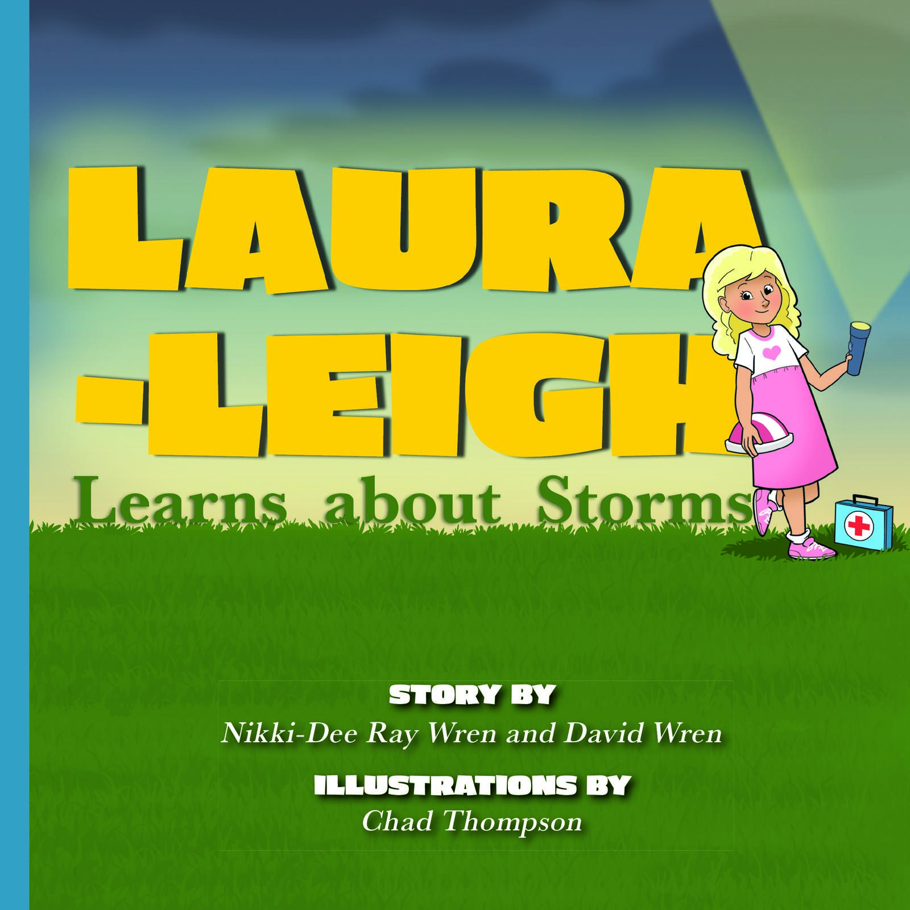

While Laura-Leigh and her friends are playing outside, they notice a big, dark storm cloud moving in. Laura-Leigh has never seen a storm quite like this one! At first, she is nervous and scared, but Mom’s quick thinking and valuable instruction show Laura-Leigh that she can weather any storm that comes her way.

**About the Author**

[Nikki-Dee Ray Wren](https://www.nikki-dee.com/) was born and raised in northern Alabama. She received her degree in atmospheric sciences at Mississippi State University and has since worked as a television meteorologist in Texas, Virginia, and Tennessee. During her time in Virginia, Nikki-Dee met her husband, David Wren, in his hometown of Richmond. They now live in Nashville, Tennessee, where Nikki-Dee is a television meteorologist and David owns a recruiting firm. Nikki-Dee and David have two beautiful children, son T. Copeland and daughter Windley-Ray, as well as their beloved Maltese, Louis. They both have a passion for their faith, serving others, and advocating for inclusion.

**About the Illustrator**

After graduating from the Columbus College of Art & Design, [Chad](https://www.chadthompsonillustration.com/Chad_Thompson_Illustration/Welcome.html) was hired by Walt Disney Feature Animation studio in Florida. For the next seven years, he worked on animated movies such as Mulan, Tarzan, Lilo & Stitch, and Brother Bear. He currently works as a children’s book illustrator and designer for a wide variety of clients. When he is not at the drawing board, Chad enjoys spending time with his wife and two young children.

**Interviews available upon request.**

[Belle Isle Books](http://www.belleislebooks.com/) is a proud imprint of [Brandylane Publishers, Inc.](https://brandylanepublishers.com/), which is an independent press located in Richmond, Virginia, that has published books since 1985.

_____

*Laura-Leigh Learns about Storms* (32 pages, hardback $22.95 / paperback $13.95 / e-book $2.99) is available for pre-order through [Bookshop](https://bookshop.org/books/laura-leigh-learns-about-storms/9781951565275), [Amazon](https://www.amazon.com/Laura-Leigh-Learns-about-Storms-Nikki-Dee/dp/1951565274/), [Barnes and Noble](https://www.barnesandnoble.com/w/laura-leigh-learns-about-storms-nikki-dee-ray-wren/1139141474?ean=9781951565275), and other fine booksellers.