**FOR IMMEDIATE RELEASE**

**August 2023**

**Publicity Team**

804-644-3090  
pr@brandylanepublishers.com

**Take Your Kids on a Beach Day and Watch Them Grow with *Adeline by the Sea*!**

written by Lauren Oakey

illustrated by Britt Van Deusen

on sale August 10, 2023

“. . . a tender portrait of the small moments that shape us into brave beings . . . a book that kids and adults can enjoy over and over again.”

- Meaghan Rady, executive producer of *Brené Brown: Atlas of the Heart*

[Belle Isle Books](http://www.belleislebooks.com/) of Richmond, Virginia, is pleased to announce the release of a new children’s picture book, [*Adeline by the Sea*](http://www.belleislebooks.com/store/p222/Adeline_by_the_Sea.html), written by Lauren Oakey and illustrated by Britt Van Deusen.

Every summer, young Henry visits Grandpa’s house with his family, including his older and younger sisters. There, he enjoys walking on the beach; birdwatching; collecting seashells; and looking after his baby sister Adeline. But with each year that passes, Adeline grows up a little more. After caring for her throughout her toddler phase, can Henry find the courage to reconsider his identity as Adeline’s protector and encourage her growing desire to fly free?

A heartwarming story of a young brother’s love and a young sister’s blossoming independence, fully illustrated for children ages 3 to 8 who are just learning how to navigate their own beaches, *Adeline by the Sea* was released on August 10, 2023.

[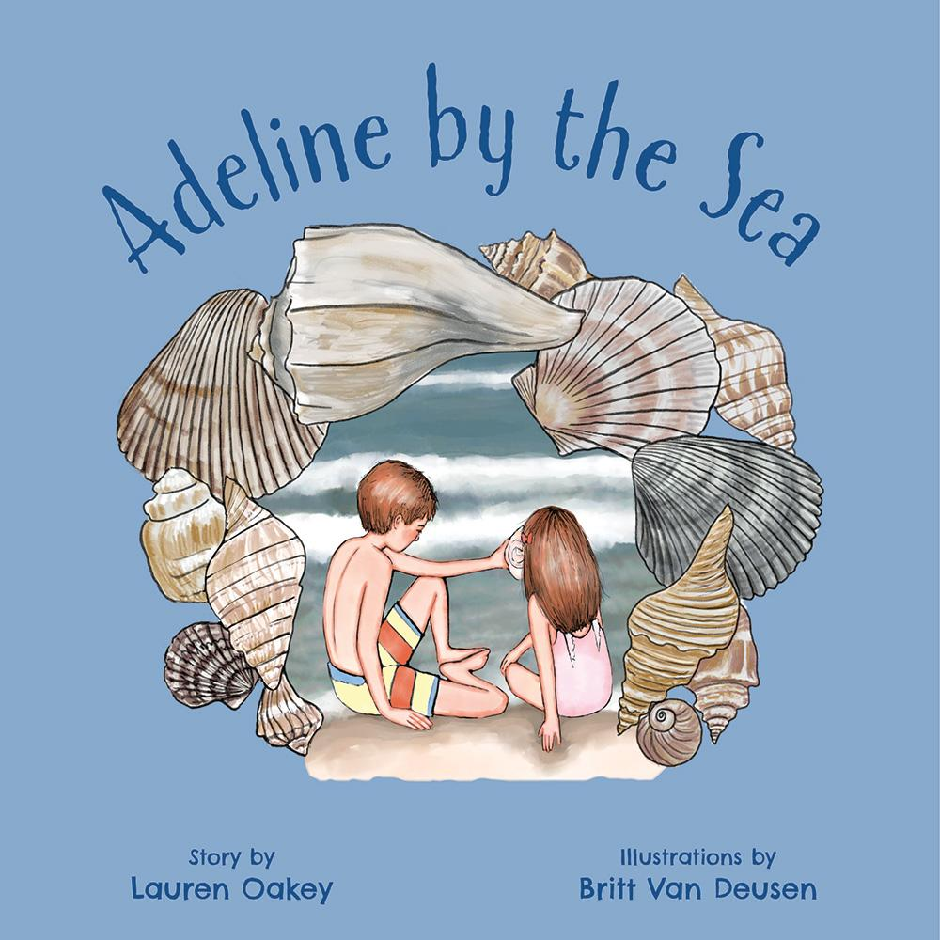](http://www.belleislebooks.com/store/p222/Adeline_by_the_Sea.html)

*It’s summer, and that means a family trip to visit Grandpa on the coast! Henry loves staying in the old house by the water. He loves listening to Grandpa’s stories, watching the purple martins build their nests, and of course, keeping an eye on his baby sister, Adeline. After all, that’s a big brother’s responsibility! But with little Adeline getting bigger, is it time for Henry to learn the difference between protecting someone and loving them enough to let go?*

**About the Author**

[Lauren Tweel Oakey](http://www.belleislebooks.com/laurenoakey.html) lives in Richmond, Virginia, and is a graduate of the University of Virginia, where she studied world religions and Italian language. She has lived in Italy and Switzerland, worked mostly in non-profits, and is a lover of language and the rhythm of words. She also enjoys playing piano; practicing yoga; and spending time with her husband, three children, and very beautiful but high-maintenance black Lab.

**About the Illustrator**

[Britt Van Deusen](http://www.belleislebooks.com/brittvandeusen.html) is an artist who lives in Richmond, Virginia, with her husband and three girls (two human and one canine). Britt studied painting at the College of William & Mary and the Marchutz School in France, and she has been a portrait artist for many years. When she is not making art, Britt often reads books that feature both people and animals in starring roles; regularly cooks somewhat fancy meals; occasionally plays silly songs on her guitar; and with stunning frequency, discovers birds’ nests abandoned in nature.

**Interviews available upon request.**

[Belle Isle Books](http://www.belleislebooks.com/), an imprint of [Brandylane Publishers, Inc.](https://brandylanepublishers.com/), is an independent press located in Richmond, Virginia that has published books since 1985.

___________

*Adeline by the Sea* (hardcover, 36 pages, $26.95 / paperback, 36 pages, $15.95) is available for purchase from [Amazon](https://www.amazon.com/Adeline-Sea-Lauren-Oakey/dp/1958754498), [Barnes & Noble](https://www.barnesandnoble.com/w/adeline-by-the-sea-lauren-oakey/1143650572?ean=9781958754498), and other fine booksellers.