**FOR IMMEDIATE RELEASE**

**August 2022**

**Publicity Team**

pr@brandylanepublishers.com

804-644-3090

**Explore the Little-Known History of Mesozoic Virginia with *The Age of Dinosaurs in Virginia and Nearby States***

written by Dr. Robert Weems

on sale September 27, 2022

In recent decades, the *Jurassic Park* and *Jurassic World* films have greatly helped to bring reasonably accurate renditions of many of these creatures to life in the popular mind. But where within the vastness of prehistoric time did each of these creatures live? Which of them lived in Virginia? And how do we know?

- from *The Age of Dinosaurs in Virginia and Nearby States*

[Belle Isle Books](http://www.belleislebooks.com/) of Richmond, Virginia, is pleased to announce the upcoming release of a new scientific resource, *The Age of Dinosaurs in Virginia and Nearby States*, written by Dr. Robert E. Weems.

Discover Virginia’s ancient past with this new work of scientific inquiry into the geographic history of what would come to be the Mid-Atlantic states—and meet their awe-inspiring inhabitants, both aquatic and terrestrial. Filled with comprehensive figures and maps detailing the evolution of the dinosaurs and the world around them, their appearances, and even their footprints, *The Age of Dinosaurs in Virginia and Nearby States* not only describes what we know of this fascinating period, but also how we know it—as well as sharing all the best places to see Mesozoic fossils and exhibits related to Virginia. From the late Triassic to the dawn of the Cenozoic era following the dinosaurs’ extinction, this fantastic resource will fit perfectly on the shelf of any lover of dinosaurs, paleontology, and the world as it was sixty-five million and more years ago. Compiled from a lifetime of passionate research into the rocks and fossils beneath our feet, *The Age of Dinosaurs in Virginia and Nearby States* is scheduled for release on September 27, 2022.

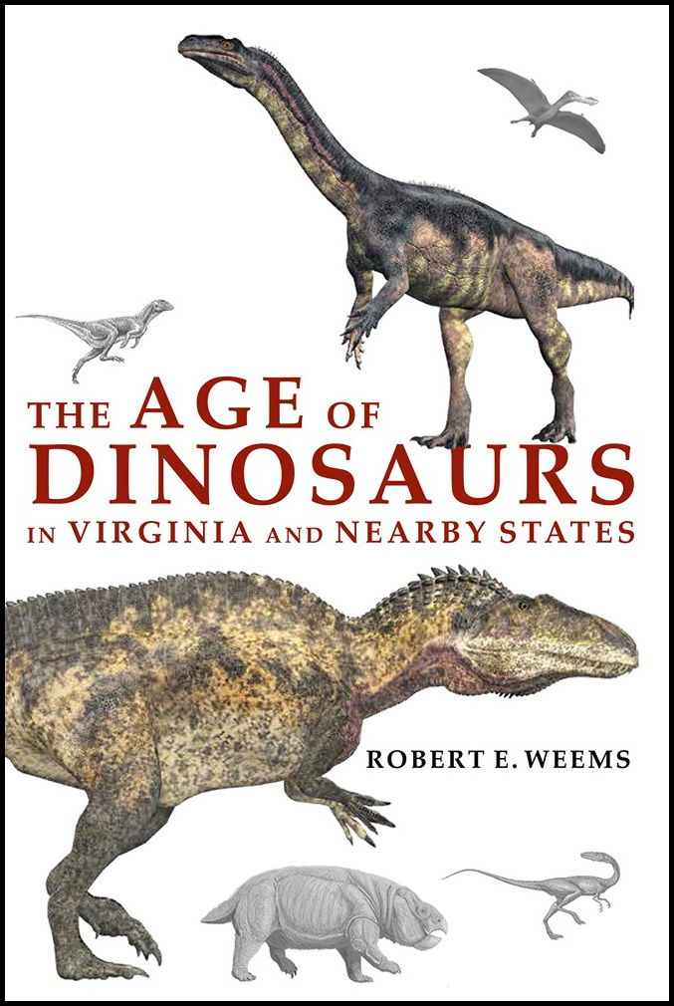

*Although the fossil dinosaur deposits of the western United States are justly famous and widely appreciated, the fossil deposits of the eastern United States have received much less publicity.* The Age of Dinosaurs in Virginia and Nearby States *provides a detailed guide to this little-publicized history of the age of dinosaurs in the Mid-Atlantic states. This book focuses primarily on Virginia, but also extensively covers the age of dinosaurs in North Carolina, Maryland, Delaware, southern Pennsylvania, and southern New Jersey—thereby offering a more comprehensive view of the age of dinosaurs in the Mid-Atlantic region than has ever been previously attempted.*

**About the Author**

[Dr. Robert E. Weems](http://www.belleislebooks.com/roberteweems.html) read a book called *All About Dinosaurs* when he was in the second grade, and has been fascinated by dinosaurs and other fossil animals ever since. He started collecting fossil bones and teeth when he was ten years old; and since then, he has spent over sixty years searching for fossil vertebrates in and around Virginia.

Besides becoming interested in fossil vertebrates, Dr. Weems also became fascinated with the stratigraphy and geologic history of the Mid-Atlantic states. After graduating from The George Washington University in 1978, he got a job with the US Geological Survey in Reston, Virginia, and began his professional career working on the Charleston, South Carolina, earthquake project as a stratigrapher. He went on to spend thirty-two years with the USGS, working mostly in South Carolina, North Carolina, Virginia, Maryland, and Missouri, and publishing many papers and maps on that subject before retiring in 2010 to return to his studies on the vertebrate paleontology of the Virginia region. During his career, Dr. Weems has authored or coauthored 159 scientific papers and geologic maps, publishing works on his fossil discoveries in professional journals for over forty years. *The Age of Dinosaurs in Virginia and Nearby States* represents a summary of his own lifetime of work, as well as the work of many others who have explored the age of dinosaurs in the Virginia region.

**Interviews available upon request.**

[Belle Isle Books](http://www.belleislebooks.com/), an imprint of [Brandylane Publishers, Inc.](https://brandylanepublishers.com/), is an independent press located in Richmond, Virginia that has published books since 1985.

___________

*The Age of Dinosaurs in Virginia and Nearby States* (paperback, 186 pages, $16.95) is available for pre-order from [Amazon](https://www.amazon.com/Age-Dinosaurs-Virginia-Nearby-States/dp/1953021778), [Barnes & Noble](https://www.barnesandnoble.com/w/the-age-of-dinosaurs-in-virginia-and-nearby-states-rob-weems/1142035347?ean=9781953021779), and other fine booksellers. Kindle e-book (retail $4.99) forthcoming.