

**FOR IMMEDIATE RELEASE**

**December 2021**

**Publicity Team**

pr@brandylanepublishers.com

804-644-3090

**Dream Along with *Albert: A Frog and His Dream***

written by Doug Warren

illustrated by Keegan Williams

on sale January 31, 2022

“. . . one of those rare books that is both an enjoyable read and carries a valuable lesson . . . a book that will be read many times over.”

- Paul Sinor, author and screenwriter

[Belle Isle Books](http://www.belleislebooks.com/) of Richmond, Virginia, is pleased to announce the upcoming release of a new children’s book, *Albert: A Frog and His Dream*, written by Doug Warren and illustrated by Keegan Williams. “*Albert is a tree frog. He is like all of his tree frog friends and family in many ways, except for one . . . Albert is a dreamer.*” A heartfelt ode to all those who refuse to stop dreaming, *Albert* and his unconventional wish will delight both children and adults.

Complimented by beautiful illustrations reminiscent of classic children’s books, *Albert: A Frog and His Dream* is scheduled for release on January 31, 2022.

[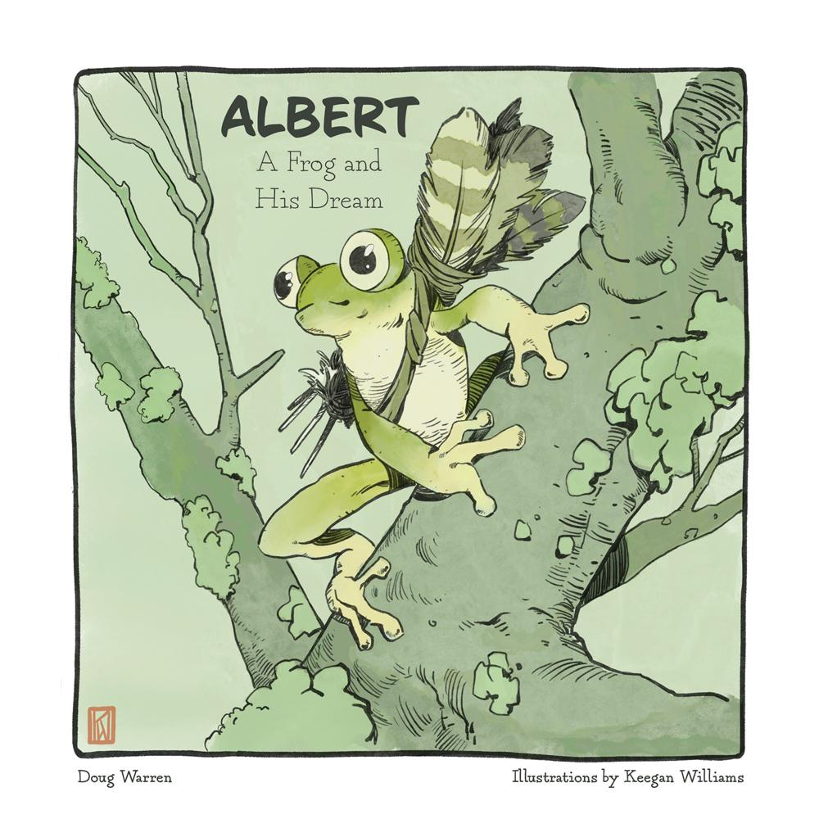](https://www.amazon.com/Albert-Frog-Dream-Doug-Warren/dp/1953021468)

*When Albert the tree frog announces he is going to learn to fly like a bird, his friends and neighbors all think it’s a big joke. After all, Albert is very clever, but he’s also a little odd, what with his constant daydreaming and odd hobbies. But Albert is determined to prove to his friends—and to himself—that with hard work and a little imagination, anything is possible!*

**About the Author**

[Doug Warren](http://www.belleislebooks.com/dougwarren.html) was born in northern California and currently lives in Lake Stevens, Washington, with his two daughters, Sophie and Daphne. A multifaceted artist, Doug has devoted himself to teaching his two daughters to always chase their dreams, using his gifts for both music and storytelling. Doug’s love of both aviation and nature are comfortably at home in the Pacific Northwest. When he’s not working as a graphic artist or dreaming up new adventures for Albert, he can be found playing his original music at live shows.

**About the Illustrator**

[Keegan Williams](http://www.belleislebooks.com/keeganwilliams.html) is an independent illustrator from western Washington. Williams began drawing at an early age, inspired by the steady diet of video games, fantasy novels, and comic books on which he was raised. These days, when not working to make rent at his day job, he enjoys channeling that initial inspiration from video games, fantasy novels, and comic books into his illustrative work.

**Interviews available upon request.**

[Belle Isle Books](http://www.belleislebooks.com/), an imprint of [Brandylane Publishers, Inc.](https://brandylanepublishers.com/), is an independent press located in Richmond, Virginia that has published books since 1985.

___________

*Albert: A Frog and His Dream* (hardcover, 32 pages, $22.95 / paperback, 32 pages, $13.95) is available for pre-order from [Amazon](https://www.amazon.com/Albert-Frog-Dream-Doug-Warren/dp/1953021468), [Barnes & Noble](https://www.barnesandnoble.com/w/albert-doug-warren/1140618135?ean=9781953021465), and other fine booksellers. Kindle e-book (retail $2.99) forthcoming.