**FOR IMMEDIATE RELEASE**

**February 2022**

**Publicity Team**

pr@brandylanepublishers.com

804-644-3090

**Find a Friend in *Astra the Lonely Airplane*!**

written by Julie Whitney

illustrated by Michelle Simpson

on sale March 2, 2022

“It’s rare that a children’s book teaches such a broad range of lessons. . . . a total home run for parents and kids.”

- Rocky Boiman, former NFL linebacker, college football analyst for ESPN, and author of *Rocky’s Rules*

[Belle Isle Books](http://www.belleislebooks.com/) of Richmond, Virginia, is pleased to announce the upcoming release of a new children’s book, [*Astra the Lonely Airplane*](http://www.belleislebooks.com/store/p183/Astra_the_Lonely_Airplane.html), written by Julie Whitney and illustrated by Michelle Simpson.

What’s an airplane without a flight path? Grounded until she finds a buyer, Astra misses her daily flights with Captain Dan—but she still won’t settle for just any owner. Fly along with Astra as she shows young readers how to soar without compromise.

Told in charming rhyming couplets and accompanied by vivid illustrations that accentuate the characters’ personalities, *Astra the Lonely Airplane* is scheduled for release on March 2, 2022.

[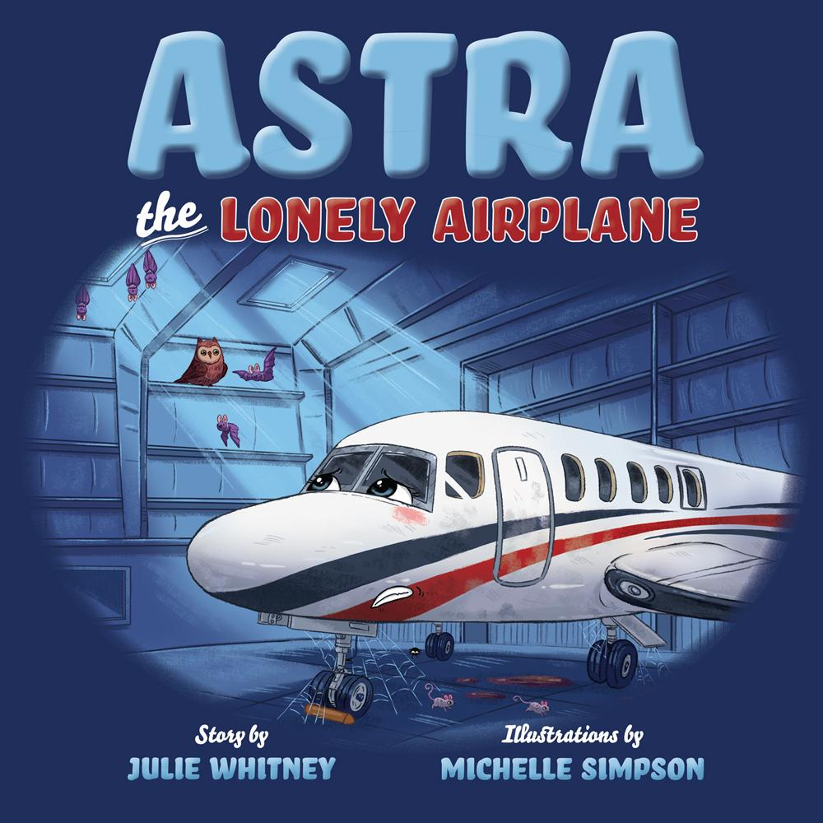](http://www.belleislebooks.com/store/p183/Astra_the_Lonely_Airplane.html)

*Astra is a sleek, shiny airplane who loves to go flying with her best friend, Captain Dan. But when Astra and Dan suddenly find themselves out of a job, Astra must wait in her lonely hangar for a new owner to come along and give them somewhere to go! As the weeks turn into months and the right buyer still doesn’t appear, Astra begins to wonder: Will she ever get to fly again?*

**About the Author**

[Julie Whitney](http://www.belleislebooks.com/juliewhitney.html) is a public relations professional with forty years of experience in public relations and marketing, having worked on both the agency and client side as well as in the television industry. Her company, Phillippi-Whitney Communications, LLC, founded in 2000, represents both large and small clients in a wide variety of industries. She has promoted dozens of authors throughout her career, often supplementing the efforts of the internal PR teams of their publishers. She also works as on-camera talent, appearing in both television commercials and video podcasts. She even appeared as an extra in the movie *Grease,* which was shot on location in the summer of 1977 in Los Angeles.

Julie lives in Cincinnati with her husband Dan, a corporate pilot upon whom the character of Captain Dan is based. A naval aviator and USNA grad, he flew the P-3 Orion on active duty, and has flown a Gulfstream G100 (Astra) for the past thirteen years. With four grown children, they are now empty nesters and love spending time with their black Lab, Brody. They also enjoy traveling, boating, golfing, and all types of physical fitness.

**About the Illustrator**

[Michelle Simpson](http://www.belleislebooks.com/michellesimpson.html) is a full-time illustrator based out of the Niagara region of Canada. She graduated with a BAA in illustration from Sheridan College. Michelle's main focus is on children's book illustrations and educational material for kids. She has worked with many large publishing houses and has also created concept artwork and final backgrounds for season two of the children’s TV show *Ollie: The Boy Who Became What He Ate* and season one of *Tee and Mo.*

**Interviews available upon request.**

[Belle Isle Books](http://www.belleislebooks.com/), an imprint of [Brandylane Publishers, Inc.](https://brandylanepublishers.com/), is an independent press located in Richmond, Virginia that has published books since 1985.

___________

*Astra the Lonely Airplane* (hardcover, 44 pages, $24.95 / paperback, 44 pages, $14.95) is available for pre-order from [Amazon](https://www.amazon.com/Astra-Lonely-Airplane-Julie-Whitney/dp/1953021417320/), [Barnes & Noble](https://www.barnesandnoble.com/w/astra-the-lonely-airplane-julie-whitney/1140360765?ean=9781953021410), and other fine booksellers. Kindle e-book (retail $2.99) forthcoming.