**FOR IMMEDIATE RELEASE**

**February 2020**

**Christina Kann, Publicist**

brandylanepr@gmail.com or 804.644.3090

**“Poetry of the Highest Sort”:**

***Before the Foundation of the World***

**by Susan Weiner**

**on sale February 28, 2020**

“. . . rich food for the soul not to be devoured hastily, but savored slowly and deliberately.”

—Joanne Hamilton, former president, Associate Reformed Presbyterian Women’s Ministries

[Belle Isle Books](http://www.belleislebooks.com/) of Richmond, Virginia is excited to announce the upcoming release of a new devotional book, [*Before the Foundation of the World*](https://www.amazon.com/Before-Foundation-World-Susan-Weiner/dp/1947860453/ref=tmm_pap_swatch_0?_encoding=UTF8&qid=1582050291&sr=8-12). A powerful collection of spiritual poems and songs, *Before the Foundation of the World* is scheduled for release on February 28, 2020.

[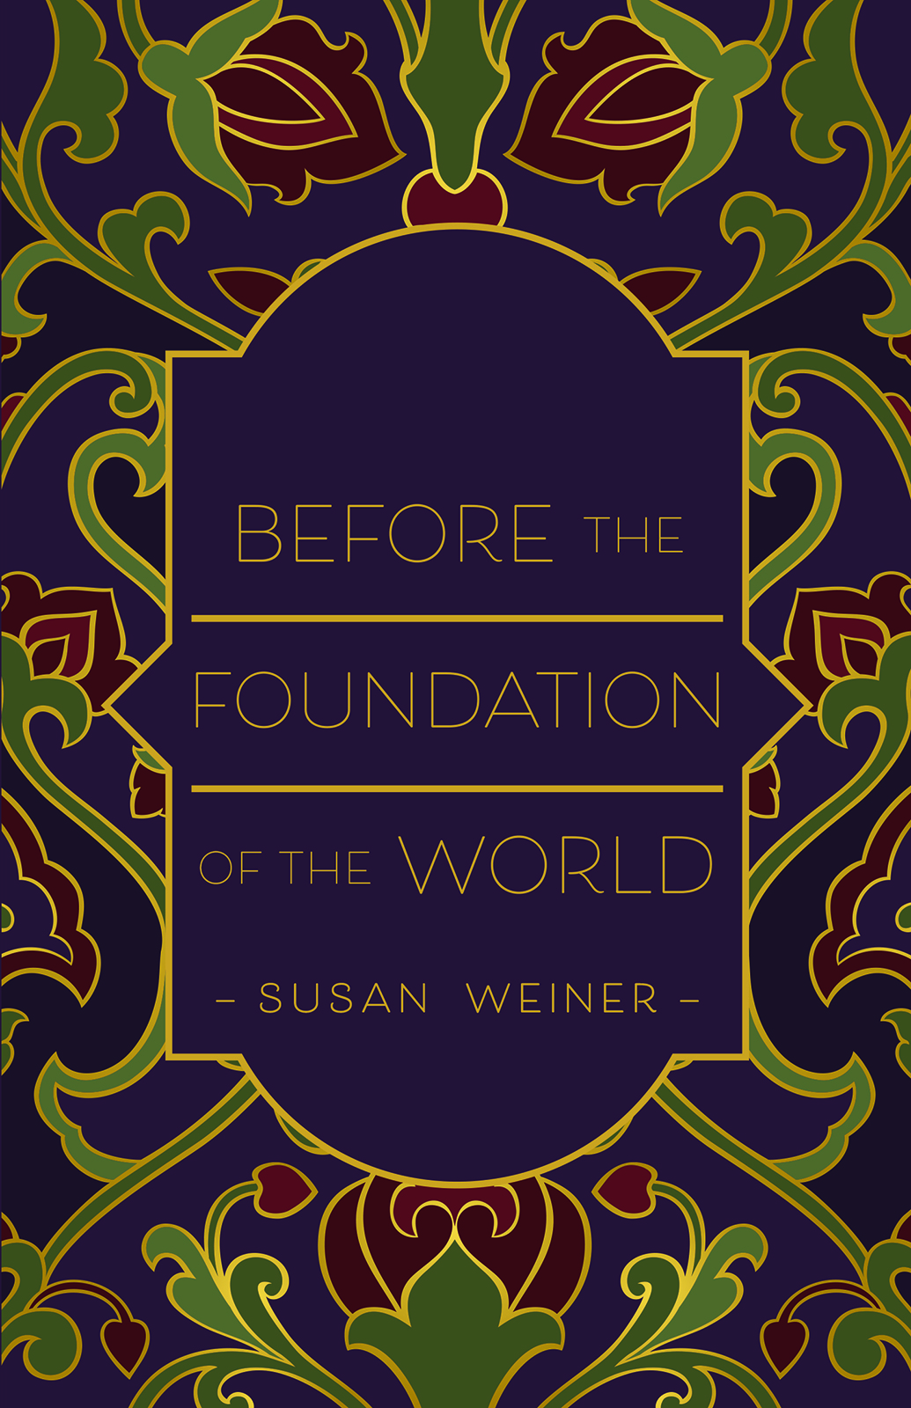](https://www.amazon.com/Before-Foundation-World-Susan-Weiner/dp/1947860453/ref=tmm_pap_swatch_0?_encoding=UTF8&qid=1582050291&sr=8-12)

[*Before the Foundation of the World*](https://www.amazon.com/Before-Foundation-World-Susan-Weiner/dp/1947860453/ref=tmm_pap_swatch_0?_encoding=UTF8&qid=1582050291&sr=8-12) examines the nature of good and evil in God’s creation. Using poetry and song lyrics, this collection offers a celebration of joy in response to God’s covenant with man. From Christmas poems to simple lullabies, the author paints a vivid picture of the incredible experience of wonder in a world of God’s design. An extended exchange in Appendix I with “The Father of Lies” (“Pater Mendaciorum”) and the promises of Christian faith reflects our reconciliation with God and explores the redemption of mankind in the face of radical evil. Journeying from the psychology of evil to the good news of the spirit, *Before the Foundation of the World* speaks to the ways of God, embodying gratitude and love as the foundation for mature Christian belief.

**About the Author**

[Susan Weiner](https://www.susanweinerbooks.com/) completed her undergraduate studies in English literature in England and America. She matriculated to UCLA to study seventeenth-century English history in graduate school. Following her education in secular institutions, she found enduring Christian faith as an adult. As a writer, her love of God informed this book, dedicated to sharing the good news of the Messiah and examining the nature of good and evil in the world. Susan lives in Maryland, next to a farm. She spends time in her study, overlooking a herd of deer grazing in the fields.

[Belle Isle Books](http://www.belleislebooks.com/) is an imprint of [Brandylane Publishers, Inc](http://brandylanepublishers.com/)., an independent press located in Richmond, Virginia that has published books since 1985.

____________

*Before the Foundation of the World*  (paperback, 50 pages, retail $12.95) is available for preorder from [Amazon](https://www.amazon.com/Before-Foundation-World-Susan-Weiner/dp/1947860453/ref=tmm_pap_swatch_0?_encoding=UTF8&qid=1582050291&sr=8-12),[Barnes & Noble](https://www.barnesandnoble.com/w/before-the-foundation-of-the-world-susan-weiner/1133348467?ean=9781947860452), and other fine booksellers.