**FOR IMMEDIATE RELEASE**

**February 2024**

**Publicity Team**

804-644-3090  
pr@brandylanepublishers.com

**Try *Bokky for Breakfast* and Uncover the Mystery of Toddlers’ Tastes in a Playful New Children’s Book!**

written by Dr. Lisa Curry

illustrated by Kelly O’Neill

on sale February 22, 2024

“. . . Excellent for new moms who want to encourage their toddlers to eat healthy foods as their kids find their voice and language. I have read many books to my children, but I cannot think of one with such a colorful reflection of them—innocent, beautiful, bright, and brown!”

- Dr. Hazel Glasper, speaker, business coach, and dentist at Revive Dental

[Belle Isle Books](http://www.belleislebooks.com/) of Richmond, Virginia, is pleased to announce the upcoming release of a new children’s picture book, [*Bokky for Breakfast*](http://www.belleislebooks.com/store/p233/Bokky_for_Breakfast.html), written by Dr. Lisa Curry and illustrated by Kelly O’Neill.

Coaxing toddlers to try different foods can be tough—but so can understanding what they want when they have something in mind! Little Jossie is a three-year-old with big feelings, and big ideas about what she wants for breakfast. Kids and parents alike will delight in joining Jossie and her mother for this mealtime mystery as Mommy tries her best to discover exactly what her daughter wants to eat.

Cheerfully illustrated with vibrant artwork featuring expressive characters and a variety of yummy breakfast offerings that will inspire and encourage child readers to find their own favorite foods,*Bokky for Breakfast* is scheduled for release on February 22, 2024.

[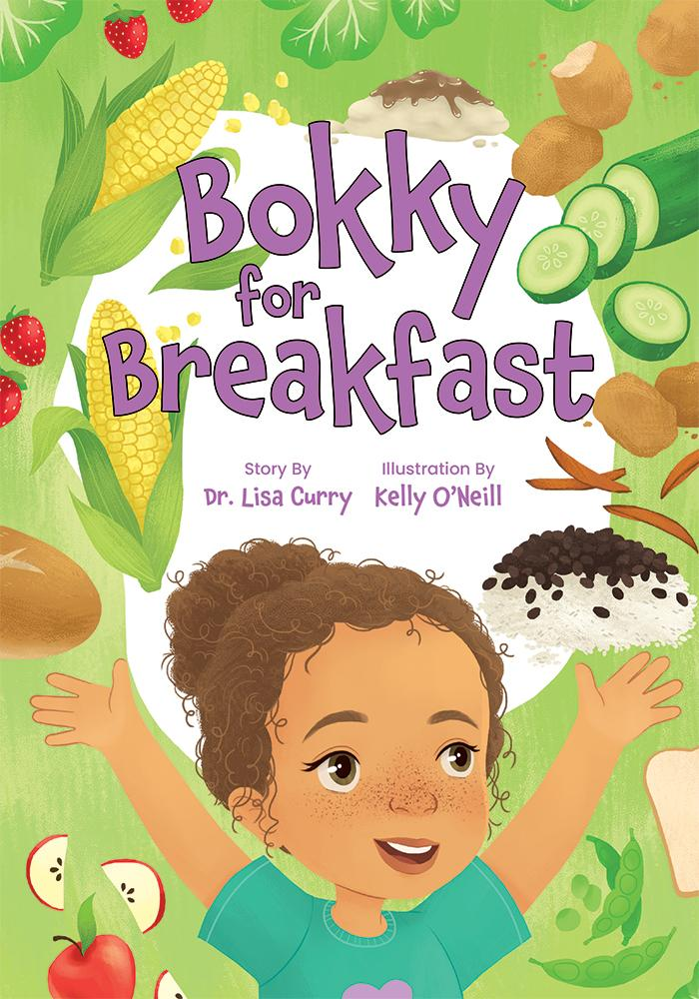](http://www.belleislebooks.com/store/p233/Bokky_for_Breakfast.html)

*Jossie is NOT a typical toddler.*

*Jossie’s favorite time is mealtime. She loves trying new, yummy foods.*

*Sometimes yummy foods are crunchy. Sometimes yummy foods are soft. Sometimes yummy foods taste salty, and sometimes they taste sweet.*

*But when Jossie asks Mommy for a certain yummy food for breakfast one morning, it’s not what you would expect!*

*Will Mommy figure out what Jossie wants to eat?*

**About the Author**

[Dr. Lisa Curry](http://www.belleislebooks.com/lisacurry.html) was born and raised in Gales Ferry, Connecticut. At twelve years old, she knew she wanted to become a dentist. Dr. Curry fulfilled her career goal by graduating from Hampton University and the University of Connecticut School of Dental Medicine.

Dr. Curry’s love of books began with titles such as *The Snowy Day* by Ezra Jack Keats and *Corduroy* by Don Freeman. She has always had a creative side, with interests in art, music, and literature. As a child, she wrote and illustrated comic and picture books. However, it was parenthood that really inspired her to get serious about writing. Now married with two daughters, her goal is to help children of color find positive books featuring characters that look like them. Her motto is: “Reading is the best way to grow your imagination and travel for free.”

**About the Illustrator**

[Kelly O’Neill](http://www.belleislebooks.com/kellyoneill.html) loves to tell stories through cute, fun, and whimsical imagery. She earned a BFA in illustration from Syracuse University in 2017, and currently resides in Princeton, NJ, where she works creating illustrations for children’s books.

**Interviews available upon request.**

[Belle Isle Books](http://www.belleislebooks.com/), an imprint of [Brandylane Publishers, Inc.](https://brandylanepublishers.com/), is an independent press located in Richmond, Virginia that has published books since 1985.

___________

*Bokky for Breakfast* (hardcover, 32 pages, $25.95 / paperback, 32 pages, $14.95) is available for pre-order from [Amazon](https://www.amazon.com/Bokky-Breakfast-Lisa-Curry/dp/1958754900), [Barnes & Noble](https://www.barnesandnoble.com/w/bokky-for-breakfast-lisa-curry/1144814236?ean=9781958754900), and other fine booksellers. Kindle e-book (retail $4.99) forthcoming.