**FOR IMMEDIATE RELEASE**

**February 2024**

**Publicity Team**

804-644-3090  
pr@brandylanepublishers.com

**Learn How to Spread Your Wings and Soar with *Brave Bird*!**

written by Judy Jamison

illustrated by Yasemin Arkun

on sale February 12, 2024

“. . . a beautiful, tender book that . . . shows that being brave doesn’t mean never being fearful or worried. It . . . will encourage children and adults as they look for paths forward in life, in both small and large ways.”

- Anna Whiston-Donaldson, *NYT* bestselling author of *Rare Bird: A Memoir of Loss and Love* and *A Hug from Heaven*

[Belle Isle Books](http://www.belleislebooks.com/) of Richmond, Virginia, is pleased to announce the release of a new children’s picture book, [*Brave Bird*](http://www.belleislebooks.com/store/p231/Brave_Bird.html), written by Judy Jamison and illustrated by Yasemin Arkun.

Now that Little Bird and her siblings have grown up, it’s time for them to learn to soar like the other birds—but Little Bird is afraid to fly, not excited like her brothers and sisters. Before leaving to find a fresh meal for her nestlings, Mama Bird reminds her that she must be brave if she wants to learn and grow.

Little Bird knows her mother is right—but she just isn’t ready. Still full of nerves, she solicits the advice of the friends she knows and trusts—Bee, Squirrel, the Sun, the Wind, and the Tree in which she lives. Finally, bolstered and prepared by advice from each of these helpers, Little Bird knows she is ready to soar—and become Brave Bird.  
 Like Little Bird, young children constantly face new, potentially scary situations—from going to a new school to visiting the dentist to trying to make new friends. Even adults who have already weathered a few challenges might sometimes encounter new and nerve-wracking situations we must navigate. The fact is, the older we get, the braver we all have to be—and the more we all need Little Bird’s guidance in developing resilience, navigating past our fears, and soaring into the next phases of our lives.

Enhanced with gorgeous, soothing multimedia illustrations that offer comfort to nervous kids, *Brave Bird* is releasing today, February 12, 2024.

[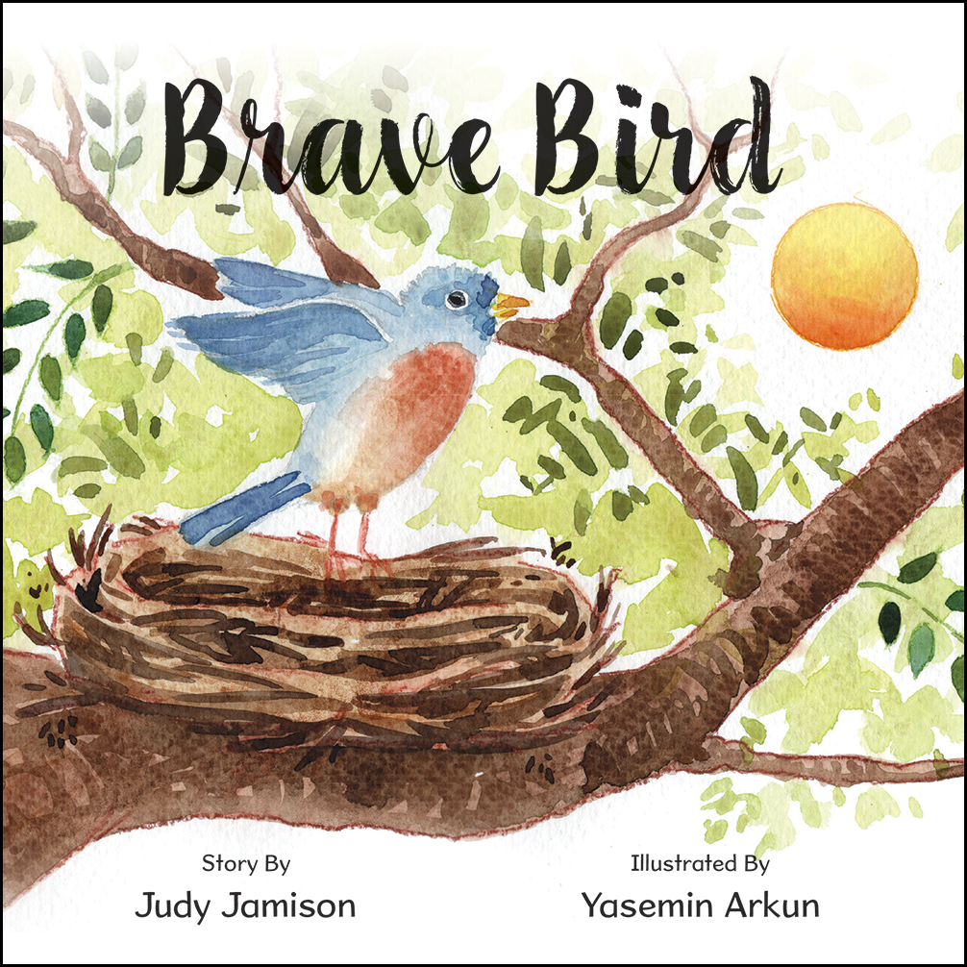](http://www.belleislebooks.com/store/p231/Brave_Bird.html)

*Little Bird became Brave Bird when she found the courage to fly. We all experience anxiety, fear, and insecurities. Brave Bird shows the way to overcome those feelings. Have you ever been a “brave bird”? Share your story at judyjamison.com.*

**About the Author**

[Judy Jamison](http://www.belleislebooks.com/judyjamison.html) grew up in Portsmouth, Virginia and graduated from Virginia Tech, where she studied child and family development. Her love of children’s literature grew from her years as a preschool, kindergarten, and first grade teacher.

Judy is the mother of three adult children, Nana to six grandchildren, and “Grandma” to a family of Nigerian sextuplets who live in Richmond. She loves playing the piano, creating ikebana arrangements, traveling with her husband Russ, and snuggling with her dog, Finn.

**About the Illustrator**

[Yasemin Arkun](http://www.belleislebooks.com/yaseminarkun.html), an architecture graduate, spent her “serious” professional life as a 3D visualization artist in various offices, while following her passion for drawing and building her own professional career in painting. Since 2018, she has continued her journey as a full-time artist, using her Etsy shop to connect with art lovers and realize their dreams in traditional materials such as watercolor, charcoal, and oils.

The mother of a wonderful psychologist, Yasemin lives in Bodrum with her cats, where she continues to enjoy painting and children’s book illustrations.

**Interviews available upon request.**

[Belle Isle Books](http://www.belleislebooks.com/), an imprint of [Brandylane Publishers, Inc.](https://brandylanepublishers.com/), is an independent press located in Richmond, Virginia that has published books since 1985.  
___________

*Brave Bird* (hardcover, 28 pages, $25.95 / paperback, 28 pages, $15.95) is available from [Amazon](https://www.amazon.com/Brave-Bird-Judy-Jamison/dp/1958754560), [Barnes & Noble](https://www.barnesandnoble.com/w/book/1144313125?ean=9781958754566), and other fine booksellers.