**FOR IMMEDIATE RELEASE**

**September 2022**

**Publicity Team**

804-644-3090  
pr@brandylanepublishers.com

**This Fall, Explore Every Seaside Season with *Carole Jane from Starfish Lane*!**

written by Diane Twomley

illustrated by Cheryl Grant

on sale October 11, 2022

“A descriptive debut . . . sure to lure more readers to the shore life all year long! Recommended for all ages.”

- Dustin Brackbill, librarian, Pennsylvania School Library Association member, committee co-chair, and former library director

[Belle Isle Books](http://www.belleislebooks.com/) of Richmond, Virginia, is pleased to announce the upcoming release of a new children’s book, [*Carole Jane from Starfish Lane*](http://www.belleislebooks.com/store/p203/Carole_Jane_from_Starfish_Lane.html), written by Diane Twomley and illustrated by Cheryl Grant.

The pale yellow house at the end of Starfish Lane is home to Carole Jane, an intrepid young explorer who always finds fun things to do on Mac Island—no matter the season or weather! Join Carole Jane as she follows her imagination all over her island home, from reading on a dock in the fall to sipping hot cocoa by a beach bonfire in the winter to braving storms in the spring. Along the way, soft watercolor illustrations welcome readers to the small coastal community, and encourage us to appreciate the beauty of the seaside year-round.

A sentimental slice of North American island life captured in charming scenes that engage the senses, *Carole Jane from Starfish Lane* is scheduled for release on October 11, 2022.

[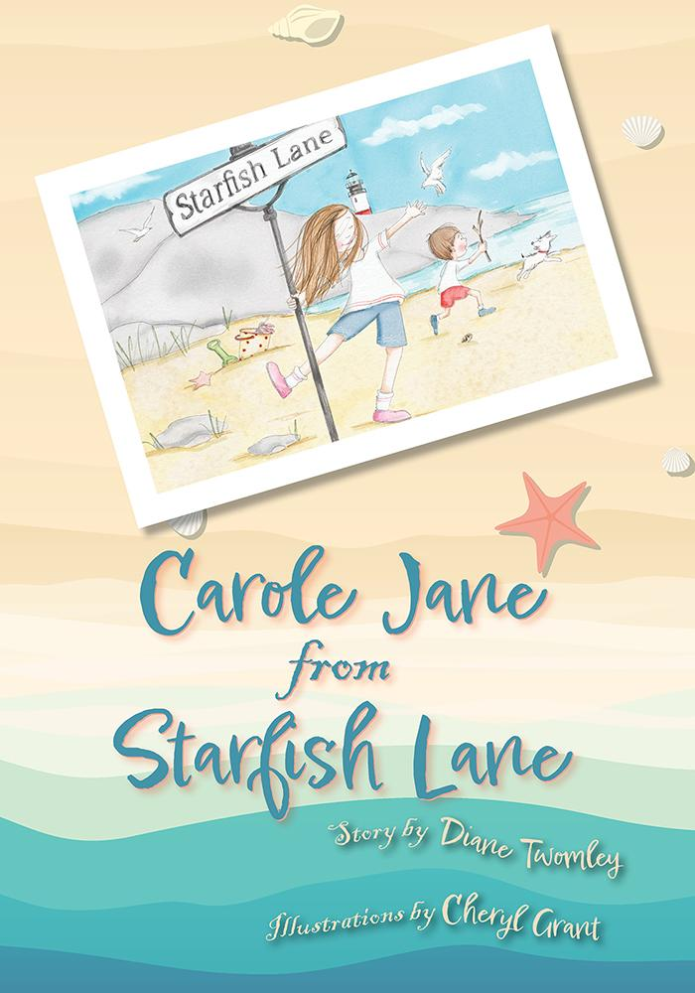](http://www.belleislebooks.com/store/p203/Carole_Jane_from_Starfish_Lane.html)

*What do you do at the beach when it’s not summertime? Carole Jane lives on Mac Island, and even though summer is fun, Carole Jane thinks she might love the other seasons even more. She can peek into tide pools in the spring, talk to gulls in the fall, and play in the sand all year round, building all sorts of things. Home on Mac Island is Carole Jane’s favorite place to be.*

**About the Author**

[Diane Twomley](http://www.belleislebooks.com/dianetwomley.html) is a mother and grandmother who has an interesting laugh and always sees a silver lining, even when others don't. Diane Twomley has always worked in jobs that allow her to help others. She spent almost twenty-five years in a middle school library, where her favorite thing was helping students find the perfect book.

Some of Diane’s favorite things include sand between her toes, books, jelly donuts, cozy pajamas, and the laughter of little children. She believes you’re never too old to try something new—such as writing a book. Her next project, *Picking Patch,* is based on a true story about a surprise in a pumpkin patch.

Diane now lives in central Pennsylvania with her husband, Mike. They have raised two wonderful sons, and treasure every moment with their grandson, Harper T.S.

**About the Illustrator**

[Cheryl Grant](http://www.belleislebooks.com/cherylgrant.html) was born and raised in the mountains of Virginia, and attended Mary Baldwin University, graduating in 1990 with an art degree. When her son was born, she decided to stay home with him. During this time, she continued to create treasured art for friends and family.

Cheryl returned to work in the early 2000s, creating a popular website that made her art available for digital download. Simple country living and love of family influenced many of her illustrations, some of the most popular of which feature her adorable puppy, her two cats, and their sassy adventures.

Cheryl now enjoys spending time with her grandson and watching him grow. *Carole Jane from Starfish Lane* is her first illustrated picture book.

**Interviews available upon request.**

[Belle Isle Books](http://www.belleislebooks.com/), an imprint of [Brandylane Publishers, Inc.](https://brandylanepublishers.com/), is an independent press located in Richmond, Virginia that has published books since 1985.

___________

*Carole Jane from Starfish Lane* (hardcover, 32 pages, $23.95 / paperback, 32 pages, $13.95) is available for pre-order from [Amazon](https://www.amazon.com/Carole-Jane-Starfish-Diane-Twomley/dp/1953021972ef=sr_1_1?crid=6YSG4U4H71EI), [Barnes & Noble](https://www.barnesandnoble.com/w/carole-jane-from-starfish-lane-diane-twomley/1141960918?ean=9781953021977=9781953021731), and other fine booksellers.