**FOR IMMEDIATE RELEASE**

**February 2024**

**Publicity Team**

804-644-3090  
pr@brandylanepublishers.com

***Chelsea Skye, Nature Spy* Encourages Readers to Take a Peek at the World Outside Their Window**

written by Kate McCarroll Moore

illustrated by Michelle Simpson

on sale February 28, 2024

“*Chelsea Skye, Nature Spy* highlights a lesson that hopefully everyone learns when facing troubled times: there is joy and adventure and connection everywhere, no matter what, if you slow down and look carefully.”

- Kate Roberts, literacy consultant at kateandmaggie.com

[Belle Isle Books](http://www.belleislebooks.com/) of Richmond, Virginia, is pleased to announce the upcoming release of a new children’s picture book, [*Chelsea Skye, Nature Spy*](http://www.belleislebooks.com/store/p234/Chelsea_Skye%2C_Nature_Spy.html), written by Kate McCarroll Moore and illustrated by Michelle Simpson.

Inquisitive Chelsea Skye is a spy on a mission! Her parents and sister are constantly absorbed in their electronic devices, and in the absence of anyone to talk to, she decides to make her own fun—by exploring every nook and cranny of her house as the world’s finest spy!

Still, there is only so much to spy in a single house—so once Chelsea has finished exploring the indoors, she turns to observing the world that continues to move on beyond her window. Setting up a spying station that allows her to watch over the ever-changing landscape of her own backyard, she finds peace and purpose in marveling over the animals, flowers, and clouds. When she spots a soon-to-be mother bird in need of some assistance, empathic Chelsea quickly devises a way to help—and discovers a way to bring her own family together again in the process.

Though the lockdowns of 2020 may be over, the lessons to be learned from this period when so many people found themselves suddenly stuck at home are carried through in this beautiful book, as *Chelsea Skye, Nature Spy* recalls the simultaneously isolationist, restless, and calming atmosphere that prevailed when our world was “turned upside down.” Reminding the entire family to slow down and pay attention not only to the little things in life, but also to our own relationships during trying times; and resplendent with vibrant illustrations that showcase the beauty of the natural world around us, *Chelsea Skye, Nature Spy* is scheduled for release on February 28, 2024.

[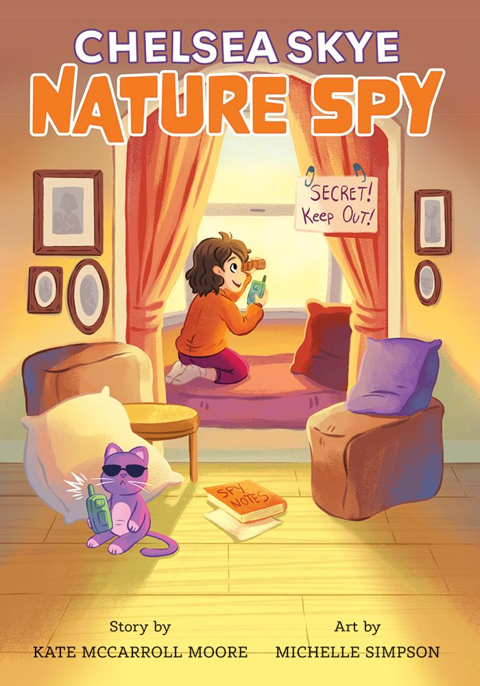](http://www.belleislebooks.com/store/p234/Chelsea_Skye%2C_Nature_Spy.html)

*Chelsea Skye grows bored when her family spend all their time on their devices during “the year the world turned upside down.”*

*With nothing to do, she begins watching the world outside her window—and when she spies a mama robin struggling to build a nest, she comes up with an ingenious way to help.*

*This is a story about hope, love, and paying attention to the beauty around us—and doing our part to help those in need.*

**About the Author**

[Kate McCarroll Moore](http://www.belleislebooks.com/katemccarrollmoore.html) is a lifelong educator and former poet laureate for the City of San Ramon, California. She is the author of two novels for children, Elinormal and New Girl: The Further Adventures of Elinormal, and has also published poetry collections for adults. She never grows tired of people-watching and eavesdropping, using her writer’s imagination to turn ordinary events into unique characters with interesting stories to tell.

Kate lives with her family in Northern California. Most days, you can find her in her garden, reading, writing, painting, and listening to the birds.

**About the Illustrator**

[Michelle Simpson](http://www.belleislebooks.com/michellesimpson.html) is a full-time illustrator based out of the Niagara Region of Canada. She graduated with a BAA in illustration from Sheridan College. Michelle’s main focus is on children’s book illustrations and educational material for kids. She has worked with many large publishing houses and has also created concept artwork and final backgrounds for season two of the children’s TV show *Ollie: The Boy Who Became What He Ate* and season one of *Tee and Mo.*

**Interviews available upon request.**

[Belle Isle Books](http://www.belleislebooks.com/), an imprint of [Brandylane Publishers, Inc.](https://brandylanepublishers.com/), is an independent press located in Richmond, Virginia that has published books since 1985.

___________

*Chelsea Skye, Nature Spy* (hardcover, 28 pages, $25.95 / paperback, 28 pages, $14.95) is available for pre-order from [Amazon](https://www.amazon.com/Chelsea-Skye-Nature-McCarroll-Moore/dp/1958754889), [Barnes & Noble](https://www.barnesandnoble.com/w/chelsea-skye-nature-spy-kate-mccarroll-moore/1144771490?ean=9781958754887), and other fine booksellers.