

**FOR IMMEDIATE RELEASE**

**December 2021**

**Publicity Team**

pr@brandylanepublishers.com

804-644-3090

**Visit the *City in the Sky***

written by Luke Yesbeck

on sale January 26, 2022

***“Freedom. Must. Fall.”***

[Belle Isle Books](http://www.belleislebooks.com/) of Richmond, Virginia, is pleased to announce the upcoming release of a new work of fiction, [*City in the Sky*](http://www.belleislebooks.com/store/p184/City_in_the_Sky.html), by Luke Yesbeck.   
 Most people know Atlantis as a myth—an ancient city that vanished beneath the waves. But what if the stories were at least partly true? What if the descendants of Atlantis had rebuilt, using their technology to create a highly advanced hidden city, floating in the clouds?  
 And what if you were invited?

A breathless adventure in speculative fiction derived from historical legend, *City in the Sky* is scheduled for release on January 26, 2022.

[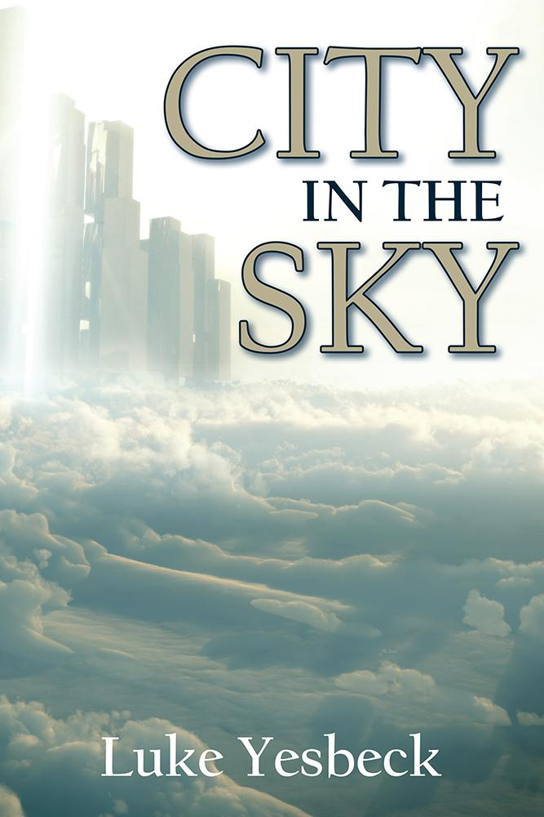](https://www.amazon.com/City-Sky-Luke-Yesbeck/dp/1951565118)

*For Ryan Kendrick, being mugged on the way home from work is the perfect end to another terrible day. So when a stranger appears just hours later with a job offer from a mysterious organization, Ryan accepts without knowing anything more than the company’s name: Atlantis Technologies, Inc. But Atlantis is no ordinary company. In fact, it’s not a company at all—it’s a civilization.*

*Atlantis, thought to be long lost to legend, has been hiding in plain sight for millennia, and Ryan has been offered a chance to be part of it. Now, Ryan must adapt quickly to life on a city floating thousands of feet above the Atlantic Ocean, where telepathy and flying soldiers are commonplace. But even as he makes friends and strives to build a life for himself in this new world, Ryan soon realizes Atlantis is not quite the utopia it claims to be.*

*And far worse, an ancient enemy known only as the Order has finally emerged from the shadows, vowing to destroy the Atlantean way of life. The Order sank Atlantis once before, thousands of years ago. Now, Ryan must do what he can to protect his new home and stop the Order from doing it again—this time permanently.*

**About the Author**

After obtaining an undergraduate degree in systems engineering from the University of Virginia, [Luke Yesbeck](http://www.belleislebooks.com/lukeyesbeck.html) returned to Richmond, Virginia for three years to work as a medical scribe while he applied to medical school. Currently, he is working to complete his final year of medical school in Roanoke, Virginia. Outside of school, Luke enjoys traveling and has hiked the Inca Trail to Machu Picchu and Mt. Kilimanjaro, the highest peak in Africa.

**Interviews available upon request.**

[Belle Isle Books](http://www.belleislebooks.com/), an imprint of [Brandylane Publishers, Inc.](https://brandylanepublishers.com/), is an independent press located in Richmond, Virginia that has published books since 1985.

___________

*City in the Sky* (paperback, 482 pages, $21.95) is available for pre-order from [Amazon](https://www.amazon.com/City-Sky-Luke-Yesbeck/dp/1951565118), [Barnes & Noble](https://www.barnesandnoble.com/w/city-in-the-sky-luke-yesbeck/1140350403?ean=9781951565114), and other fine booksellers. Kindle e-book (retail $4.99) forthcoming.