**FOR IMMEDIATE RELEASE**

**January 2023**

**Publicity Team**

804-644-3090  
pr@brandylanepublishers.com

**Get Curious About *Curious Design*!**

written by Bonnie Stanard

on sale January 25, 2023

*Once I felt at one with the sky.  
I thought I had inborn clouds,  
whether restless or calm.  
I had in my blood rain and sunshine.*

- from *Curious Design*

[Belle Isle Books](http://www.belleislebooks.com/) of Richmond, Virginia, is pleased to announce the release of a new poetry collection, *Curious Design* by Bonnie Stanard.

*Some people speak of soft rain / or a gentle shower. And yes, / there was a time when a tin roof told me / rain’s gentle story and I believed it. / But today things are different.*

In a book that begins with this lament over the loss of a connection to nature, Stanard expresses a nervous tension mirrored in the selected drawings of Italian Renaissance artist Giovanni Battista Bracelli, which feature human figures twisted into shapes both abstract and alien, skeletal and full of life. Through forty-seven poems, each accompanying one such drawing, Stanarddescribes the poet’s lonely intellectual and philosophical journey through the facets of modern life—overbearing, mind-numbing commercials; self-medication with fashion and fake, “everlasting suntans”; and the impersonality of the Internet—as she attempts to rediscover herself. Through it all, Standard deftly connects her poetry to the figures—junkyard figurines both built of and garishly adorned in the detritus of humanity, whose occasionally harsh edges and tortured poses speak to the narrator’s keen sense of loss.

A poignant collection of fleeting portraits that chronicle the struggle to find meaning in a strange, ambiguous world, *Curious Design* is releasing today, January 25, 2023.

[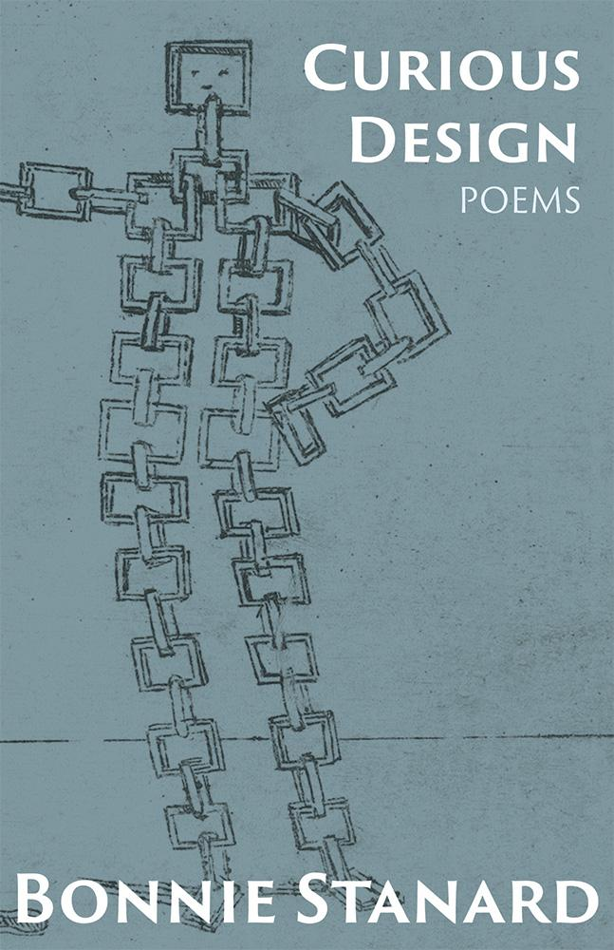](http://www.belleislebooks.com/store/p216/Curious_Design.html)

*We don't all think alike, but to some of us, life is an ever-present enigma. Stanard writes that life “chases me in cycles defying viewpoint.” With Bracelli's cubist art as inspiration, she skillfully renders compositions that introduce us to an original and unexpected reading experience. This is a mix of pithy poems, some profound and others amusing.*

**About the Author**

[Bonnie Stanard](http://www.belleislebooks.com/bonnie-stanard.html) writes short stories, novels, and poetry. Her work has appeared in journals such as the *American Journal of Poetry,* the *Wisconsin Review, Harpur Palate*, and *Broad River Review,* and her historical fiction novels and children’s books are available at various online venues. Her poetry chapbook is currently available from Main Street Rag.

**About the Illustrator**

Giovanni Battista Bracelli was an Italian engraver and painter working in Florence, Italy, in the seventeenth century. The artwork here is taken from his book of prints titled *Bizzarie di Varie Figure* (“*Oddities of Various Figures*”). In forty-seven plates, he portrayed interacting human figures, their forms made of cubes, rings, and squares, as well as rackets and screws. A digital copy of the original manuscript can be found at the Library of Congress.

**Interviews available upon request.**

[Belle Isle Books](http://www.belleislebooks.com/), an imprint of [Brandylane Publishers, Inc.](https://brandylanepublishers.com/), is an independent press located in Richmond, Virginia that has published books since 1985.

___________

*Curious Design* (paperback, 106 pages, $14.95) is available from [Amazon](https://www.amazon.com/Curious-Design-Bonnie-Stanard/dp/1958754072maker/dp/1958754021), [Barnes & Noble](https://www.barnesandnoble.com/w/curious-design-bonnie-stanard/1142876881?ean=9781958754078), and other fine booksellers.