

**FOR IMMEDIATE RELEASE**

**August 2019**

**Christina Kann, Publicist**

brandylanepr@gmail.com or 804.644.3090

**Robert Pruett, Publisher**

brandylanerhpruett@gmail.com or 804.644.3090

**To all of the Warriors who are Fighting the Battle:**

***Impressions Beyond the Terminal Cancer Diagnosis***

**written by Norma Woody**

**on sale October 1, 2019**

“Norma Woody takes an unflinching look at her life after she was diagnosed with terminal cancer. Her book is filled with poetry, pain, reminiscences good and bad, apologies for being sick, an assessment that her life by her own standards has been ‘mediocre,’ and a hard look at cancer and ‘all the stigma and negativity and needing that comes with it.’ I recommend it highly to anyone interested in how one should confront his or her own life and death or the life and death of a family member or friend.”

—Randy Fitzgerald, *Boomer* magazine columnist

[Belle Isle Books](http://www.belleislebooks.com/), an imprint of [Brandylane Publishers, Inc.](http://brandylanepublishers.com/) of Richmond, Virginia, is proud to announce the release of *Impressions Beyond the Terminal Cancer Diagnosis,* a gripping followup to [*Impressions Behind the Pink Ribbon*](https://www.amazon.com/Impressions-Behind-Pink-Ribbon-Metastatic/dp/1939930545/ref=sr_1_1?keywords=Impressions+Behind+the+Pink+Ribbon&qid=1564418701&s=gateway&sr=8-1), where the late Norma Woody explores a range of emotions and trials only a woman facing her own death can experience. *Impressions Beyond the Terminal Cancer Diagnosis* is scheduled for release on October 1, 2019.

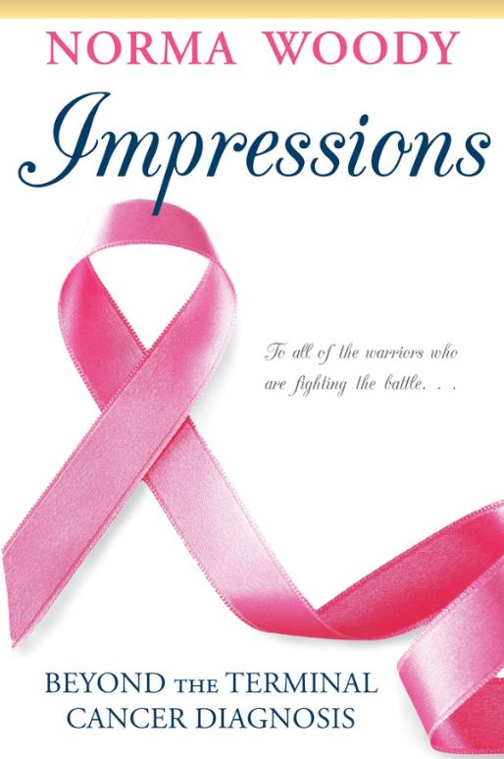

In this collection, as in her first book, Norma explores a range of emotions and trials only a woman facing her own death can experience. A true and rich testament that only the examined life is worth living, she probes the depths and meaning of honesty, hope, friendship, and faith, as well as her own fear, isolation, heartache, and failures. For Norma, life was a kaleidoscope of miracles and experiences she felt compelled to capture in her writing, and had she lived, she would have penned many more books. We regret that this is her final manifesto of life, love, and hope.

**About the Author**

Through sheer will, resolve, and deep faith, Norma Woody was able to complete a draft of this, her second memoir, while in the relentless grip of Stage IV metastatic cancer. After a long and grueling battle, she passed away in September 2016. To honor Norma’s labor of love, her husband, Richard, worked with her Belle Isle Books to assemble, edit, and publish these essays posthumously.

____________

Brandylane Publishers, Inc. is an independent press located in Richmond, Virginia that has published books since 1985.

____________

*Impressions Beyond the Terminal Cancer Diagnosis* (paperback, 122 pages, retail $15.00) is available for preorder from [Brandylane Publishers](https://brandylanepublishers.com/wp/book/list-all/memoirautobiography/lifeline65/), [Amazon](https://www.amazon.com/Lifeline-65-Connections-Enthusiasm-Education/dp/1947860593/ref=sr_1_1?keywords=lifeline+65+ryan+t+stein&qid=1561581446&s=gateway&sr=8-1), [Barnes & Noble](https://www.barnesandnoble.com/w/lifeline-65-ryan-t-stein/1132211444?ean=9781947860599), and other fine booksellers.