**FOR IMMEDIATE RELEASE**

**September 2022**

**Publicity Team**

pr@brandylanepublishers.com

804-644-3090

**When Interstellar War Breaks Out, Humanity Must Fight to Save Itself—in This Story of One *Desperate Endeavor***

written by Glen Olson

on sale October 4, 2022

“Olson has combined military science fiction with quantum and string theory in a first-contact story that combines a series of fascinating what-ifs that will challenge readers.”

- Francis Hamit, author, playwright, and screenwriter

[Belle Isle Books](http://www.belleislebooks.com/) of Richmond, Virginia, is pleased to announce the upcoming release of a new science fiction novel, [*Desperate Endeavor*](http://www.belleislebooks.com/store/p200/Desperate_Endeavor.html)*,* written by Glen Olson.

On New Hearth, a human colony a mere few hundred years old, former naval captain Mikail Benson maintains a suspicious watch over the curious research-based requests made by humanity’s first interstellar foes, the feline AranthChi. This ancient, technically gifted empire spans hundreds of systems—and not more than forty years ago, was poised to crush the human colonies in this and another fledgling sector, Caledonia. Instead, in a move Mikail has always doubted, the alien enemies brokered an odd peace, even offering up three state-of-the-art ships to help with the sector’s resettlement.

The ships prove more valuable than anyone thought possible, giving humans the ability to access incredible power sources, speak to real sentient artificial intelligences, and even control gravity. But with the new revelations comes a nasty surprise: the AranthChi forces that participated in the war weren’t what the humans thought they were.

In fact, they weren’t even ten percent of the force the AranthChi could have brought to bear.

Meanwhile, Marsh(ee), an AranthChi lord, plots and schemes to use humanity to elevate his clan. But unbeknown to the arrogant alpha of Least Clan, a chance scan by an ancient observatory has ruined everything. Now, under threat of total annihilation by a terrifying AranthChi empire determined to protect itself, the heroes of humanity’s colonies must quickly bring to bear new technologies and strategies to defeat their monstrously superior adversary—in a last, desperate endeavor to save humanity.

Full of twists, turns, and surprises around every new star, *Desperate Endeavor* is scheduled for release on October 4, 2022.

[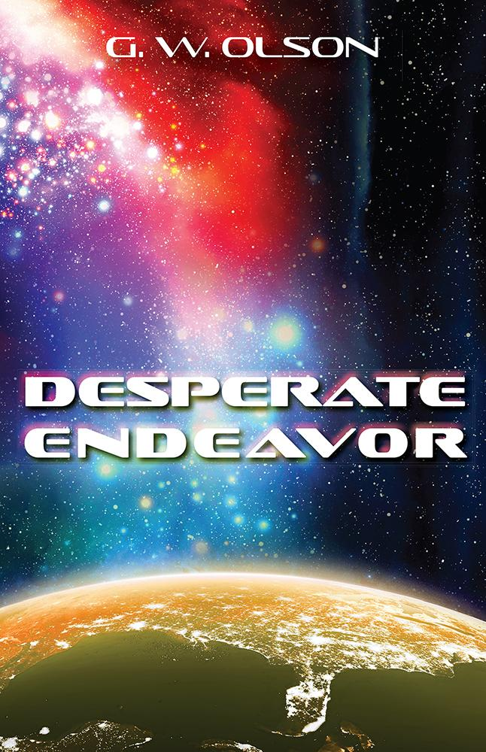](http://www.belleislebooks.com/store/p200/Desperate_Endeavor.html)

If only Humanity knew what sense to make of the fight with AranthChi, the future would be less bleak.

*Thirty-five years after the only interstellar war Humanity has ever fought—with the only aliens Humanity has ever met—one man has wondered his entire adult life why the hell that war happened. As part of the peace, the AranthChi hired Humanity to do scientific research for them, and it’s Mikail's job to ensure the safety of Humanity's secrets. But the AranthChi's long-term conspiracy is beginning to unravel, and Mikail knows something is very wrong. When he sets out on a quest to find answers, he soon learns Humanity is in more danger than ever before—and time is running out.*

**About the Author**

[Glen Olson](http://www.belleislebooks.com/glenolson.html) grew up in the San Fernando Valley, a suburb of Los Angeles. He would have had an absolutely normal childhood except for one fact: it was the sixties, and his best friend's father worked in cold war aerospace . . . and he owned a mimeograph machine. So, along with a dog, a bicycle, and a baseball mitt, Olson had access to a device that allowed him to put out a neighborhood newspaper—and he shamelessly did so! Thankfully, no copies of the paper still exist, or he would have to leave town and change his name.

Olson continued to write (and read) throughout his career with the fire department, where he had several roles, including paramedic, disaster preparedness educator, inspector, and captain. He wrote training manuals for firefighters and contributed to the disaster preparedness student manual that FEMA distributes nationwide. Olson’s fiction career restarted with the story “Nightwatch,” which earned him an honorable mention in the L. Ron Hubbard Writers of the Future contest.

Olson still lives in the Los Angeles area. He has a very patient wife, two adult children, and a cat who jumps on the keyboard several times a day and refuses to move until thoroughly petted.

**Interviews available upon request.**

[Belle Isle Books](http://www.belleislebooks.com/), an imprint of [Brandylane Publishers, Inc.](https://brandylanepublishers.com/), is an independent press located in Richmond, Virginia that has published books since 1985.

___________

*Desperate Endeavor* (paperback, 308 pages, $20.95) is available for pre-order from [Amazon](https://www.amazon.com/Desperate-Endeavor-Glen-Olson/dp/1953021832), [Barnes & Noble](https://www.barnesandnoble.com/w/desperate-endeavor-glen-olson/1141758082?ean=9781953021830), and other fine booksellers. Kindle e-book (retail $4.99) forthcoming.