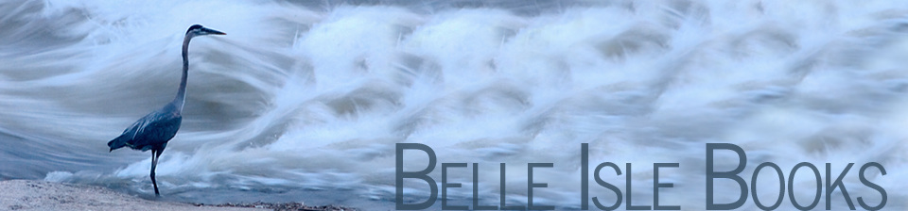

DATE: December 2014
NEWS (Release Immediately)
CONTACT: Tim Hagood, Publicist, or Robert H. Pruett, Publisher, 804.644.3090; FAX 804.644.3092. Email brandylanepr@gmail.com or rhpruett@brandylanepublishers.com

Camera-Shy Canine Stars in New Tale of Holiday Cheer

Belle Isle Books of Richmond, Virginia, is pleased to announce the release of its new children’s book Dogs Do NOT Love Holiday Cards! With the holidays upon us, it’s time for greeting card photos. But for the family dog, that can mean scratchy sweaters, humiliating hats, and confusing camera-work. Written by Caley Cantrell and illustrated by Sarah Berkheimer, Dogs Do NOT Love Holiday Cards! uses playful rhymes and sharp witticisms to tell the story of one bewildered dog who’s had enough of greeting-card stardom and is putting his paw down. A special epilogue detailing how to keep one’s four-legged friends safe from holiday hazards accompanies the story. Children, parents, and pet owners young and old are sure to enjoy this lighthearted look at the season from a dogs-eye view.
Dogs Do NOT Love Holiday Cards! is the second collaboration between Cantrell and Berkheimer, reuniting readers with the family and dog from You’re Bringing Me a Baby?! (Belle Isle Books, 2013). As the family brainstorms ideas for their best holiday card yet, they run up against a stubbornly unwilling star: the family dog. As the pup revisits memories of photo calamities past, the family must convince him that he’s crucial to the tradition. When the story comes to a close, Cantrell leaves the reader with helpful tips for keeping one’s dog safe during the holiday season.
Caley Cantrell is a professor and head of the Communication Strategy Track at the Virginia Commonwealth University Brandcenter. She and her husband Sean live in Richmond, Virginia, where they are raising their daughter with help and guidance from the dogs they adopt from local shelters. Sarah Berkheimer has worked as an illustrator, graphic designer, and digital artist since entering the world of advertising in 2002, and continues to develop her knack for creating digital worlds. She lives in Richmond, Virginia, along with her husband and two children.
Belle Isle Books is an imprint of Brandylane Publishers, Inc., an independent press located in Richmond, Virginia, that has published fiction, non-fiction, and poetry since 1985.
_____________________________________________
Dogs Do NOT Love Holiday Cards! (Hardcover, 40 pages, $15.95 retail) is available from fine booksellers, online through Amazon, Barnes & Noble, and belleislebooks.com, by calling 804.644.3090, or by writing 5 South First Street, Richmond, VA 23219. Requests for review copies should be made to the publisher.

