**FOR IMMEDIATE RELEASE**

**July 2025**

**Publicity Team**

pr@brandylanepublishers.com

804-644-3090

**Author’s Experience in *Living Tidal* on a Small Boat Inspires Women to Seize Hope—and Appreciate Their Own Capabilities *Dust on the Bible***

written by Bonnie Stanard

on sale February 25, 2025

“Lily’s story and her world will linger with readers long after they’ve finished reading the final pages.”

- *Chanticleer Book Reviews*

[Belle Isle Books](http://www.belleislebooks.com/) of Richmond, Virginia, is pleased to announce the release of a new work of historical fiction for children ages 8 to 12, [*Dust on the Bible*](https://www.belleislebooks.com/store/p258/Dust_on_the_Bible.html), written by Bonnie Stanard.

**Laws meant to regulate drugs have often been used to unjustly prosecute people of color and people of lower socioeconomic classes. Lawyer Peter Meyers knows this—and has spent his career fighting for justice for his clients and working at the George Washington University Law School, where he teaches a class titled “Drugs and the Law.” In his new novel, he _.**

**In *Jill’s Trials,* Meyers follows protagonist Jill Hansen’s progression from law student to public defender—and then to a partner at a prestigious law firm. Along the way, he draws on his own experience to point out racism in the system, advocate for more just policy, and show how lawyers can have significant positive impacts on their clients’ lives—even to the detriment of their mental health.**

**Jill learns early on that it’s important for lawyers to keep a professional relationship with their clients. But as she progresses in her career and throws herself into her work, she finds herself toeing the line of maintaining professional relationships with her clients as she struggles to maintain a healthy relationship with family members and her own mental health.**

**An investigation of work/life balance, family, and the importance of working to improve the justice system,** *Dust on the Bible* released February 25, 2025.

A 12-year-old girl endures poverty and agonizes over her missing father.

JUV039030 JUVENILE FICTION / Social Themes / Death, Grief, Bereavement

JUV039280 JUVENILE FICTION / Social Themes / Religion & Faith

JUV039070 JUVENILE FICTION / Social Themes / Poverty & Homelessness

JUV039020 JUVENILE FICTION / Social Themes / Adolescence & Coming of Age

[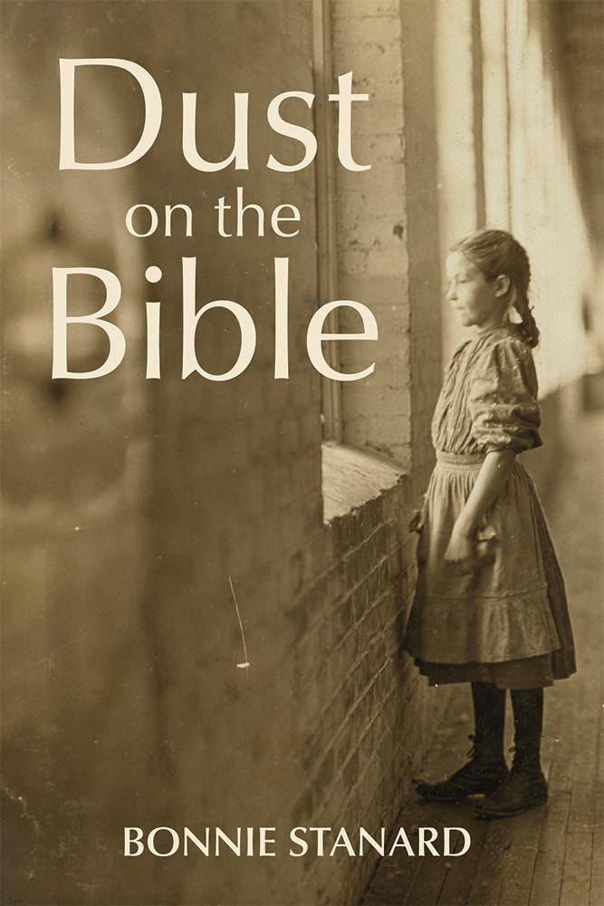](https://www.belleislebooks.com/store/p258/Dust_on_the_Bible.html)

*To Lily, truth is out of reach and elusive—especially the truth of the reason for her father’s absence from her extended family. As clues multiply, she discovers that the people in her family are less easily known than she previously imagined. What she learns about them and about her father sets in motion questions about life itself.*

**About the Author**

[Bonnie Stanard](https://www.belleislebooks.com/bonnie-stanard.html) is an award-winning writer of short stories, novels, and poetry. Her work has appeared in journals such as the *Hollins Critic,* the *American Journal of Poetry,* the *Wisconsin Review,* and *Broad River Review.* Her historical fiction novels and children’s books are available at various online venues. Main Street Rag and Belle Isle Press have published her poetry. She lives in Lexington, SC, with her husband.

**Interviews available upon request.**

[Belle Isle Books](http://www.belleislebooks.com/), an imprint of [Brandylane Publishers, Inc.](https://brandylanepublishers.com/), is an independent press located in Richmond, Virginia that has published books since 1985.

___________

*Dust on the Bible* (paperback, 230 pages, $17.95 / Kindle e-book, $7.99) is available for sale from [Amazon](https://www.amazon.com/Dust-Bible-Bonnie-Stanard/dp/1962416739), [Barnes & Noble](https://www.barnesandnoble.com/w/dust-on-the-bible-bonnie-stanard/1123171377?ean=9781962416733), and other fine booksellers.