**FOR IMMEDIATE RELEASE**

**May 2024**

**Publicity Team**

804-644-3090  
pr@brandylanepublishers.com

***Elroy’s Remarkable Day Fishing* Invites Readers on a Playful Outing as a Boy Enjoys His First Fishing Lesson**

written by Emily Hanson Collis

illustrated by Jeanne Conway

on sale May 16, 2024

“A heartwarming and delightful picture book for everyone . . . . Emily captures the joy of fishing and love between three generations: a grandfather, son, and grandson.”

- Kim Frederking, public school dyslexia specialist

[Belle Isle Books](http://www.belleislebooks.com/) of Richmond, Virginia, is pleased to announce the upcoming release of a new children’s picture book, [*Elroy’s Remarkable Day Fishing*](https://www.belleislebooks.com/store/p238/Elroy%E2%80%99s_Remarkable_Day_Fishing.html)*,* written by Emily Hanson Collis and

illustrated by Jeanne Conway.

This feel-good tale for readers ages two to six invites readers to come along with Elroy, a young boy, as he goes on his very first fishing trip. Armed with a new fishing hat, fishing tackle, and a box full of squirmy bait, Elroy sets out with his father and grandfather on their little blue boat, eager to reach their fishing spot. But Elroy will need more than gear to fish—he’ll also need a boatload of patience! Despite a number of mishaps, with words of wisdom and advice from his caring family members, Elroy is certain to be able to catch a fish. It’s going to be a remarkable day!

Filled with expressive watercolor illustrations that introduce the fun of fishing to readers who are ready to take their own first fishing trips, *Elroy’s Remarkable Day Fishing* is scheduled for release on May 16, 2024.

[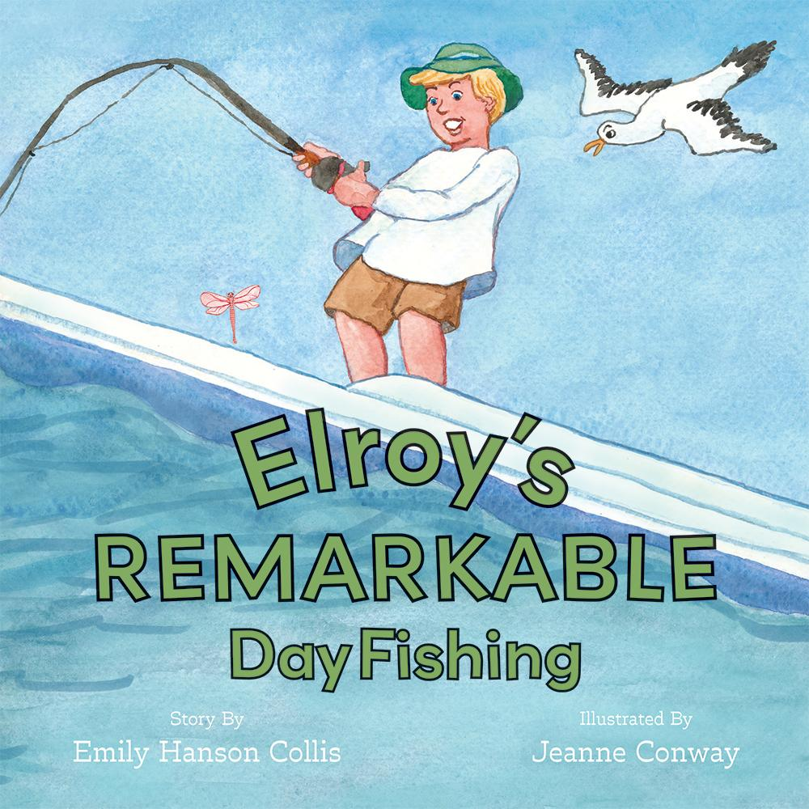](https://www.belleislebooks.com/store/p238/Elroy%E2%80%99s_Remarkable_Day_Fishing.html)

*Elroy is thrilled to spend the day with his dad and grandpa. He will be fishing for the first time! He had no idea there would be so much to learn. Through playful repetition and fun-to-read-aloud rhyming text, readers will enjoy watching Elroy’s curiosity create charming, wonder-filled circumstances where he is reminded to use patience and perseverance during a remarkable day’s fishing adventure.*

**About the Author**

[Emily Hanson Collis](https://www.belleislebooks.com/emilyhansoncollis.html) fondly remembers spending time outdoors and fishing with her family at their second home in Galveston, Texas, where they spent time during weekends away from their primary home in Houston when Emily was a child. She has since retired from a thirty-year career as a school fundraiser, and now lives in Carlsbad, California, after having raised two sons in Albuquerque, New Mexico, with her late husband.

**About the Illustrator**

[Jeanne Conway](https://www.belleislebooks.com/jeanneconway.html) is an artist, illustrator, children’s book author, and art educator from St. Louis, Missouri. She has illustrated children’s picture books, children’s early readers, and middle grade children’s books in addition to writing and illustrating her own books. She is a member of the Society of Children’s Writers and Illustrators. Readers can view more of her art, illustrations, and books on her website, www.jeanniespaintings.com.

**Interviews available upon request.**

[Belle Isle Books](http://www.belleislebooks.com/), an imprint of [Brandylane Publishers, Inc.](https://brandylanepublishers.com/), is an independent press located in Richmond, Virginia that has published books since 1985.

___________

*Elroy’s Remarkable Day Fishing* (hardcover, 36 pages, $26.95 / paperback, 36 pages, $15.95) is available for pre-order from [Amazon](https://www.amazon.com/Elroys-Remarkable-Fishing-Emily-Collis/dp/1962416062), [Barnes & Noble](https://www.barnesandnoble.com/w/elroys-remarkable-day-fishing-emily-hanson-collis/1144713693?ean=9781962416061), and other fine booksellers. Kindle e-book (retail $7.99) forthcoming.