**FOR IMMEDIATE RELEASE**

**July 2023**

**Publicity Team**

pr@brandylanepublishers.com

804-644-3090

***Fireflies and Zeroes*: An Emotionally Charged LGBTQ+ Punk Rock Mystery That Will Leave You “Bouncing Off the Walls”**

written by Liz Larson

on sale July 19, 2023

“A heart-pounding story of love and mystery, of self-discovery and suspense, full of the thousand conflicts . . . that make life so beautiful and so painful. This is a story I’ll be picking up again.”

- Morgan Jensen, book blogger

[Belle Isle Books](http://www.belleislebooks.com/) of Richmond, Virginia, is pleased to announce the release of a contemporary LGBTQ+ mystery for the young and new adult audience, [*Fireflies and Zeroes*](http://www.belleislebooks.com/store/p224/Fireflies_and_Zeroes.html), written by Liz Larson.

A year has passed since Max, the stubborn but charismatic leader of the pop-punk band The Generation, retreated from the fame he engineered, sending the band spiraling into an

indefinite hiatus. But now, in a phone call to his best friend Jason, the band’s guitarist, Max

declares he’s ready to come back. Jason, who grew up alongside Max and tends to glamorize

even his most self-serving eccentricities, is eager to reunite—and desperate for a brighter future

following a lonely summer punctuated by the violent rally that made his and Max’s hometown of

Charlottesville, Virginia the subject of national headlines. However, Tara, the band’s drummer

and voice of reason, is more skeptical of Max’s apparent return—especially since, as the opening show of their tour approaches, Max remains moody and withdrawn, even sending his brother Alex to events in his place.

At a party to celebrate the start of their tour, tensions over Max’s reclusive behavior flare

between Jason and Tara, and later that night, chaos erupts as Alex—who is standing in for

Max—and an unrelated lookalike are both attacked. Suddenly, the real Max is nowhere to be

found—sending Jason and his fellow band members spinning into a spiral of confusion that will

leave Jason questioning everything from his sexuality to his sense of reality.

An impressive, passionate debut novel as complex and rich as the town it portrays in loving

detail, *Fireflies and Zeroes* was released on July 19, 2023.

[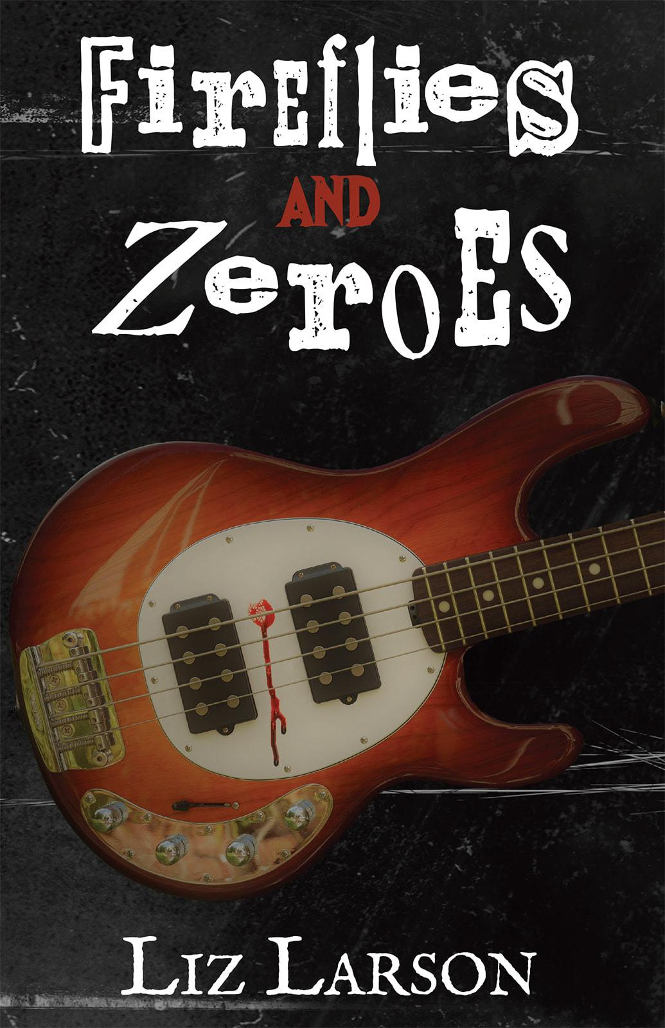](http://www.belleislebooks.com/store/p224/Fireflies_and_Zeroes.html)

*February 2018, Charlottesville, Virginia.*

*The Generation is back—finally. Over the course of a yearlong hiatus, the pop-punk trio has seen their beloved hometown rocked by racist violence and endured months of radio silence from their brilliant yet volatile front man, Max. But guitarist Jason is ready to put all of that behind him when a late-night call from Max reconnects the lifelong friends and reunites the band.*

*At a party on the eve of the band’s reunion tour, Jason watches in horror as Max is thrown to his death off a balcony—or so he thinks. In the chaotic hours that follow, two things become clear: the victim on the balcony was an imposter, and—as usual—there are no simple answers when it comes to the real Max. He’s just . . . gone.*

*Troubled by the emotional storms that drove Max away even before his disappearance, but desperate to bring him home, Jason resolves to find Max himself. In the long winter shadow of Virginia’s Blue Ridge, Jason sets out on a race against time to save his friend. In doing so, he unravels a series of surprising personal truths about the people and places he cares about most.*

**About the Author**

[Liz Larson](http://www.belleislebooks.com/lizlarson.html) has spent half of her life in Charlottesville, Virginia, and the other half in State College, Pennsylvania. She loves both of her hometowns, faults and all. Despite her “real” job as a physics graduate student, her inner emo kid is still going strong. You can usually find her writing, playing bass, or out exploring the countryside—in all cases, surrounded by her animals and far, far too many Green Day albums.

**Interviews available upon request.**

[Belle Isle Books](http://www.belleislebooks.com/), an imprint of [Brandylane Publishers, Inc.](https://brandylanepublishers.com/), is an independent press located in Richmond, Virginia that has published books since 1985.

___________

*Fireflies and Zeroes* (paperback, 208 pages, $17.95 / Kindle e-book, $9.99) is available from [Amazon](https://www.amazon.com/Fireflies-Zeroes-Liz-Larson/dp/1958754293), [Barnes & Noble](https://www.barnesandnoble.com/w/fireflies-and-zeroes-liz-larson/1143391508?ean=9781958754290), and other fine booksellers.