**FOR IMMEDIATE RELEASE**

**February 2022**

**Publicity Team**

pr@brandylanepublishers.com

804-644-3090

**Bringing Readers *From Basketball to Bow Ties,* on *A Journey in Leadership, Self-Discovery, and Success through Service***

written by Harold E. Harris, Jr.

on sale March 10, 2022

“Direct, personal, and inspiring….Anyone serious about taking their leadership to the next level will profit from reading this deeply moving book.”

- Jean B. Gasen, PCC, PhD, executive leadership coach and retired information systems professor

[Belle Isle Books](http://www.belleislebooks.com/) of Richmond, Virginia, is pleased to announce the upcoming release of a new memoir, [*From Basketball to Bow Ties: A Journey in Leadership, Self-Discovery, and Success through Service*](http://www.belleislebooks.com/store/p187/From_Basketball_to_Bow_Ties%3A_A_Journey_in_Leadership%2C_Self-Discovery%2C_and_Success_through_Service.html), written by Harold E. Harris, Jr.

Over the last thirty years, Harold E. Harris, Jr. has taught more than fifty people how to tie a bow tie—just as Mr. Magoo, his clothier, did for him thirty years ago. Now, he brings that same mindset of mentoring and service to readers in the form of a book that demonstrates how he reframed his most personal struggles into inspirational lessons that allowed him to develop into a passionate, compassionate leader—and how you, too, can implement his insights and translate your experiences into actionable ideas.Packed with insightful, thought-provoking, and captivating creative storytelling, this must-read for aspiring leadersprompts readers to consider the value of every aspect of their lives, from good to bad, as they develop their own leadership style.

Encouraging us to lead by embracing responsibility in every aspect of our lives, from the locker room to the boardroom, *From Basketball to Bow Ties: A Journey in Leadership, Self-Discovery, and Success through Service* is scheduled for release on March 10, 2022.

[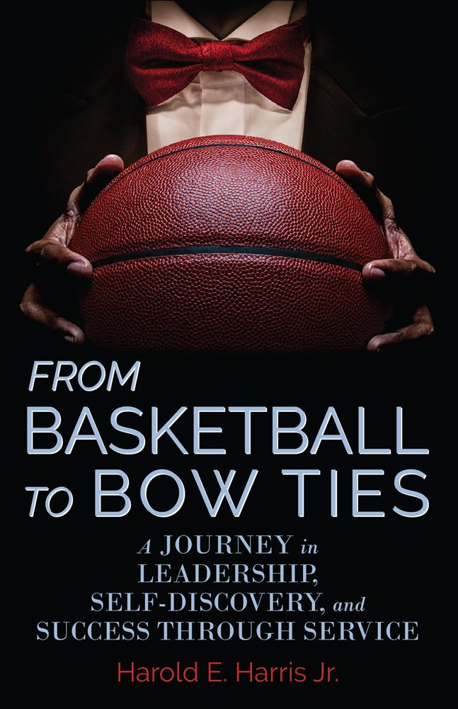](http://www.belleislebooks.com/store/p187/From_Basketball_to_Bow_Ties%3A_A_Journey_in_Leadership%2C_Self-Discovery%2C_and_Success_through_Service.html)

*What do basketball and bow ties have in common? More than you’d expect. Namely: leadership. Part memoir, part self-help book,* From Basketball to Bow Ties *follows Harold E. Harris Jr. from his tumultuous youth spent playing and eventually coaching basketball to his adulthood as a successful businessman who is never without his signature bow tie. Harris’s journey through the hoops helps to shape his ultimate career path, where he leads a team with the foundations of teamwork and diligence. He skillfully translates lessons learned on the court to actionable tips for professional leadership. Leaders, professionals, sports fans, and students will find this book an invaluable resource for developing their leadership skills.*

**About the Author**

[Harold Edward Harris, Jr.](http://www.belleislebooks.com/haroldeharrisjr.html) is an IT leadership professional with thirty-two years of experience in multiple disciplines. He received a bachelor’s degree in public administration and political science from James Madison University in 1988, and a master’s degree in information systems and IT management from Virginia Commonwealth University in 2010.

Since 1989, Harold has cultivated a diverse background that includes fiscal management, clinical support management, telephony, networking infrastructure, desktop support, and hardware and software application support. Throughout his career, he has directed multifunctional teams supporting thirteen states and averaging sixty thousand phone calls per month. He is currently responsible for twenty IT professionals across six different teams, with a focus on delivering business value via technology management principles that improve the customer’s experience.

Harold devotes much of his time to mentoring young professionals and giving back to the community, and currently serves on the board of directors for nonprofit VA Voice, which provides broadcasted programming that reads and performs content for the vision- and hearing-impaired. He is also an avid fitness enthusiast and intermediate yoga practitioner, and has served as an NCAA Division I basketball official for the last thirty-two years.

A father of three daughters and one son, Harold currently resides in Stafford, Virginia with his wife.

**Interviews available upon request.**

[Belle Isle Books](http://www.belleislebooks.com/), an imprint of [Brandylane Publishers, Inc.](https://brandylanepublishers.com/), is an independent press located in Richmond, Virginia that has published books since 1985.

___________

*From Basketball to Bow Ties; A Journey in Leadership, Self-Discovery, and Success through Service* (hardcover, 240 pages, $29.95 / paperback, 240 pages, $16.95) is available for pre-order from [Amazon](https://www.amazon.com/Basketball-Bow-Ties-Leadership-Self-Discovery/dp/1953021387), [Barnes & Noble](https://www.barnesandnoble.com/w/from-basketball-to-bow-ties-harold-e-harris-jr/114076807540123551?ean=9781953021328), and other fine booksellers. Kindle e-book (retail $4.99) forthcoming.