**FOR IMMEDIATE RELEASE**

**September 2020**

**Christina Kann, Publicist**

[pr@brandylanepublishers.com](mailto:pr@brandylanepublishers.com)

**Sharing Her Marriage to Strengthen Yours: *From Chaos to Connection***

**written by Lori Epting**

**on sale October 9, 2020**

“Reading *From Chaos to Connection* is like sitting down with a seasoned counselor who understands the dynamics of building a healthy marriage. . . . It is a hope-filled book for all who want a growing marriage.”

—Gary D. Chapman, PhD, author of *The 5 Love Languages*

[Belle Isle Books](http://www.belleislebooks.com/) of Richmond, Virginia, is proud to announce the upcoming release of [*From Chaos to Connection*](https://www.amazon.com/Chaos-Connection-Marriage-Counselors-Candid/dp/1951565932/ref=sr_1_2?dchild=1&keywords=from+chaos+to+connection&qid=1596213878&s=books&sr=1-2) by [Lori Epting](http://www.loriepting.com/). Marriage counselor Lori Epting shares both her own and her clients’ stories of marital conflict, compromise, and forgiveness to help guide couples from separation and heartache to connection, security, and trust. *From Chaos to Connection* is scheduled for release on October 9, 2020.

[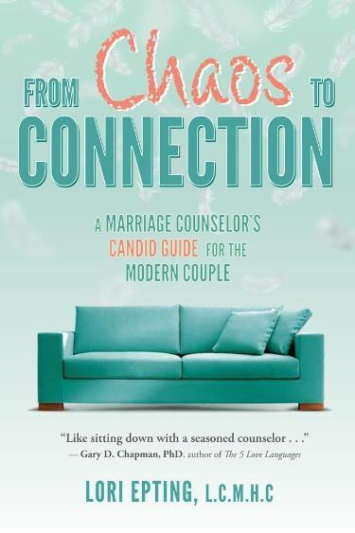](https://www.amazon.com/Blameless-S-Christison/dp/1951565606)

Get inside the mind and marriage of Lori Epting, an experienced marriage counselor, wife, and mother who has guided thousands of couples from disconnection, heartache, and fighting to connection, security, and safety. Through the stories of her couples—and yes, even her own relationship—learn how she protects her marriage and helps couples survive during their most vulnerable times. You’ll walk away with candid advice that can help you and your loved one find connection amid the chaos.

**About the Author**

[Lori Epting](http://www.loriepting.com) is a licensed clinical mental health counselor in North Carolina. She holds a master’s in counseling and has focused her professional training on couples and addiction therapy. She is certified in the Advanced Training in Problematic Sexual Behaviors (ATPSB) program and formally trained in the professionally accepted and empirically validated treatment model of emotionally focused couples therapy (EFT). Lori currently works in private practice, treating couples and families at Lori Epting Counseling, PLLC, where she specializes in marital therapy using EFT. When she isn’t counseling, she writes a professional blog, “Marriage Sense,” and is a topic expert for GoodTherapy.org, contributing articles about marriage and addiction.

Lori lives in Charlotte, NC, with her husband and their two daughters.

**Interviews available upon request.**

[Belle Isle Books](http://www.belleislebooks.com/) is an imprint of [Brandylane Publishers, Inc.](https://brandylanepublishers.com/), an independent press located in Richmond, Virginia, that has published books since 1985.

_____

*From Chaos to Connection* (262 pages, paperback $17.95 / e-book $4.99) is available for pre-order from [Amazon](https://www.amazon.com/Chaos-Connection-Marriage-Counselors-Candid/dp/1951565932/ref=sr_1_2?dchild=1&keywords=from+chaos+to+connection&qid=1596213878&s=books&sr=1-2), [Barnes and Noble](https://www.barnesandnoble.com/w/from-chaos-to-connection-lori-epting/1137352593?ean=9781951565930), and other fine booksellers.