

**FOR IMMEDIATE RELEASE**

**December 2019**

**Christina Kann, Publicist**

brandylanepr@gmail.com or 804.644.3090

**How Everyday Objects Are Made with Love: *From a Tree to a Chair***

**written by Roseanne McDonald**

**illustrated by Mary Barrows**

**on sale in December**

“. . . an innovative look at how the trees we live under become the furniture we use . . . interesting and fun.”

*­ Rob McCallum, social studies teacher and former newspaper reporter from timber country*

[Belle Isle Books](http://www.belleislebooks.com/), an imprint of Brandylane Publishers, Inc., is excited to announce the upcoming release of Roseanne McDonalds’s new children’s book, [*From a Tree to a Chair*](https://www.amazon.com/Tree-Chair-Roseanne-McDonald/dp/1947860763/ref=sr_1_1?crid=387EVAHYI0EOV&keywords=from+a+tree+to+a+chair+mcdonald&qid=1575493015&sprefix=from+a+tree+to+a+chair%2Caps%2C133&sr=8-1). Told in a fun, scrapbook style, this educational book teaches kids how trees become everyday items. *From a Tree to A Chair* is scheduled for release on December 13.

[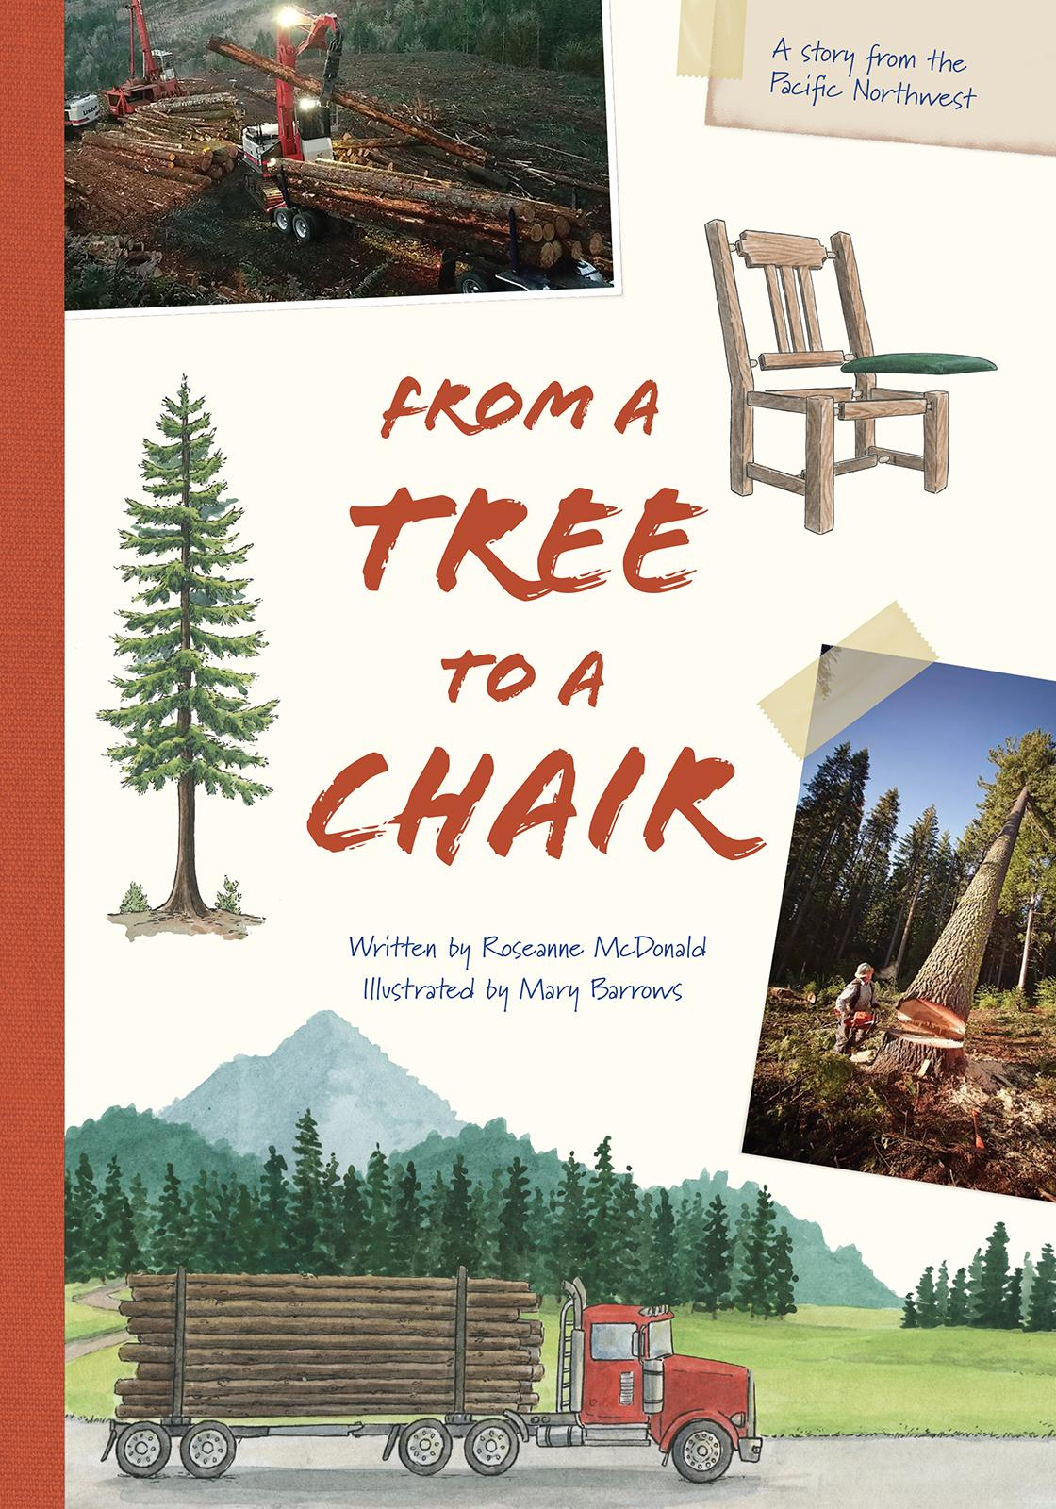](https://www.amazon.com/Tree-Chair-Roseanne-McDonald/dp/1947860763/ref=sr_1_1?crid=387EVAHYI0EOV&keywords=from+a+tree+to+a+chair+mcdonald&qid=1575493015&sprefix=from+a+tree+to+a+chair%2Caps%2C133&sr=8-1)

Beginning in a busy logging site deep in the woods, follow the journey of a tree as it is harvested, processed into lumber, and carefully crafted into a beautiful set of chairs. With a deep respect for the trees and the useful things they give us, this book reveals all the hard work that goes into making the things we take for granted every day.

**About the Author**

[Roseanne McDonald](http://www.belleislebooks.com/roseannemcdonald.html) lives in the rural countryside of Oregon. Although she always wanted to be a writer, she set that dream aside to raise five children and pursue a career teaching elementary school. Finally, at the age of sixty-five, she is ready to share her stories with the world!

**About the Illustrator**

[Mary Barrows](http://www.marybarrowsillustration.com/) is a freelance illustrator from the small town of Walkersville, MD. Since she was old enough to hold a crayon, she has been drawing pictures of her favorite stories, and she hasn’t stopped yet. Her illustrations are done in a traditional style using ink, watercolor, gouache, colored pencil, graphite, or whatever else she can get her hands on.

**Interviews are available upon request.**

[Belle Isle Books](http://www.belleislebooks.com/) is an imprint of [Brandylane Publishers, Inc.](http://brandylanepublishers.com/), an independent press located in Richmond, Virginia that has published books since 1985.

____________

*From a Tree to a Chair* (children’s fiction, 36 pages, hardcover $22.95 / paperback $14.95 / ebook $2.99) is available for pre-order from [Belle Isle Books](http://www.belleislebooks.com/store/p144/fromatreetoachair.html), [Amazon](https://www.amazon.com/Tree-Chair-Roseanne-McDonald/dp/1947860763/ref=sr_1_1?crid=387EVAHYI0EOV&keywords=from+a+tree+to+a+chair+mcdonald&qid=1575493015&sprefix=from+a+tree+to+a+chair%2Caps%2C133&sr=8-1), [Barnes & Noble](https://www.barnesandnoble.com/w/from-a-tree-to-a-chair-roseanne-mcdonald/1134926667?ean=9781947860810), and other fine booksellers.