**FOR IMMEDIATE RELEASE**

**July 2025**

**Publicity Team**

pr@brandylanepublishers.com

804-644-3090

**Attorney and Professor Emeritus Paul H. Meyers Invites Readers to Witness *Jill's Trials* in Dramatic Debut Novel**

written by Peter H. Meyers

on sale February 18, 2025

“An insightful cross-generational tale of trials, both criminal and psychological. . . . This multilayered story illuminates important issues of trust and betrayal, service and sacrifice, blame and forgiveness.”

- Phyllis Goldfarb, coeditor in chief of the *Clinical Law Review*

[Belle Isle Books](http://www.belleislebooks.com/) of Richmond, Virginia, is pleased to announce the release of a dramatic new work of contemporary fiction, [*Jill’s Trials*](https://www.belleislebooks.com/store/p255/Jill%27s_Trials.html), written by Peter H. Meyers.

Laws meant to regulate drugs have often been used to unjustly prosecute people of color and people of lower socioeconomic classes. Lawyer Peter Meyers knows this—and has spent his career fighting for justice for his clients and workingat the George Washington University Law School, where he teaches a class titled “Drugs and the Law.” In his new novel, he puts his experience to work to describe the intricacies of courtroom drama.

In *Jill’s Trials,* Meyers follows protagonist Jill Hansen’s progression from law student to public defender—and then to a partner at a prestigious law firm. Along the way, he draws on his own experience to point out racism in the system, advocate for more just policy, and show how lawyers can have significant positive impacts on their clients’ lives—even to the detriment of their mental health.

Jill learns early on that it’s important for lawyers to keep a professional relationship with their clients. But as she progresses in her career and throws herself into her work, she finds herself toeing the line of maintaining professional relationships with her clients as she struggles to maintain a healthy relationship with family members and her own mental health.

An investigation of work/life balance, family, and the importance of working to improve the justice system,*Jill’s Trials* released February 18, 2025.

[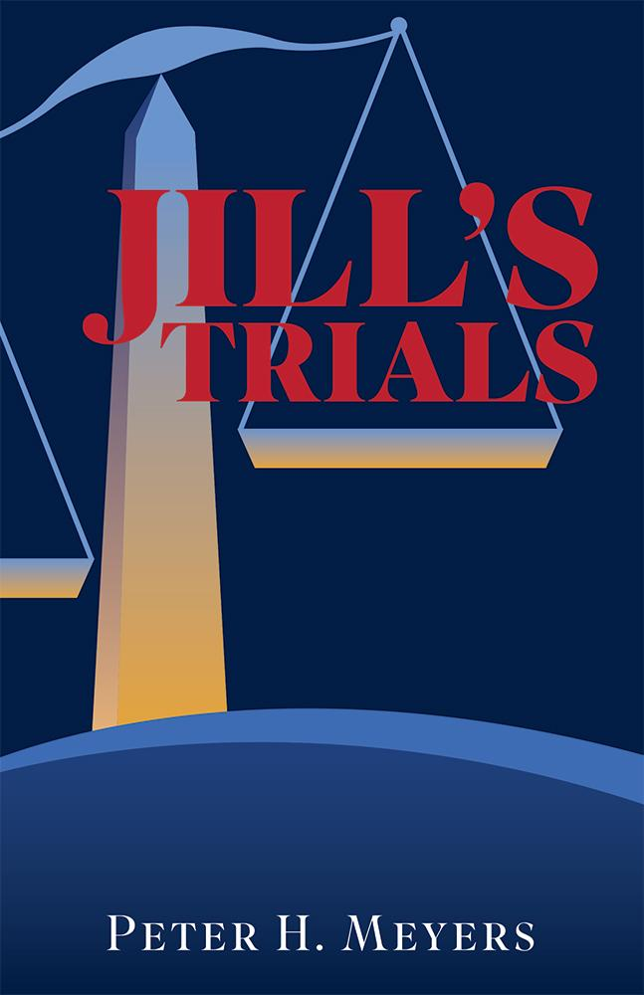](https://www.belleislebooks.com/store/p255/Jill%27s_Trials.html)

*In her final year of law school, Jill Hansen’s greatest joy is representing criminal defendants in court through her school’s criminal justice clinic. But when she’s appointed to represent Carl, a handsome, charming man who’s been charged with assault, she and her supervising professor face dangerous challenges and choices that could threaten their careers.*

Jill’s Trials, *a courtroom drama, follows Jill’s path from law school, to the public defender’s office, to a prestigious law firm. She fights for her clients, victims of drug abuse and domestic violence, in a criminal justice system that is stacked against them. Her searing cross-examinations bring her success in the courtroom—but will her dedication to her clients and professional ambition come at the cost of poisoning her personal life?*

**About the Author**

[Peter Meyers](https://www.belleislebooks.com/petermeyers.html) has practiced as an attorney for more than forty years, winning an important decision in the US Supreme Court involving standing and representing many clients who were found not guilty, or had their convictions overturned on appeal, of murder, armed robbery, drug dealing, and other crimes. He’s also a professor emeritus at the George Washington University Law School and former director of the school’s criminal appeal clinic, where he supervised law students representing convicted defendants in appellate proceedings. He has been widely quoted in national and international media, including the Washington Post, USA Today, FOX TV, the Times (UK), and TBS (South Korea). His interests include jazz, golf, and Chinese calligraphy. He lives in Washington, DC, with his wife Sara Schotland and Biscuit, their cocker spaniel.

**Interviews available upon request.**

[Belle Isle Books](http://www.belleislebooks.com/), an imprint of [Brandylane Publishers, Inc.](https://brandylanepublishers.com/), is an independent press located in Richmond, Virginia that has published books since 1985.

___________

*Jill’s Trials* (paperback, 210 pages, $18.95 / Kindle e-book, $9.99) is available for sale from [Amazon](https://www.amazon.com/Jills-Trials-Peter-H-Meyers/dp/1962416631), [Barnes & Noble](https://www.barnesandnoble.com/w/jills-trials-peter-h-meyers/1146367925?ean=9781962416634), and other fine booksellers.