**FOR IMMEDIATE RELEASE**

**July 2022**

**Publicity Team**

pr@brandylanepublishers.com

804-644-3090

**Take a Lyrical Step into *The Land of Opposite Attractions***

written by Catherine Carson

on sale August 9, 2022

“Sumptuous, seductive, and searing. I found myself wanting to melt into each page. Like clay in her hands, Catherine Carson forms poems with the rich soul of the potter and the delicate refinement of the sculptor.”

- Anne Poarch, author of *Flight: Of Butterflies and Robins and Other Winged Dreams* and *The Grit and Joy of Being*

[Belle Isle Books](http://www.belleislebooks.com/) of Richmond, Virginia, is pleased to announce the upcoming release of a new book of poetry, [*The Land of Opposite Attractions*](http://www.belleislebooks.com/store/p193/The_Land_of_Opposite_Attractions.html), written by Catherine Carson.  
 *Why*

*do my dreams come*

*coded in devastation,*

*drenched in joy,*

*dismantled into destiny?*

A piercing, vibrant collection of crystallized moments of love, heartbreak, and joy, *The Land of Opposite Attractions* is scheduled for release on August 9, 2022.

[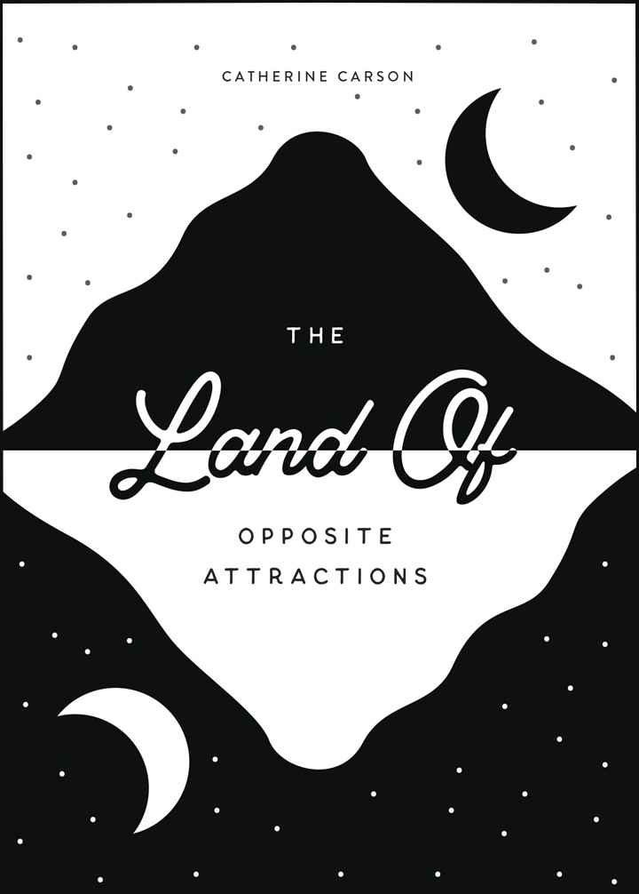](http://www.belleislebooks.com/store/p193/The_Land_of_Opposite_Attractions.html)

*From debut poet Catherine Carson comes an examination of everyday life, as seen through the lens of a mentally ill young woman navigating her twenties. Full of persistent optimism and honesty, this collection celebrates the tragedy and beauty to be found, not only in the world around us, but in the worlds we carry within ourselves.*

**About the Author**

[Catherine Carson](http://www.belleislebooks.com/catherinecarson.html) studied poetry at James Madison University, but her love affair with poetry began at the age of fifteen. With heroes like Sylvia Plath, Joy Harjo, and Mary Oliver, Catherine writes in a confessional free-verse style. Her award-winning work—which delves into topics such as mental illness, her experiences as a woman, relationships and friendships, and the trials of youth—has been published in *Dreamers Creative Writing* magazine. Catherine now pursues poetry as a profession, writing both formally in workshops as well as in her spare time. She regards writing poetry as both a need and a want, and will continue to publish more work.

**Interviews available upon request.**

[Belle Isle Books](http://www.belleislebooks.com/), an imprint of [Brandylane Publishers, Inc.](https://brandylanepublishers.com/), is an independent press located in Richmond, Virginia that has published books since 1985.

___________

*The Land of Opposite Attractions* (paperback, 60 pages, $11.95) is available for pre-order from [Amazon](https://www.amazon.com/Land-Opposite-Attractions-Catherine-Carson/dp/1953021654), [Barnes & Noble](https://www.barnesandnoble.com/w/the-land-of-opposite-attractions-catherine-carson/1141216388?ean=9781953021656), and other fine booksellers. Kindle e-book (retail $4.99) forthcoming.