**FOR IMMEDIATE RELEASE**

**May 2024**

**Publicity Team**

804-644-3090  
pr@brandylanepublishers.com

**Readers Look for Leprechauns as a Young Leprechaun Girl Finds Herself in New Children's Book *Lia the Leprechaun***

written and illustrated by Jenny Olson

on sale May 21, 2024

“. . . a beautiful message of love, acceptance, adventure, and the joy found in helping others, coupled with engaging illustrations that will capture the attention and hearts of readers for years to come!”

- Laura Stuckey, BAK Elementary School principal, mother, and farmer’s wife

[Belle Isle Books](http://www.belleislebooks.com/) of Richmond, Virginia, is pleased to announce the upcoming release of a new children’s picture book, [*Lia the Leprechaun*](https://www.belleislebooks.com/store/p241/Lia_the_Leprechaun.html)*,* written and illustrated by Jenny Olson.

Everyone knows leprechauns wear green—but Lia wants to try a new color for a change! When she swaps her green dress for a purple one, though, she quickly learns that leprechauns wear green for a reason. In this charming tale for readers ages 4 to 8, Jenny Olson draws on traditional Irish folklore and legend to present a fresh new story about recognizing your own talents and accepting yourself, while also daring to try new things.

Illustrated by the author with charming watercolors and intricately detailed Celtic knotwork borders,*Lia the Leprechaun* is scheduled for release on May 21, 2024.

[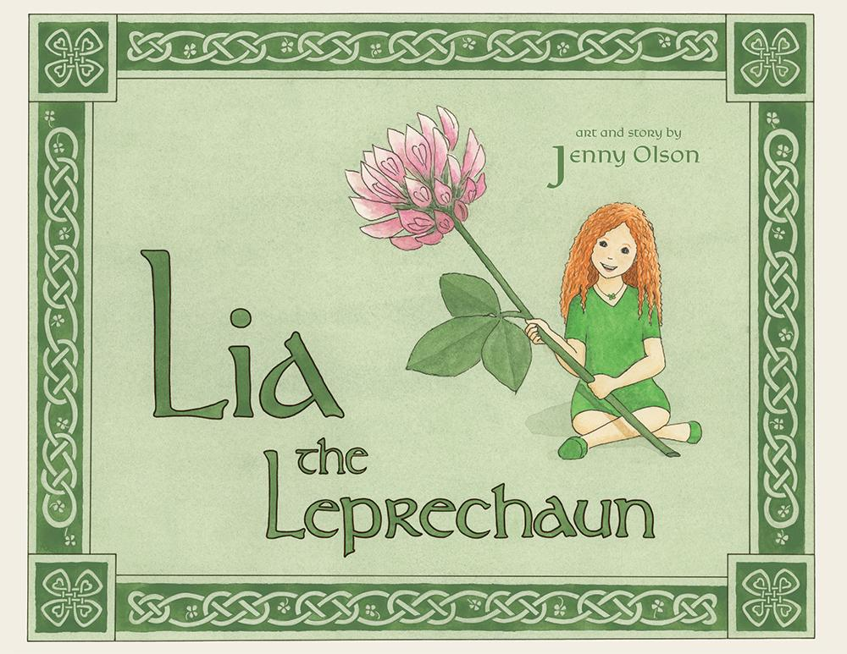](https://www.belleislebooks.com/store/p241/Lia_the_Leprechaun.html)

What happens when an adventurous young leprechaun girl gets tired of wearing nothing but green every day of her life?

*Lia and her family are leprechauns—which means they all wear green, to hide from the humans who might otherwise steal their gold or demand they grant wishes. Still, Lia wishes she could try on some of the other beautiful colors she sees in the forest. When she gets the chance, Lia dares to swap her usual green outfit for a beautiful purple fairy dress. But when she meets a human girl who needs her help, Lia comes to appreciate who she is and the magic she holds inside.*

**About the Author / Illustrator**

[Jenny Olson](https://www.belleislebooks.com/abigailolson-413392.html) is half Irish, and enjoys learning about Irish mythology and folklore. She first began writing children’s stories for her young daughters. Jenny lives with her husband, younger daughter, and three dogs in Richmond, Virginia. She spends summers in a rural home in the beautiful Driftless area of southwest Wisconsin, a land running with rivers and rolling with hills. When she isn’t writing, drawing, and painting, Jenny enjoys hiking, kayaking, and looking for signs of leprechauns.

**Interviews available upon request.**

[Belle Isle Books](http://www.belleislebooks.com/), an imprint of [Brandylane Publishers, Inc.](https://brandylanepublishers.com/), is an independent press located in Richmond, Virginia that has published books since 1985.

___________

*Lia the Leprechaun* (hardcover, 34 pages, $26.95 / paperback, 34 pages, $15.95) is available for pre-order from [Amazon](https://www.amazon.com/Lia-Leprechaun-Jenny-Olson/dp/1962416275), [Barnes & Noble](https://www.barnesandnoble.com/w/lia-the-leprechaun-jenny-olson/1145381674?ean=9781962416276), and other fine booksellers.