**FOR IMMEDIATE RELEASE**

**September 2024**

**Publicity Team**

804-644-3090  
pr@brandylanepublishers.com

**New Children’s Book Helps Kids Fall Asleep with *Littlest Mano at Bedtime***

written by Anita Dromey

illustrated by Taranggana

on sale September 17, 2024

“. . . captures the age-old story of young ones’ desire to delay bedtime as long as possible. This book has the hallmarks of a nightly ‘must read’ that will help children transition to bedtime. A true delight.”

- Matt Fairbank, principal consultant, Sageland Mediation and Facilitation Service, LLC

[Belle Isle Books](http://www.belleislebooks.com/) of Richmond, Virginia, is pleased to announce the upcoming release of a new children’s picture book, [*Littlest Mano at Bedtime*](https://www.belleislebooks.com/store/p247/Littlest_Mano_at_Bedtime.html)*,* written by Anita Dromey and illustrated by Taranggana.

It’s a peaceful night by the sea as a herd of goats prepare for sleep—but the littlest goat, Mano, doesn’t want to come when his mother calls him. Though the other goats are anxious to depart, Mano is content to leave the hill where the herd grazes and make the trek down the path from the hill to the sleeping grounds only when he is able to lead the other goats in a parade. But when little Mano discovers unforeseen consequences to his unwillingness to head to bed when his mother requested, he receives not condemnation, but an important lesson in grace— as well as comforting acceptance, patience, and forgiveness.

Told in charming rhyming verse evocative of classic bedtime stories, and accompanied by rich illustrations, *Littlest Mano at Bedtime* is scheduled for release on September 17, 2024.

[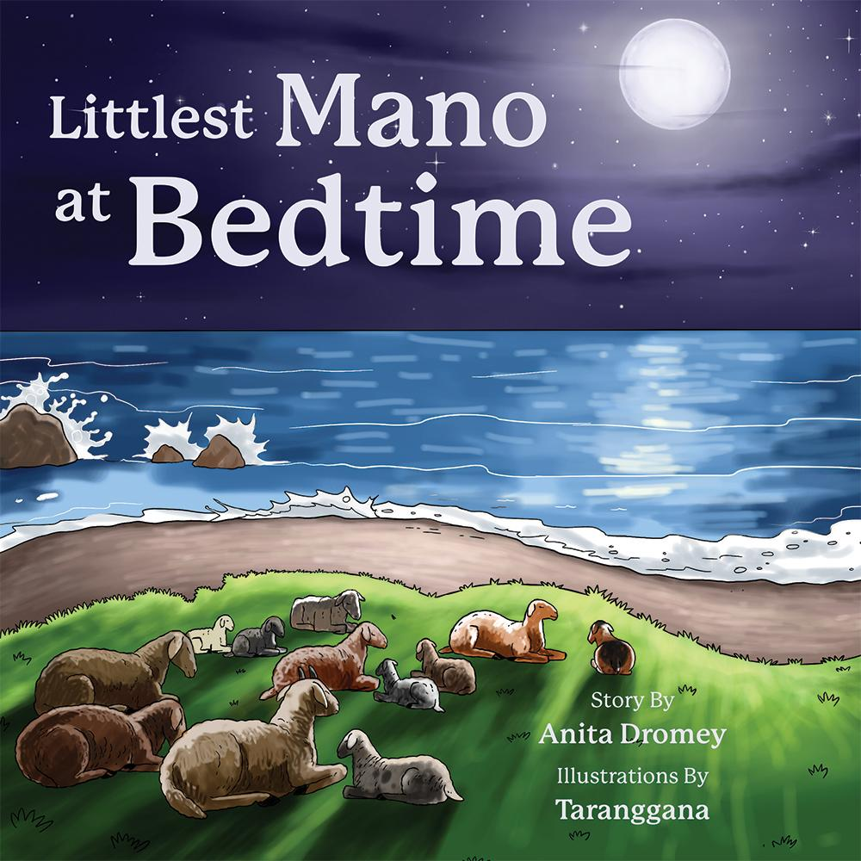](https://www.belleislebooks.com/store/p247/Littlest_Mano_at_Bedtime.html)

*The goats love to graze and play all day on the sunny hillside. But when it's time to trek to the cooler breezes of the seaside for their evening rest, Littlest Mano says he isn’t tired of playing yet! How will Mama Goat keep Littlest Mano with the group so they can all settle down together for the night?*

**About the Author**

[Anita Dromey](https://www.belleislebooks.com/anitadromey-376010.html) is a speech therapist with a lifelong interest in writing. *Littlest Mano at Bedtime* is her first published book, with a sequel in process containing more of Littlest Mano’s adventures. She won first place for poetry in the 2023 Idaho Writers’ Guild annual writing contest, and her work has been seen in *SVPN* magazine and other publications. Anita is fascinated by people, nature, and the flow of life on our little planet. Aside from work, she spends time practicing yoga, bicycling, or browsing through a bookstore.

**About the Illustrator**

[Taranggana](https://www.belleislebooks.com/lintangpandupratiwi.html) is an art studio created by Lintang Pandu Pratiwi of Indonesia. Through her art studio, Lintang has illustrated over a hundred picture books for various publishers and clients in the United States, Europe, and Asia. A lover of art and nature, she is inspired by the ideas of nostalgic childhood innocence and the beautiful countryside. But Lintang’s biggest inspirations in life are her parents, Widayati Sri Wulandari and Mudjab Widjaya. Through their everlasting and continual support, they have provided her with good examples of how to live her life and be successful in her own way.

**Interviews available upon request.**

[Belle Isle Books](http://www.belleislebooks.com/), an imprint of [Brandylane Publishers, Inc.](https://brandylanepublishers.com/), is an independent press located in Richmond, Virginia that has published books since 1985.

___________

*Littlest Mano at Bedtime* (hardcover, 32 pages, $26.95 / paperback, 32 pages, $15.95 / Kindle e-book $6.99) is available for pre-order from [Amazon](https://www.amazon.com/Littlest-Mano-Bedtime-Anita-Dromey/dp/1962416127), [Barnes & Noble](https://www.barnesandnoble.com/w/littlest-mano-at-bedtime-anita-dromey/1145785862?ean=9781962416122), and other fine booksellers.