**FOR IMMEDIATE RELEASE**

**June 2024**

**Publicity Team**

pr@brandylanepublishers.com

804-644-3090

**Author’s Experience in *Living Tidal* on a Small Boat Inspires Women to Seize Hope—and Appreciate Their Own Capabilities**

written by Sheena Jeffers

on sale June 25, 2024

“. . . a poignant, funny memoir that will resonate with everyone who has recognized a desperation for action and a frustration with their status quo. This book teaches you how to change your life.”

- Kate Lewis, essayist with work featured in the *New York Times* and the *Washington Post*

[Belle Isle Books](http://www.belleislebooks.com/) of Richmond, Virginia, is pleased to announce the release of a new memoir, [*Living Tidal*](https://www.belleislebooks.com/store/p242/Living_Tidal.html), written by Sheena Jeffers.

Life on the open ocean can be challenging for any relationship—but even more so for a relationship that is less than two years old, especially when one of the pair has yet to find her sea legs! When thirty-one-year-old Sheena Jeffers decides to put away the careful, cautious persona born of her dutiful upbringing and get behind her new boyfriend’s dream of selling everything he owns, restoring an old boat, and sailing the seas on the forty-three-foot catamaran full-time, she must also commit to leaving behind her own job, possessions, and life in Virginia Beach, Virginia. The ensuing adventure sees the pair sail thousands of nautical miles over two years, exploring multiple countries and dozens of picturesque tropical islands throughout the Caribbean and Central and South America. As they grapple with treacherous passages, stormy seas, and the ins and outs of living life out of sight of shore and all its obligations, Sheena comes to realize her own resourcefulness and capacity to grow—and in doing so, attains a more complete understanding of herself. But between ports of call, those same experiences that lead Sheena to lean on the wisdom of the moon and trust in her feelings see her drifting further from her partner—even as they journey together in the same intimately small space amid a vast ocean.

A brutally, beautifully honest coming-of-age memoir pieced together from the author’s own journals and filled with tender vulnerability, curiosity, and a triumphant exploration of the sea and the self, *Living Tidal* releases today, June 25, 2024.

[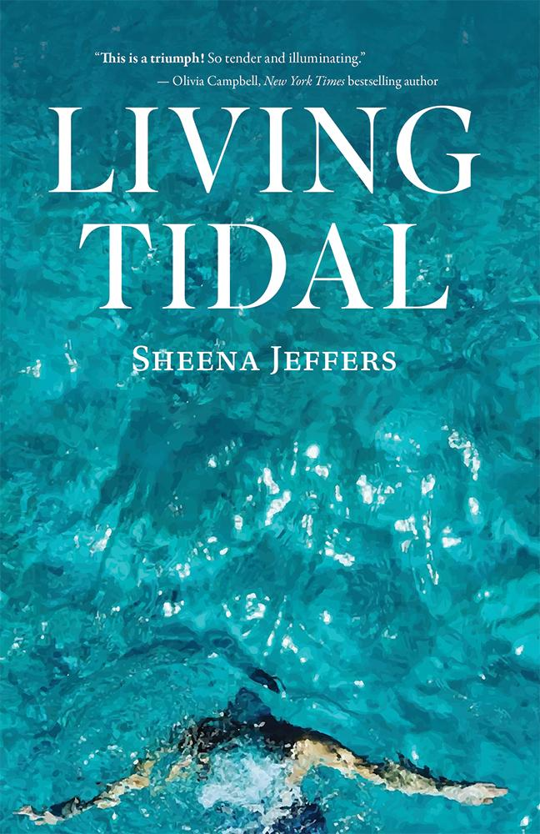](https://www.belleislebooks.com/store/p242/Living_Tidal.html)

*On a frigid November night at high tide, a young woman unties the dock lines and watches the land recede as the sailboat she’s standing on floats out to sea. She has a jacket, a scarf, and a deep need to reinvent herself.* Living Tidal *is part adventure, part love story: a coming-of-age memoir that captures the hearts and minds of readers with each page. Journalist Sheena Jeffers addresses the curiosity, self-doubt, and the desire we all have to deeply experience the world as we embark on the lifelong journey to know ourselves.*

**About the Author**

[Sheena Jeffers](https://www.belleislebooks.com/judyjamison-363618.html), MSEd, is a writer, doula, certified wellness coach, and yoga and dance instructor from Virginia. Her work has appeared in the *Richmond Times-Dispatch*, the *Washington Examiner, Waterborne* magazine, *Sailing Scuttlebutt*, and the anthology *Facing Fear Head On: True Stories from Women on the Water.* She has been featured on TODAY.com, the *Inspired Woman’s Podcast*, and the *Roanoke Times,* and in 2016 was awarded “Millennial on the Move” by CoVaBiz Mag. During her travels, she was the host of podcasts *Breathe Full* and *Seas Life for Good*, as well as the producer of a sailing YouTube channel that gathered over ten thousand engaged followers.

Today, Sheena is loving her full days as a mother living by a river. She keeps her lifelong flame for ballet and contemporary dance ablaze, and in times of trouble, always remembers to consult the moon.

**Interviews available upon request.**

[Belle Isle Books](http://www.belleislebooks.com/), an imprint of [Brandylane Publishers, Inc.](https://brandylanepublishers.com/), is an independent press located in Richmond, Virginia that has published books since 1985.

___________

*Living Tidal* (paperback, 193 pages, $17.95 / Kindle e-book, $7.99) is available for sale from [Amazon](https://www.amazon.com/Living-Tidal-Sheena-Jeffers/dp/1958754846), [Barnes & Noble](https://www.barnesandnoble.com/w/living-tidal-sheena-jeffers/1145214409?ean=9781958754849), and other fine booksellers.