**FOR IMMEDIATE RELEASE**

**November 2024**

**Publicity Team**

804-644-3090  
pr@brandylanepublishers.com

**New Picture Book *Llama, Girl, and the Sunriseflower* Shows Children What to Do When We Miss Our Friends**

written by Greg Clay

illustrated by Andrea Bures

on sale November 6, 2024

“. . . by far one of my favorite children’s books. It brought tears to my eyes. Greg Clay . . . captures the compassion and the essence of true love in an incredibly imaginative way.”

- Puja Suri, Canadian certified counselor, MC, CCC, and author of *Mamta's Lovely Mustache*

[Belle Isle Books](http://www.belleislebooks.com/) of Richmond, Virginia, is pleased to announce the upcoming release of a new children’s picture book, [*Llama, Girl, and the Sunriseflower*](https://www.belleislebooks.com/store/p249/Llama%2C_Girl%2C_and_the_Sunriseflower.html)*,* written by Greg Clay and illustrated by Andrea Bures.

Llama and Girl are two best friends who live in a house at the foot of a mountain amid a bucolic landscape. Every morning, they ascend the mountain to watch the sun rise. Every afternoon, they work in their garden and have a lunch of vegetables—though Girl drinks tea, while Llama drinks coffee. And every afternoon, they play together in the starflower field before listening to the hills whisper to each other as the stars appear.

Llama and Girl are inseparable. So when, one day, an illness prevents Girl from participating in all their usual activities, Llama tries everything to keep her in his thoughts as he goes about their daily routine. He even drinks tea, instead of coffee.

But no matter what Llama tries, he can’t seem to summon up any happiness. So the next morning, Llama has an idea of something magical he can do to make sure he feels close to Girl—and that Girl knows Llama is thinking of her. In enacting his plan, Llama reminds us of the love we feel for our friends—and teaches us how to share it with them, even when they can’t always be there with us.

Accompanied by charming, colorful illustrations resplendent with patterns and textures, *Llama, Girl, and the Sunriseflower* is scheduled for release on November 6, 2024.

[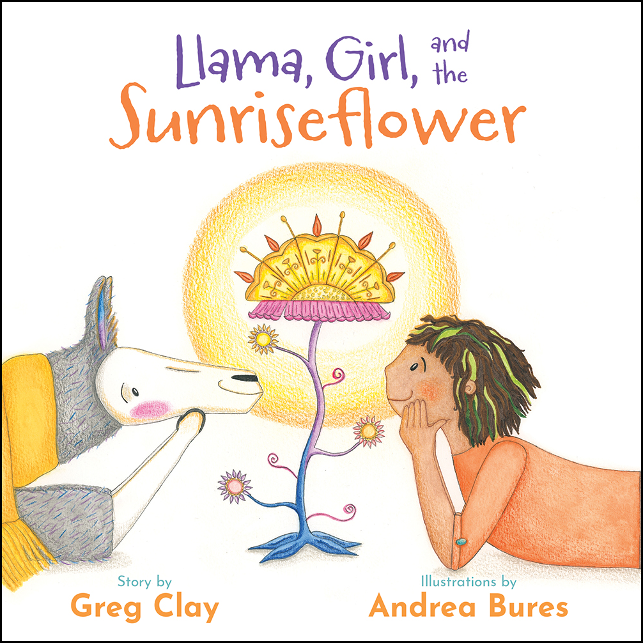](https://www.belleislebooks.com/store/p249/Llama%2C_Girl%2C_and_the_Sunriseflower.html)

*Best friends Llama and Girl share a life of magic, wonder, and adventure. Together they spend their days racing clouds, singing to the Grumblewhump, watching sunrises, and tending to their garden. They do everything together. But when Girl gets sick, how will Llama spend the day without her?*

Llama, Girl, and the Sunriseflower *is a warmhearted, wholesome story of friendship, the wonder of nature, TOP-SECRET llama magic, and connecting and caring for one another. This gentle and surprising tale forges a fantastical world with unforgettable characters, charming storytelling, and whimsical, hand-drawn illustrations.*

**About the Author**

[Greg Clay](https://www.belleislebooks.com/gregclay-325019.html) is a professional copywriter—who therefore writes a lot!—but his day-to-day writing is more business-y and less llama-y. He spends his free time with his family exploring wild spaces, watching the clouds and stars, sitting quietly by the fire, and getting lost (and found) in his imagination. *Llama, Girl, and the Sunriseflower* is his first children's book, and he hopes you like it!

**About the Illustrator**

[Andrea Bures](https://www.belleislebooks.com/andreabures-819831-382221.html) began making quirky greeting cards for family and friends when she was a little girl. Eventually, this blossomed into selling her work at markets, creating commissioned paintings, and illustrating her first children’s picture book, *Llama, Girl, and the Sunriseflower.*

Inspired by different forms of art, nature, and the ordinary-yet-magical moments of daily life, Andrea enjoys exercising her imagination regularly and infusing whimsy into her creations. She would love to come across a sunriseflower on a meandering walk and be invited to a secret llama dance party one day.

**Interviews available upon request.**

[Belle Isle Books](http://www.belleislebooks.com/), an imprint of [Brandylane Publishers, Inc.](https://brandylanepublishers.com/), is an independent press located in Richmond, Virginia that has published books since 1985.

___________

*Llama, Girl, and the Sunriseflower* (hardcover, 36 pages, $26.95 / paperback, 36 pages, $15.95) is available for pre-order from [Amazon](https://www.amazon.com/Llama-Girl-Sunriseflower-Greg-Clay/dp/1962416011), [Barnes & Noble](https://www.barnesandnoble.com/w/llama-girl-and-the-sunriseflower-greg-clay/1145856180?ean=9781962416016), and other fine booksellers.