**FOR IMMEDIATE RELEASE**

**October 2022**

**Publicity Team**

804-644-3090  
pr@brandylanepublishers.com

***Losing a Tooth* Doesn’t Have to Be Frightening with This New Book from Belle Isle Books!**

written by Nicole Wright

illustrated by Kelly O’Neill

on sale November 8, 2022

“The delightful rhymes are adorable. . . . This book surely will make the whole family SMILE until the tooth fairy comes again.”

- Dr. Mary Beth Dunn, pediatric dentist

[Belle Isle Books](http://www.belleislebooks.com/) of Richmond, Virginia, is pleased to announce the upcoming release of a new children’s book, *Losing a Tooth*, written by Nicole Wright and illustrated by Kelly O’Neill.

*Losing a tooth can be hard to do. It’s saying “so long” to a big part of you!* Kids can get nervous when their first tooth wiggles and wobbles, but losing a baby tooth can also be an opportunity for exciting new experiences! Between the Tooth Fairy and getting all-new grownup teeth, kids will learn reasons to smile over losing a tooth with this fun and comforting book geared toward students in early elementary school.

Featuring bright, adorable illustrations that celebrate children as they face this milestone of growing up, *Losing a Tooth* is scheduled for release on November 8, 2022.

[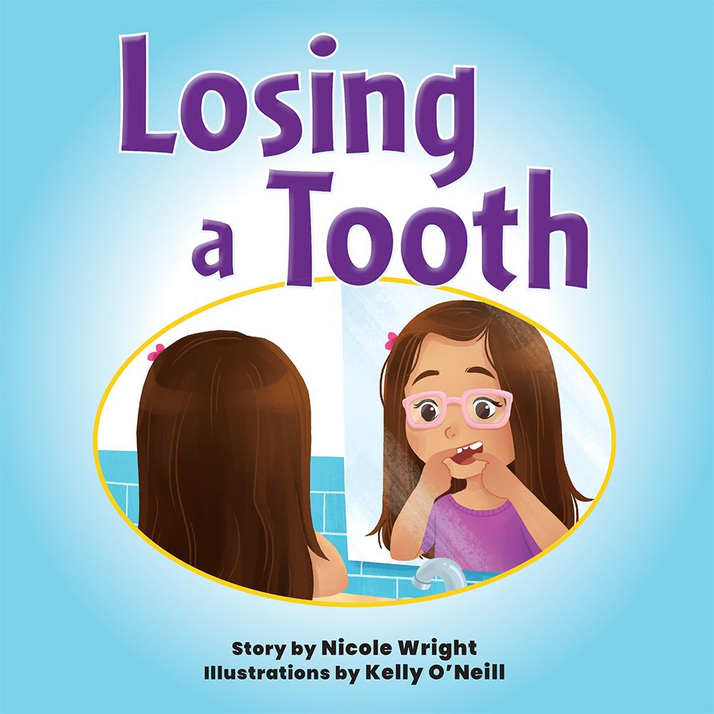](http://www.belleislebooks.com/store/p207/Losing_a_Tooth.html)

*Losing your first tooth can be hard to do . . . but it can also be exciting!*

*Feeling it wobble around in your mouth and trying to imagine your smile without it might feel a little scary. But as one little girl loses her first tooth, she learns it isn't as hard as she thought, and grows in confidence along the way!*

**About the Author**

[Nicole Wright](http://www.belleislebooks.com/nicolewright.html) grew up in Buffalo, New York, and currently balances the weight of a full-time career with the chaotic joys of being a loving wife and mother. She never dreamed of being a published children’s author until her niece, Giuliana, was losing her first tooth. Seeing how frightened she was, Nicole sat down and wrote *Losing a Tooth* to help ease the fears of any child who, like Giulianna, is nervously approaching this same milestone! Now, Nicole is excited to begin this next unwritten chapter in her life and bring readers along for the journey. She shares the reminder that sometimes the biggest dreams in life are broken down into smaller ideas and goals that you never even thought you could reach! It's those deviations that prove the best dreams really do come true.

**About the Illustrator**

[Kelly O’Neill](http://www.belleislebooks.com/kellyoneill.html) loves to tell stories through cute, fun, and whimsical imagery. She earned a BFA in illustration from Syracuse University in 2017, and currently resides in Princeton, NJ, where she works creating illustrations for children’s books.

**Interviews available upon request.**

[Belle Isle Books](http://www.belleislebooks.com/), an imprint of [Brandylane Publishers, Inc.](https://brandylanepublishers.com/), is an independent press located in Richmond, Virginia that has published books since 1985.

___________

*Losing a Tooth* (hardcover, 32 pages, $23.95 / paperback, 32 pages, $13.95) is available for pre-order from [Amazon](https://www.amazon.com/Losing-Tooth-Nicole-Wright/dp/1953021913), [Barnes & Noble](https://www.barnesandnoble.com/w/losing-a-tooth-nicole-wright/1141758083?ean=9781953021915), and other fine booksellers. Kindle e-book (retail $2.99) forthcoming.