**FOR IMMEDIATE RELEASE**

**November 2021**

**Publicity Team**

pr@brandylanepublishers.com

804-644-3090

**Try Something New with *Mabee and the Gravy!***

written by Allen Edgar Rogers

illustrated by Whitney Hill

on sale December 14, 2021

*“It’s exciting, you know,   
to try something new.  
You never know what you will find   
till you do!”*

[Belle Isle Books](http://www.belleislebooks.com/) of Richmond, Virginia, is pleased to announce the upcoming release of a new children’s book, [*Mabee and the Gravy*](http://www.belleislebooks.com/store/p182/Mabee_and_the_Gravy.html), written by Allen Edgar Rogers and illustrated by Whitney Hill.

Stubborn Mabee insists she does not like what she doesn’t already know*—*until an intriguing newcomer helps her see what she’s been missing out on! Featuring fun rhymes complemented by bright watercolor-style illustrations that remind us to be bold, *Mabee and the Gravy* is scheduled for release on December 14, 2021.

[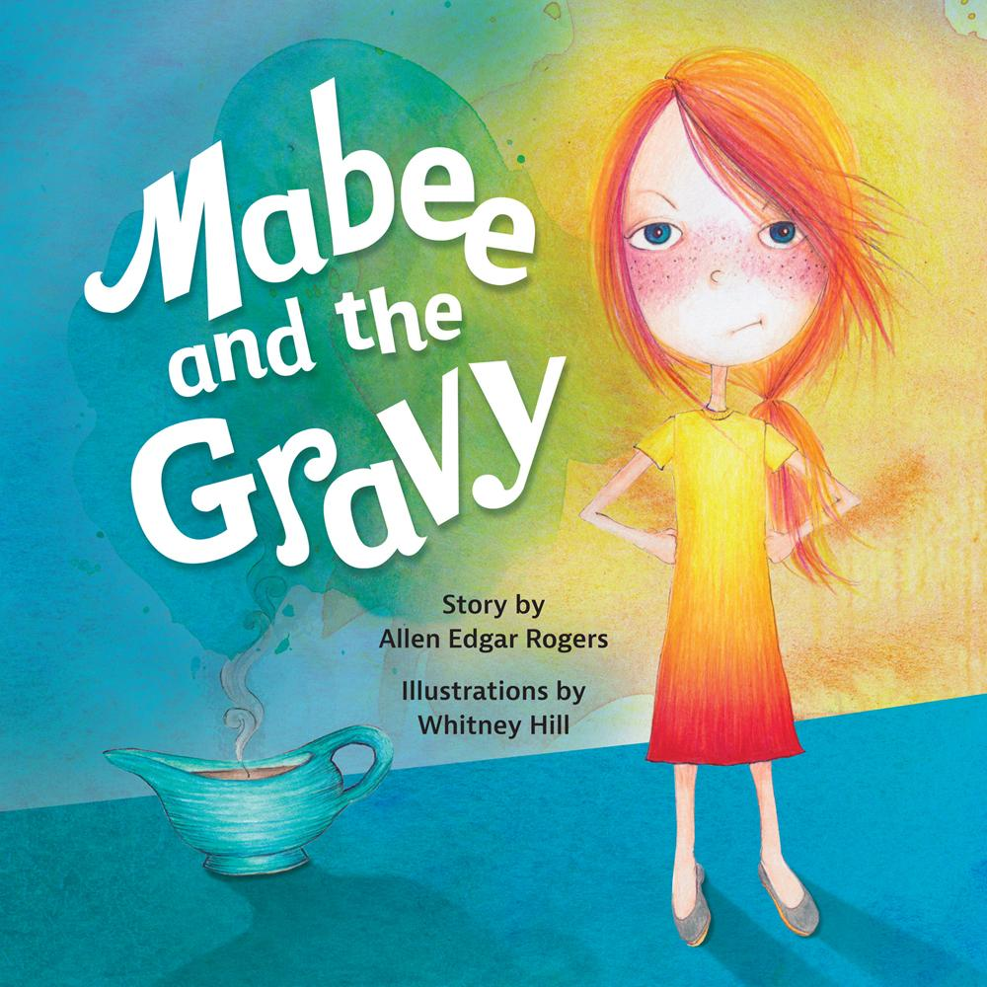](http://www.belleislebooks.com/store/p182/Mabee_and_the_Gravy.html)

*Mabee did not like flowers or taking hot showers*

*or being forced to read schoolbooks for hours.*

*She didn’t like babies or little old ladies—*

*and Mabee most certainly did not like gravy.*

*The perfect picture book for a picky eater, Mabee and the Gravy follows one girl’s journey to learning the value of taste—both literal and figurative! Broaden your horizons and try new things with Mabee, who most certainly does not like gravy.*

**About the Author**

[Allen Edgar Rogers](http://www.belleislebooks.com/allenedgarrogers.html) is a writer and entrepreneur from southeast Texas. During his career, he has worked in the education, nonprofit, and tech sectors. The common goal of his efforts is to inspire positive change in people and systems. He currently lives in Richmond, Virginia, with his wife, two daughters, and a rescue hound named Gus.

**About the Illustrator**

[Whitney Hill](http://www.belleislebooks.com/whitneyhill.html) is a creative director and illustrator based in Dallas, Texas. She shares a home with her husband, son, and their dog, Karma. When she’s not making art or chasing her son around the backyard, Whitney is pickling vegetables in her kitchen at home­—usually green beans.

**Interviews available upon request.**

[Belle Isle Books](http://www.belleislebooks.com/), an imprint of [Brandylane Publishers, Inc.](https://brandylanepublishers.com/), is an independent press located in Richmond, Virginia that has published books since 1985.

___________

*Mabee and the Gravy* (hardcover, 52 pages, $25.95 / paperback, 52 pages, $15.95) is available for pre-order from [Amazon](https://www.amazon.com/Mabee-Gravy-Allen-Rogers/dp/1953021123), [Barnes & Noble](https://www.barnesandnoble.com/w/mabee-and-the-gravy-allen-rogers/1139995518), and other fine booksellers.