**FOR IMMEDIATE RELEASE**

**June 2020**

**Christina Kann, Publicist**

pr@brandylanepublishers.com

**A Special Friendship and a Furever Home**

***Maddy and Mia: Tripaw Tales***

written by Pamela Adler

illustrated by Monique Seibel

on sale June 3, 2020

"Meet Maddy and her little three-legged dog, Mia! . . . The pair are quick to make friends with the kids they meet, and they discover that being a little different is actually pretty common. And being a LOT different can even be fun!"

— L. Meredith Averitt, DVM, author of *Seven Songs for Seven Dogs* and the upcoming *Twelve Dogs a-Howling*

[Belle Isle Books](http://www.belleislebooks.com/) of Richmond, Virginia, is excited to announce the upcoming release of a new children’s book, [*Maddy and Mia: Tripaw Tales*](https://www.indiebound.org/book/9781947860797), written by Pamela Adler and illustrated by Monique Seibel. Maddy and her three-legged dog, Mia, learn some important life lessons as best friends in *Maddy and Mia: Tripaw Tales*, scheduled for release on June 3, 2020.

[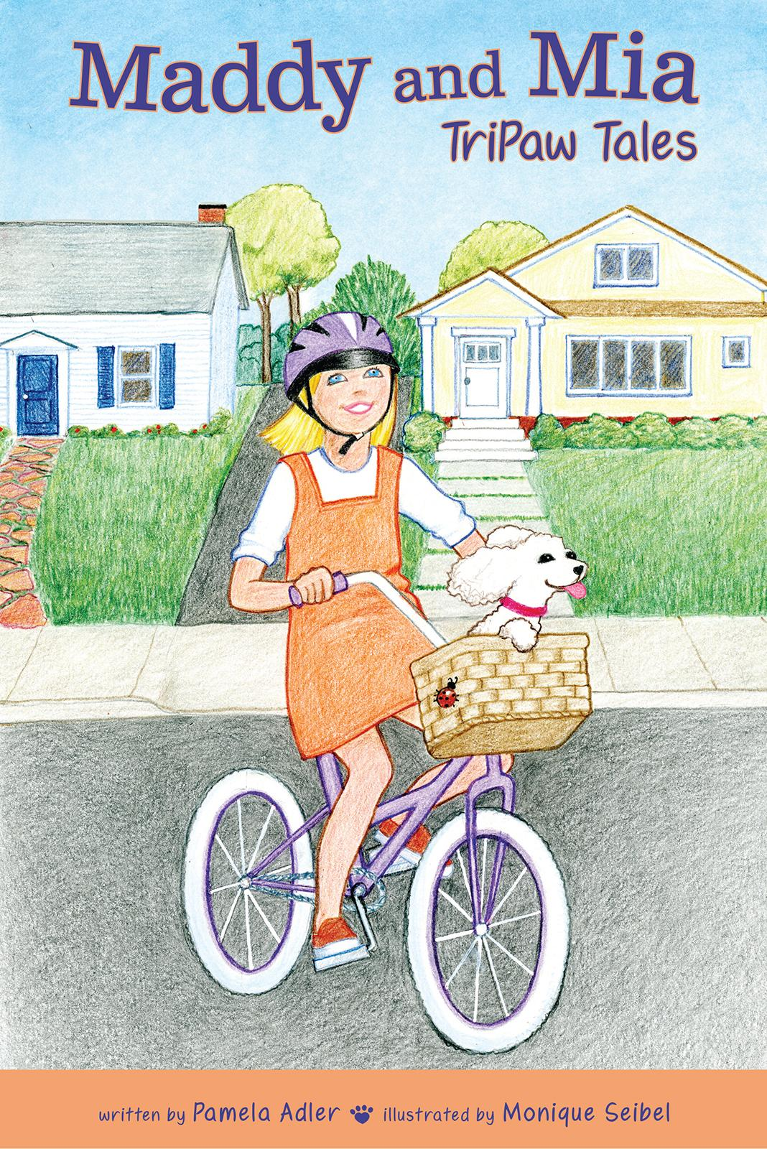](https://www.indiebound.org/book/9781947860797)

The family poodle has a litter of puppies, and Maddy’s parents say that she can choose one for her very own. Maddy instantly falls in love with the runt of the litter, who was born with only three legs. Little Mia becomes Maddy’s constant companion. When Finn and his family move in across the street, he joins Maddy and Mia on many of their adventures. Together, they learn the value of courage, acceptance, and friendship.

**About the Author**

Pamela Adler was born in Oregon, but she moved to California as an infant with her parents and two older brothers. She grew up on the San Francisco peninsula and attended junior college until she met her future husband while working at a local movie theater. They married in 1975, and three years later, they started a family with the first of two sons. Pamela worked full time as a dental office manager for twenty-eight years and part-time as a magician’s assistant. She retired in 2014. Pamela had the opportunity in 1998 to give an abandoned dog a forever home; from that day on, adopting rescued dogs and feral cats became her passion. *Maddy and Mia: TriPaw Tales* is her first book, inspired by her real-life tripod, Mia! Pamela lives in the east bay area with her husband of forty-four years, along with their pack of five rescue dogs and five feral cats.

**About the Illustrator**

Monique Seibel has worked as an illustrator, graphic designer, copyeditor, writer, and calligrapher. After earning a degree in art, she spent a few years teaching, an experience that convinced her to return to her lifelong passion. She was lucky enough to combine art with what she calls her hobby—linguistics—in a job that called for graphic design as well as editing and writing. After twenty years in the tech world, Monique opened a calligraphy business, specializing in handwritten invitations and wedding program design. Now “retired,” she continues to draw, paint, and volunteer her skills. She is an avid tennis player. *Maddy and Mia: TriPaw Tales* is the second children’s book she has illustrated. As a mother and grandmother, Monique felt a connection with Maddy, and thanks to her own little Havanese-Bichon, with Mia as well. A native of New York who has also lived in the mid-Atlantic states and the Midwest, Monique and her husband have resided in the bay area for many years.

**Interviews are available upon request.**

[Belle Isle Books](http://www.belleislebooks.com/), an imprint of [Brandylane Publishers, Inc.](https://brandylanepublishers.com/), is an independent press located in Richmond, Virginia that has published books since 1985.

__________

*Maddy and Mia: Tripaw Tales* (paperback, 56 pages, $12.95) is available for pre-order through [Indiebound](https://www.indiebound.org/book/9781947860797), [Amazon](https://www.amazon.com/Maddy-Mia-TriPaw-Pamela-Adler/dp/1947860798/ref=sr_1_1?dchild=1&keywords=maddy+and+mia&qid=1591039432&sr=8-1), [Barnes & Noble](https://www.barnesandnoble.com/w/maddy-and-mia-pamela-adler/1136608174?ean=9781947860797), and other fine booksellers. Kindle e-book (retail $2.99) forthcoming.