**FOR IMMEDIATE RELEASE**

**February 2022**

**Publicity Team**

804-644-3090  
pr@brandylanepublishers.com

**Splash Around in a World of Color and Emotion as *Maggie Discovers the Rainbow*!**

written by Kara Navolio

illustrated by Tracie Timmer

on sale March 21, 2023

“Journey through this magical world with Maggie! Readers young and old will delight in remembering just how important it is to experience all the colors of the rainbow.”

- Dolores Stratford, elementary school librarian, mother, and artist

[Belle Isle Books](http://www.belleislebooks.com/) of Richmond, Virginia, is pleased to announce the upcoming release of a new children’s book, [*Maggie Discovers the Rainbow*](http://www.belleislebooks.com/store/p220/Maggie_Discovers_the_Rainbow.html), written by Kara Navolio and illustrated by Tracie Timmer.

Whenever it rains, shy but imaginative Maggie dreams of dancing through the drizzle. But taking a leap can be difficult, so Maggie stays inside and quietly colors pictures instead–-until her grandmother gifts her a pair of sparkly pink rain boots. With their help and a burst of courage, Maggie seizes a magical moment and dances through the rainbow—experiencing all the emotions its colors inspire, and discovering her own inner strength.

Full and bright with rainbow hues bursting forth from its richly imagined watercolor illustrations, *Maggie Discovers the Rainbow* is scheduled for release on March 21, 2023.

[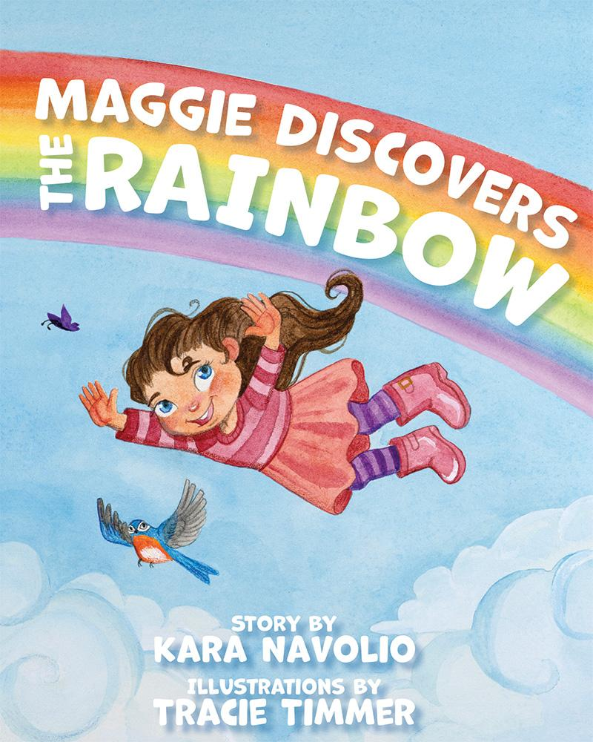](http://www.belleislebooks.com/store/p220/Maggie_Discovers_the_Rainbow.html)

Maggie Discovers the Rainbow *will empower young people to reach out of their comfort zones to try something new! In this story, a cautious girl’s shiny new rain boots inspire her to explore the possibilities of a gray afternoon. When she finds the courage to seize the moment, she is rewarded with an adventure through all the colors of a rainbow and the emotions they evoke, from safe, comfortable purple to fierce, brave red. Children will love following Maggie as she dances, drifts, and delights in a magical world of color.*

**About the Author**

[Kara Navolio](http://www.belleislebooks.com/karanavolio.html) is a children’s book author and freelance writer. Her first picture book, *Everybody Can Dance!*, celebrates the joy of dance with a message of inclusion. Her second book, *Maggie Discovers the Rainbow*, is a magical adventure discovering how color can make us feel.

When she isn’t writing for children, Kara tells stories of real-life heroes, artists and authors for local newspapers. Kara also volunteers her time as a docent at the Bedford Gallery in Walnut Creek, CA, where she takes school children on tours and teaches art in local schools.

She loves to read, travel, take photographs, paint, hike, dance, cook, and spend time with her family, especially her now-grown-up kids. She lives in the San Francisco Bay Area with her husband, and makes it a goal to learn something new every day.

**About the Illustrator**

[Tracie Timmer](http://www.belleislebooks.com/tracietimmer.html), enthusiast of all things whimsical and silly, has been drawing cute, fuzzy animals and ethereal mermaids since before she can remember. As a freelance illustrator from the Bay Area who specializes in children’s books, she uses her art as an outlet for all the zany ideas that bounce around in her head all day, bringing them to life on her canvas. *Maggie Discovers the Rainbow* is her second book.

Tracie is a graduate of the Academy of Art’s MFA program, and illustrates in addition to her full-time job at The Walt Disney Family Museum, where she creates public programming about art, animation, and the history of Walt Disney. In the past, she has worked as a painting instructor for both children and adults. Along with her work in children’s books, she also has a great love for visual development and animation.

When Tracie isn’t in her studio or at the museum, you can most often find her eating huge bowls of spaghetti and exploring the many nooks and crannies San Francisco has to offer. Look

for her debut children’s book, *The Mermaid and the Moon*, written by Susan Pace-Koch and published by Get Out Books.

**Interviews available upon request.**

[Belle Isle Books](http://www.belleislebooks.com/), an imprint of [Brandylane Publishers, Inc.](https://brandylanepublishers.com/), is an independent press located in Richmond, Virginia that has published books since 1985.

___________

*Maggie Discovers the Rainbow* (hardcover, 35 pages, $26.95 / paperback, 35 pages, $15.95) is available for pre-order from [Amazon](https://www.amazon.com/Maggie-Discovers-Rainbow-Kara-Navolio/dp/1958754250), [Barnes & Noble](https://www.barnesandnoble.com/w/maggie-discovers-the-rainbow-kara-navolio/1142960314?ean=9781958754245), and other fine booksellers.