**FOR IMMEDIATE RELEASE**

**October 2024**

**Publicity Team**

804-644-3090  
pr@brandylanepublishers.com

**New Book Invites Kids to Journey with *Marco Pollo, World-Traveling Chicken* as *The Adventure Begins***

written by Kathryn Dickerson

illustrated by Okan Bülbül

on sale October 22, 2024

“. . . a wonderful book that will share with children the riches of world exploration, family, and realizing when you need support. Marco’s curious nature speaks to the inner child in all of us!”

- Hannah Setzer, author of *Hannah Surprises Everyone (Including Herself!)*

[Belle Isle Books](http://www.belleislebooks.com/) of Richmond, Virginia, is pleased to announce the upcoming release of a new children’s picture book, [*Marco Pollo, World-Traveling Chicken: The Adventure Begins*](https://www.belleislebooks.com/store/p248/Marco_Pollo%2C_World-Traveling_Chicken%3A_The_Adventure_Begins.html)*,* written by Kathryn Dickerson and illustrated by Okan Bülbül.

Even before little Marco Pollo is fully hatched on a farmyard in Venice, he’s a baby chick on the move! Running about the farm before he’s even free of his shell, he continues following his urges to travel and explore as he grows up—even finding himself nearly stuck in one of Venice’s famous canals! Luckily, Marco’s kooky uncle Zio is always nearby to rescue him when he strays a little too far from the farm. When one of Marco’s escapades accidentally takes him farther than he ever expected, it’s up to Zio to accompany him on his first journey—and to prepare him for many more!

*Marco Pollo* invites child readers and their parents to step outside the coop—and even out of the book itself—to continue the journey, with included interactive QR codes leading to a multipage website that shares not only a variety of educational information about the places Marco visits during his travels and the things and people he sees, but also additional backstory about Marco and his family.

A colorfully, comically illustrated book perfect for kids about to take their first steps outside the home—and for the world-traveling adventurer in all of us—*Marco Pollo, World-Traveling Chicken: The Adventure Begins* is scheduled for release on October 22, 2024.

[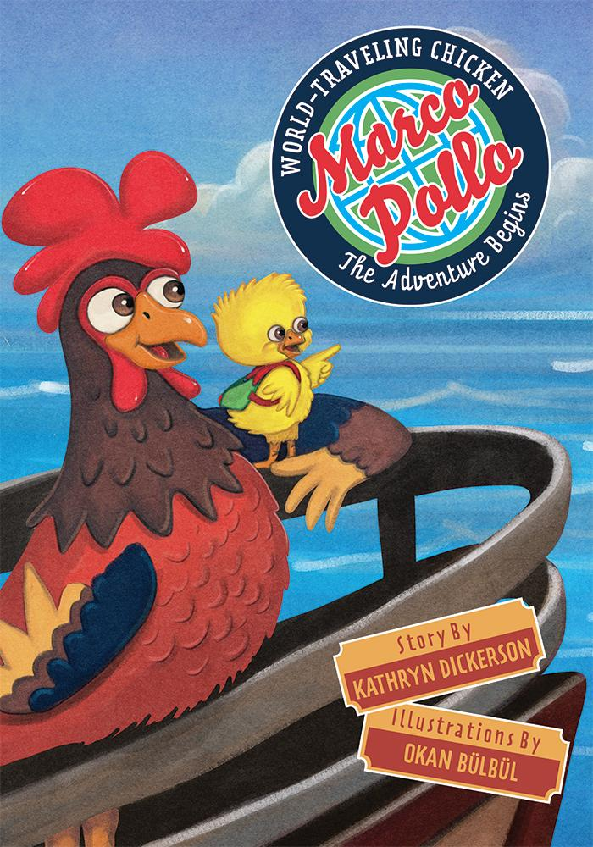](https://www.belleislebooks.com/store/p248/Marco_Pollo%2C_World-Traveling_Chicken%3A_The_Adventure_Begins.html)

*In a world completely fenced in, one young chicken dares to break away from tradition and out of the farmyard to explore the world he knows is just on the other side. Marco’s heart aches to spread his wings and go where no chicken has gone before—and one day, Marco gets his chance! But he discovers quickly that he’s not ready for the big, bustling world outside the safe nest he’s known his whole life. Luckily, his uncle is there to save him and prepare him to fulfill his destiny of becoming Marco Pollo, World-Traveling Chicken!*

**About the Author**

Having studied French and Spanish but never having touched foreign soil, Kathryn Dickerson felt something was missing. She finally felt whole when she moved from the United States to Germany in her twenties. She then traveled to as many places as possible, her heart growing fuller with each adventure. Later, she became an educator of literature and world geography, teaching that the world was a wonderful place and that most humans are good and kind and welcoming. Kathryn, along with her husband, encouraged their children to explore. Together they traveled America, some of Europe, the United Kingdom, and Central and South America. She is happy when on an adventure, under the big skies of the world, meeting interesting people, learning different languages, eating new foods, and adopting the local customs and etiquette. However, Kathryn is truly fulfilled when she can share these experiences with others.

**About the Illustrator**

Okan Bülbül is a freelance illustrator living in Turkey with his wife and daughter. He has an engineering degree, but he left the field in order to pursue his love for art. Now, he is happily realizing his childhood dream of drawing pictures for a living. Okan illustrates for all age groups, but illustrations for children’s books are his favorite.

**Interviews available upon request.**

[Belle Isle Books](http://www.belleislebooks.com/), an imprint of [Brandylane Publishers, Inc.](https://brandylanepublishers.com/), is an independent press located in Richmond, Virginia that has published books since 1985.

___________

*Marco Pollo, World-Traveling Chicken: The Adventure Begins* (hardcover, 36 pages, $26.95 / paperback, 36 pages, $15.95) is available for pre-order from [Amazon](https://www.amazon.com/Marco-Pollo-World-Traveling-Chicken-Adventure/dp/1958754668), [Barnes & Noble](https://www.barnesandnoble.com/w/marco-pollo-world-traveling-chicken-kathryn-dickerson/1145895708?ean=9781958754665), and other fine booksellers.