**FOR IMMEDIATE RELEASE**

**July 2023**

**Publicity Team**

pr@brandylanepublishers.com

804-644-3090

**Journey through Small-Town Dreams in the Hills of West Virginia with *Matewan Garden Club***

written by Iris Underwood

on sale July 5, 2023

“. . . a journey through life in the Appalachians. It’s as if you are sitting on the porch with [the characters], listening to their stories and sharing their struggles. A must-read.”

- Randy Jorgensen, Page One Corp., Imlay City, Michigan

[Belle Isle Books](http://www.belleislebooks.com/) of Richmond, Virginia, is pleased to announce the release of a new work of historical fiction, [*Matewan Garden Club*](http://www.belleislebooks.com/store/p219/Matewan_Garden_Club.html), written by Iris Underwood.

This five-part tale, spanning five separate springs from 1932 to 1959, takes the readeron a flower-strewn journey through some of the most beautiful landscapes in the Eastern US—all centered on the small community of Matewan, West Virginia. In this close-knit coal mining town, foreign transplants and established native families with deep roots help each other in turn, enduring trials and triumphs and sharing secrets, dreams, and heartaches as the Matewan Garden Club persists through the tender care of three generations of families and their closest friends.

An imaginative, poetic, true-to-life saga that will be loved by book and garden clubs alike,*Matewan Garden Club* is on-sale as of July 5, 2023.

[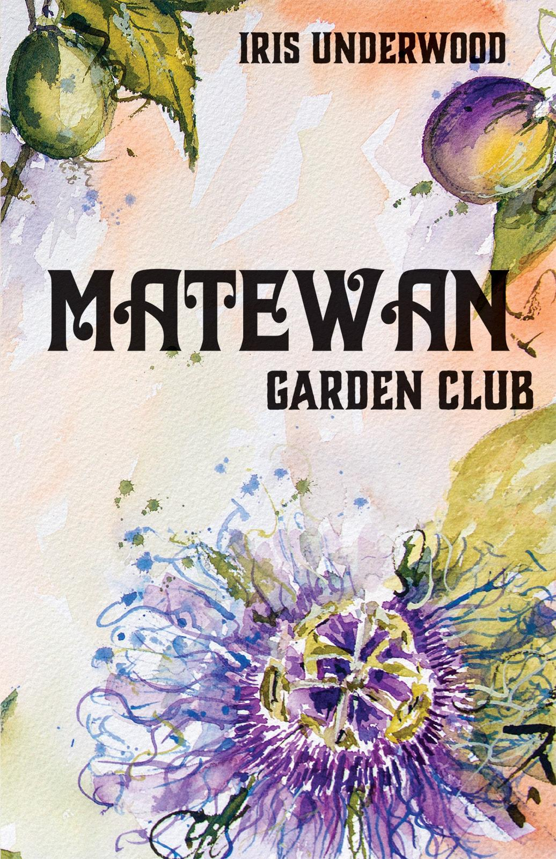](http://www.belleislebooks.com/store/p219/Matewan_Garden_Club.html)

*Eighteen-year-old Henry Blankenship dreams of building a house for his childhood sweetheart Annie Dill and his mother Gertie, known by the hill folk as the “woman with a shovel.” Meanwhile, Annie dreams of six children and a room of her own to pen the unsung legacies of Appalachian women—but Annie’s mother, Margaret Dill, President of the Matewan Garden Club, has other, grand plans for her only child. Fortunately, if unwittingly, Russian refugees Natalia Semenov and her son Olaf, Henry’s employers at Hunt’s Feed & Seed, soon come to Henry and Annie’s rescue.*

Matewan Garden Club *spans three generations and a multitude of dreams among the tight-knit immigrant coal camps and struggling towns along Tug Fork: Williamson, Blackberry City, Red Jacket, Thacker Holler, and countless hollers in between. Like the river’s many tributaries, these communities converge in Depression-era Matewan, West Virginia to build enduring love amid the business of native flora and fauna—seedlings of a post-WWI Europe in chaos, the Bolshevik Revolution, and a brand-new America.*

**About the Author**

[Iris Underwood](http://www.belleislebooks.com/irisunderwood.html) is a Michigan-based journalist, poet, author, past president of Detroit Working Writers, and former writer in residence at the Troy Public Library. She writes an award-winning weekly column, “Honest Living,” for the *Tri-City Times* (Imlay City), and her bylines have appeared in the *MacGuffin*, *Farming Magazine*, *Michigan Gardener*, *edibleWOW*, *Michigan History*, and many metro Detroit and Kentucky- area newspapers. Iris has published three books: *Encouraging Words for All Seasons* (2001), *“Growing Lavender” and Other Poems* (2007), and *The Mantle* (2018), her first award-winning novel.

Iris enjoys advocating for wholesome husbandry and encouraging people to write their own story and leave their own legacy. She lives in north Oakland County with her husband, two cats, hens, and honeybees.

**Interviews available upon request.**

[Belle Isle Books](http://www.belleislebooks.com/), an imprint of [Brandylane Publishers, Inc.](https://brandylanepublishers.com/), is an independent press located in Richmond, Virginia that has published books since 1985.

___________

*Matewan Garden Club* (hardcover, 254 pages, $30.95 / paperback, 254 pages, $19.95 / Kindle e-book, $10.99) is available from [Amazon](https://www.amazon.com/Matewan-Garden-Club-Iris-Underwood/dp/1958754269), [Barnes & Noble](https://www.barnesandnoble.com/w/matewan-garden-club-iris-underwood/1143432769?ean=9781958754269), and other fine booksellers.