**FOR IMMEDIATE RELEASE**

**December 2020**

**Christina Kann, Publicist**

[christina@brandylanepublishers.com](mailto:christina@brandylanepublishers.com) or 804.644.3090

**Finding the Real Magic of Christmas:**

***McKinley and the Present Pixies***

**written by Dirk and Debbie Kagerbauer**

**illustrated by Kelly Lane**

**on sale December 10, 2020**

“Watch out, Elf on the Shelf! The Present Pixies are the new way to teach kids to behave at

Christmastime.”

—Toni Goodall, retired kindergarten teacher

[Belle Isle Books](http://www.belleislebooks.com/) of Richmond, Virginia, is proud to announce the upcoming release of [*McKinley and the Present Pixies*](https://www.amazon.com/McKinley-Present-Pixies-Dirk-Kagerbauer/dp/1951565983/ref=sr_1_1?crid=2II2VVYQVGSBY&dchild=1&keywords=mckinley+and+the+present+pixies&qid=1602272365&sprefix=mckinley+and+the+pre%2Caps%2C152&sr=8-1) written by Dirk and Debbie Kagerbauer and illustrated by Kelly Lane. Five-year old McKinley is a good kid, but on Christmas day all he can think about is presents! It takes one story, some family creativity, and a few extraordinary visitors to help McKinley remember that family is the most important gift!*McKinley and the Present Pixies* is scheduled for release on December 10, 2020.

[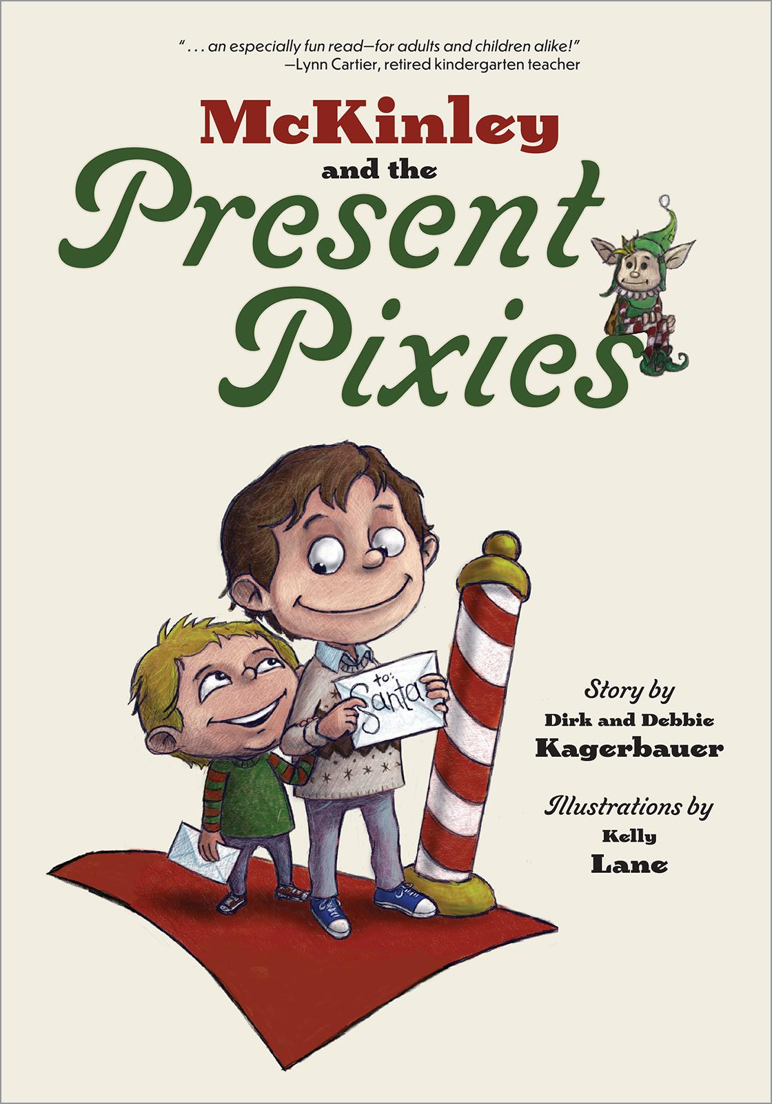](https://www.amazon.com/McKinley-Present-Pixies-Dirk-Kagerbauer/dp/1951565983/ref=sr_1_1?crid=2II2VVYQVGSBY&dchild=1&keywords=mckinley+and+the+present+pixies&qid=1602272365&sprefix=mckinley+and+the+pre%2Caps%2C152&sr=8-1)

It’s finally Christmas Day, and McKinley can’t *wait* to open his presents. In fact, he’s so excited that he doesn’t care about anything else. He wants to open his presents *NOW*! That’s when Papa Dirk tells McKinley about the Present Pixies, Santa’s magical helpers who make sure you’re good even after Santa leaves your gifts under the tree. If you’re not good on Christmas Day, they make your gifts just go away! Can the Present Pixies help McKinley remember to be good? Will McKinley save his presents and his family's Christmas?

**About the Author**

[Debbie and Dirk Kagerbauer](https://ddkagerbauer.com/) have been collaborating for the past forty-four years: first on their family, two sons who in turn each have two sons (one of whom is McKinley); then on building/remodeling projects as their family grew; and now on books for children. Debbie taught first grade for thirty-one years, while Dirk taught third grade, fifth grade, and adults. Since retiring, Deb and Dirk have been making the most of time spent with their family, their friends, and each other, while creating stories that children and the adults in their lives can enjoy. The collaboration continues!

**About the Illustrator**

Hello there. I’m [Kelly Lane](https://klaneillustration.com/), an illustrator based in Texas. I graduated with a bachelor’s degree in fine art drawing from Texas State University in 2006. I have taught for thirteen years in elementary education, from the tiny pre-k kids to the not-so-tiny third graders. This has afforded me a keen insight into the world of children and the innocent prism through which they view the world. Now I freelance out of my home studio, breathing life into imaginary worlds. I live in a cozy hobbit hole under tree and hill in San Antonio, Texas with my wife, two rambunctious boys, my Boston terrier Bobo, and a lazy bobtailed cat called Bobkitty.

**Interviews available upon request.**

[Belle Isle Books](http://www.belleislebooks.com/) is an imprint of [Brandylane Publishers, Inc.](https://brandylanepublishers.com/), an independent press located in Richmond, Virginia, that has published books since 1985.

_____

*McKinley and the Present Pixies* (36 pages, hardcover $22.95 / paperback $12.95 / ebook $2.99) is available for pre-order from [Amazon](https://www.amazon.com/McKinley-Present-Pixies-Dirk-Kagerbauer/dp/1951565983/ref=sr_1_1?crid=2II2VVYQVGSBY&dchild=1&keywords=mckinley+and+the+present+pixies&qid=1602272365&sprefix=mckinley+and+the+pre%2Caps%2C152&sr=8-1), [Barnes and Noble](https://www.barnesandnoble.com/w/mckinley-and-the-present-pixies-dirk-kagerbauer/1137752943?ean=9781951565992), and other fine booksellers.