**FOR IMMEDIATE RELEASE**

**November 2022**

**Publicity Team**

pr@brandylanepublishers.com

804-644-3090

**Discover How *Mining Your Past* Can Inspire Your Writing—and Help You Become the Author You’ve Always Wanted to Be**

written by Richard Lee Zuras

on sale December 7, 2022

“What sets *Mining Your Past* apart from all the other how-to books out there for writers is Zuras’ willingness to put his own work on the line. He doesn’t just preach his advice for fiction and poetry; he practices it, and he’s willing to show the novice what he’s done and why.”

- Lucy Ferriss, author of *Foreign Climes: Stories*

[Belle Isle Books](http://www.belleislebooks.com/) of Richmond, Virginia, is pleased to announce the upcoming release of a new how-to guide for writers, [*Mining Your Past*](http://www.belleislebooks.com/store/p213/Mining_Your_Past.html) by Richard Lee Zuras.  
 The goal of all authors is to tell a story—in poetry, short stories, or even song lyrics. In *Mining Your Past,* a successful author offers a holistic approach to identifying the stories an author wants to tell, communicating them in an entertaining and compelling way, and addressing the most common pitfalls and writers’ blocks that befall those trying to use their own history in their work. Exposing his entire process, he teaches hopeful authors the methods he uses to find his best ideas, with the understanding that they will be able to use those methods not to copy his own ideas and style, but rather to explore their own worlds and uncover their own truths—and inspire their writing across every genre, from science fiction to young adult. A must-have resource for every aspiring author, *Mining Your Past* is scheduled for release on December 7, 2022.

[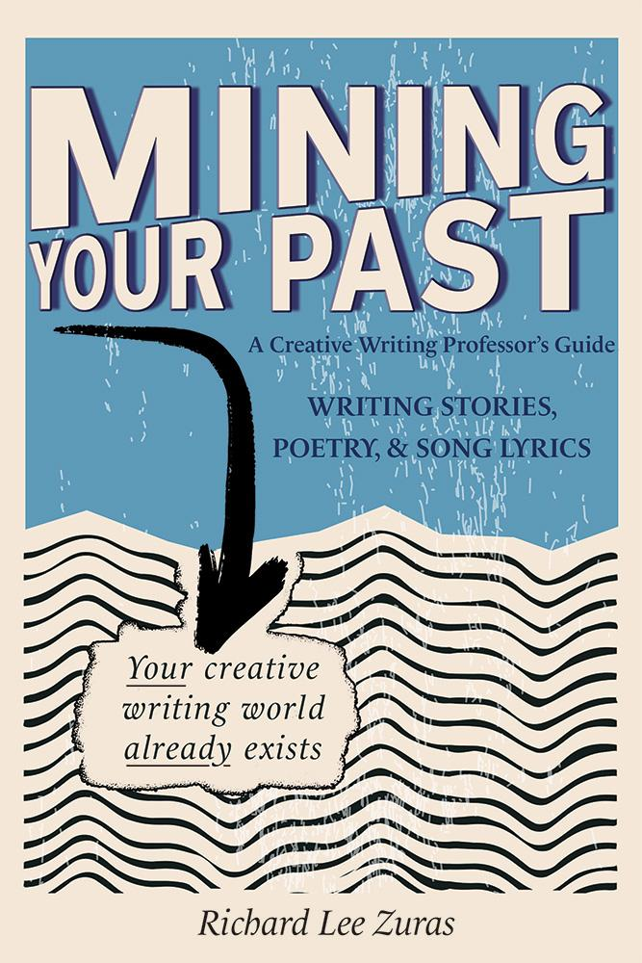](http://www.belleislebooks.com/store/p213/Mining_Your_Past.html)

*No one has ever seen the world the way you have.*

*This is a truth that noted author, poet, and professor Richard Lee Zuras knows well. Mining your past—for its characters, its lessons, its regrets, and its joys—can feel intimidating, but it leads to authenticity in a writer’s written work that cannot be replicated. No one has seen the world the way you do, and so learning how to tap into that world as you create new stories is an invaluable way of finding your voice.*

*In this accessible and informative writing guide, Zuras skillfully combines his previous written*

*works and personal histories with concrete tools for any reader looking to integrate their own*

*pasts into authentic writing. Refreshingly reader-focused,* Mining Your Past *provides its audience tangible methods for uncovering their unique worldview in order to create more compelling and genuine storytelling. Readers will step away with a greater faith in their potential as a writer and a better understanding of their own pasts, presents, and futures, making this an essential read for novice writers searching for a way to share their stories, as only they can tell them.*

**About the Author**

[Richard Lee Zuras](http://www.belleislebooks.com/richardleezuras.html) earned his MFA as a McNeese scholar under the auspices of Pulitzer Prize winner in fiction Robert Olen Butler and two-time Iowa Poetry Prize winner John Wood. A professor of English & creative writing at the University of Maine at Presque Isle, where he has taught creative writing for more than twenty years, he has held writing conference scholarships at Bread Loaf, Wesleyan University, and Pirate's Alley Faulkner, and is the author of the novels *The Bastard Year* and *The Honeymoon Corruption* as well as the poetry collection *Birds at the Post Office,* all published through Brandylane Publishers. His stories and poems have appeared in dozens of literary journals, including *Story Quarterly, South Dakota Review, Weber Journal, Big Muddy, Jabberwock Review, Lake Effect, Chicago Quarterly Review, Laurel Review, Yemassee, Xavier Review, Confrontation, Red Rock Review,* and *Passages North*.

Richard lives with his wife Kelly, sons Everett and Holden, and a red Siberian husky named Indigo.

**Interviews available upon request.**

[Belle Isle Books](http://www.belleislebooks.com/), an imprint of [Brandylane Publishers, Inc.](https://brandylanepublishers.com/), is an independent press located in Richmond, Virginia that has published books since 1985.

___________

*Mining Your Past* (paperback, 194 pages, $17.95) is available for pre-order from [Amazon](https://www.amazon.com/Phoenix-Upperville-Bradford-Moore/dp/195302159X), [Barnes & Noble](https://www.barnesandnoble.com/w/the-phoenix-of-upperville-bradford-moore/1141717813?ean=9781953021595), and other fine booksellers.