**FOR IMMEDIATE RELEASE**

**March 2023**

**Publicity Team**

804-644-3090  
pr@brandylanepublishers.com

**Take a Moment to Relax with *Momento the Beast*!**

written by Eric Albright

illustrated by Katherine Jordan

on sale March 31, 2023

“Momento will inspire you—body, mind, and soul. With its timeless and profound messages about kindness and mindfulness, this book is sure to leave a meaningful imprint on your heart.”

- Stephanie Parwulski, author of *Beatrice and the Sunflower Gift, Gloria’s Hope Tree*, and *Noble*

[Belle Isle Books](http://www.belleislebooks.com/) of Richmond, Virginia, is pleased to announce the upcoming release of a new children’s book, [*Momento the Beast*](http://www.belleislebooks.com/store/p221/Momento_the_Beast.html), written by Eric Albright and illustrated by Katherine Jordan.

What can a nine-year-old boy do when he’s bullied by brothers who are bigger than him? In George’s case, he chooses to pack his things, write a note to his parents, and leave his life behind to run into the woods!

Luckily, the mysterious Momento, a gentle beast who lives in the woods, soon takes an interest in George and his frustrations. With Momento’s help, George learns why his brothers act the way they do—but he also learns that only he can help his situation, by employing special techniques used by yoga practitioners to manage their emotions and achieve peace and calm: taking a deep breath, maintaining good posture, and grounding himself in the moment. As he learns how to approach each person and interaction with compassion, George feels his anger and sadness melt away as he takes Momento’s advice and prepares to face his brothers’ negativity with courage and confidence.

Packed with colorful, imaginative illustrations, and told in singsong rhyming couplets that will delight the ear and encourage readers to remember its lessons, *Momento the Beast* is scheduled for release on March 31, 2023.

[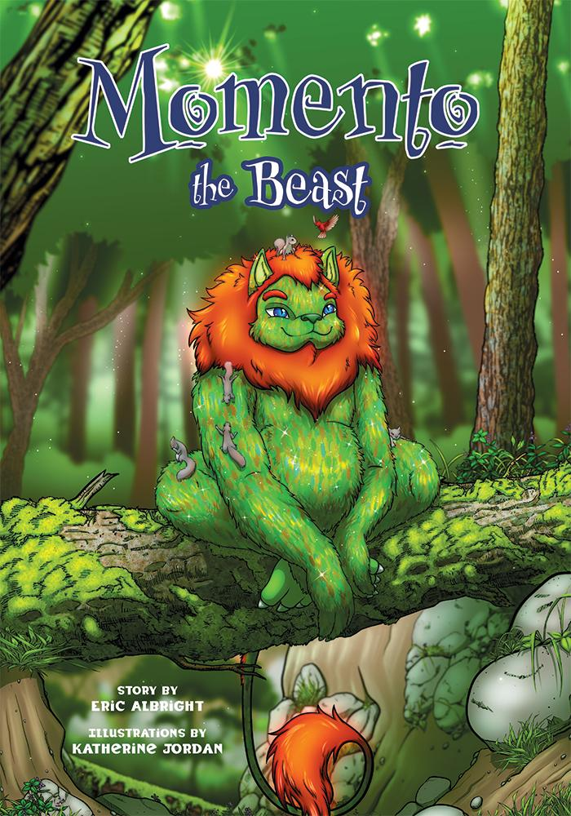](http://www.belleislebooks.com/store/p221/Momento_the_Beast.html)

*George has had enough! He’s sick of his three older brothers and their endless teasing, so he’s running away from home. But deep in the woods, George encounters a spirited, singing creature called Momento, who shares three tips to help George connect to his mind and body and keep his cool . . . in even the most stressful of moments!*

**About the Author**

[Eric Albright](http://www.belleislebooks.com/ericalbright.html) lives on the east coast of the United States with his spouse, two children, and two orange tabbies. He has been an educator for most of his professional life, with a gap of nearly a decade that he spent as a stay-at-home parent. Eric enjoys acting as a mentor to younger humans in his community and bringing people together to celebrate life. Beyond his attempts to help others find understanding and joy, he seeks his own through various forms of artistic expression, reading books on spirituality and psychology, and traveling with friends and family to new cultural and environmental landscapes to interact with the Earth and its many wonders.

**About the Illustrator**

[Kate Jordan](http://www.belleislebooks.com/katejordan.html) has done just about everything that has to do with art: drawing, painting, weaving, ceramics . . . even ink printing and bookbinding! But if you ask her what her favorite out of the bunch is, she’ll easily say digital drawing.

Brought up in a military family that moved around a lot, Kate lived an exciting childhood full of new places, new people, and new things. Now that she’s older and out of school, she finds she prefers a quieter life at home in Fredericksburg, Virginia, with her family. She hopes to write her own picture book to give to her children one day, but for now, she enjoys helping other people tell their stories with her beautiful, colorful art. She’s happiest when she’s drawing and listening to music, especially when she’s nice and cozy under a mountain of blankets on a rainy day.

You can see more of Kate’s art in her [DeviantArt gallery](http://www.deviantart.com/rahkshi-miraka).

**Interviews available upon request.**

[Belle Isle Books](http://www.belleislebooks.com/), an imprint of [Brandylane Publishers, Inc.](https://brandylanepublishers.com/), is an independent press located in Richmond, Virginia that has published books since 1985.

___________

*Momento the Beast* (hardcover, 34 pages, $25.95 / paperback, 34 pages, $15.95) is available for pre-order from [Amazon](https://www.amazon.com/Momento-the-Beast/dp/195875409), [Barnes & Noble](https://www.barnesandnoble.com/w/momento-the-beast-eric-albright/1143138902?ean=9781958754092), and other fine booksellers.