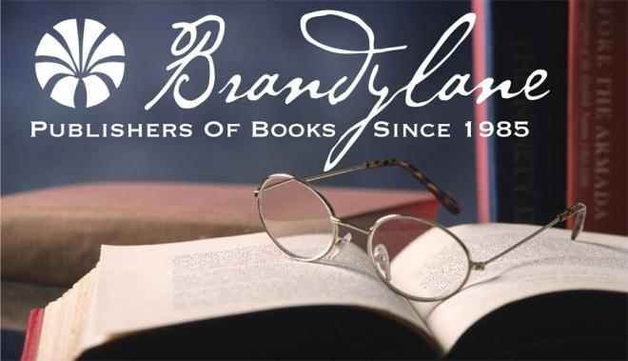

BELLE ISLE BOOKS  
*an imprint of Brandylane Publishers, Inc.*

**DATE: January 2017**

**NEWS** (Release Immediately)

**CONTACT: Publicist is at 804.644.3090; FAX 804.644.3091; E-mail brandylanepr&gmail.com or brandylanerhpruett@gmail.com**

**Morgan May Be a Little Prickly – But He Just Wants to Find a Human Friend!**

Bell Isle Books, an imprint of Brandylane Publishers, Inc. of Richmond Virginia, is pleased to announce the release of *Morgan*, the tale of an adventurous porcupine who sets out on his own to seek new friends and a new life outside the forest.

Morgan is lonely – nobody will come near him because of his quills, and his only friend, the Beaver, is usually too busy to play. One day, Morgan finally has enough and decides to head down the mountain to try his luck with the humans who live in the valley, desperately hoping to find a friend. Guided by his knowledge of the plants and animals of the American Northeast, as well as his wits and his handy quills, Morgan leads new readers on a journey they won’t soon forget. This charming tale inspires curiosity, courage, and kindness – especially to those who may seem a little prickly on the outside!

Harry Holmes was born in Nashville. As a child, he loved scouting, attaining the rank of Eagle Scout in 1959, and hiking along the Cumberland Plateau in Eastern Tennessee.

In 1962, after graduating from Huguenot High School in Richmond, Virginia, Harry joined the United States Navy. After completing his tour of duty, he reentered civilian life as Forensic Specialist for the Virginia Beach Police Dept., from which he retired after forty-one years of service. He and his wife Carol live in Chesapeake, Virginia.

Harry is an avid birdwatcher, photographer, and cook, as well as a member of Writers World and Hampton Roads Writers. This is his first book, and he plans to write many more children’s stories and mysteries in the future!

Illustrator Maryana Kachmar was born in Lviv, Ukraine in 1983. She holds a Masters of Sacred Art from the National Academy of Arts in Lviv (Ukraine) and now participates in the artistic group, Zohrafos. Maryana, has worked as editor and artist for several Christian children’s magazines (including Angelyatko and Flashlight) and was chief artist and co-founder for a publishing company, Country of Angels. Over the last 10 years, she has illustrated more than 200 journals and 10 books, including numerous children’s books (ABC, Miracle in the Woods, Christmas, and Poems for Boys and Girls). Fond of singing and making puppets, Maryana is the mother of two cheerful and energetic boys who inspire her daily with new pictures!

Brandylane Publishers, Inc. is an independent press located in Richmond, Virginia that has published books since 1985.

*Morgan* (hardcover, 50 pages, $19.95 retail) is available now from the publisher at bellislebooks.com, from amazon.com, bn.com, and from fine booksellers.

**Contact the publisher for review copies or to arrange an interview with the author.**