**FOR IMMEDIATE RELEASE**

**July 2021**

**Christina Kann, Publicist**

[pr@brandylanepublishers.com](mailto:pr@brandylanepublishers.com)

**There and back again, so to speak:**

***Mr. Robert Monkey Returns to New York***

**written by Arnold Johnston and Deborah Ann Percy**

**illustrated by Kelly O’Neill**

**on sale July 7, 2021**

“Mr. Robert Monkey is so much more than Curious George, and so much more than us! A brilliant character in storybook fiction, who will be much beloved by generations of children!”

—Fred Leebron, novelist, author of *Out West*, *Six Figures*, and *In the Middle of All This*

[Belle Isle Books](http://www.belleislebooks.com/) of Richmond, Virginia, is proud to announce the upcoming release of [*Mr. Robert Monkey Returns to New York*](https://bookshop.org/books/mr-robert-monkey-returns-to-new-york-9781953021090/9781953021083),written by [Arnold Johnston and Deborah Ann Percy](http://johnston-percy-writers.com/) and illustrated by [Kelly O’Neill](https://www.kellyoneillart.com/). Mr. Robert Monkey was like Bobby’s little brother, and if you saw one of them, you’d always see the other. *Mr. Robert Monkey Returns to New York* is scheduled for release on July 7, 2021.

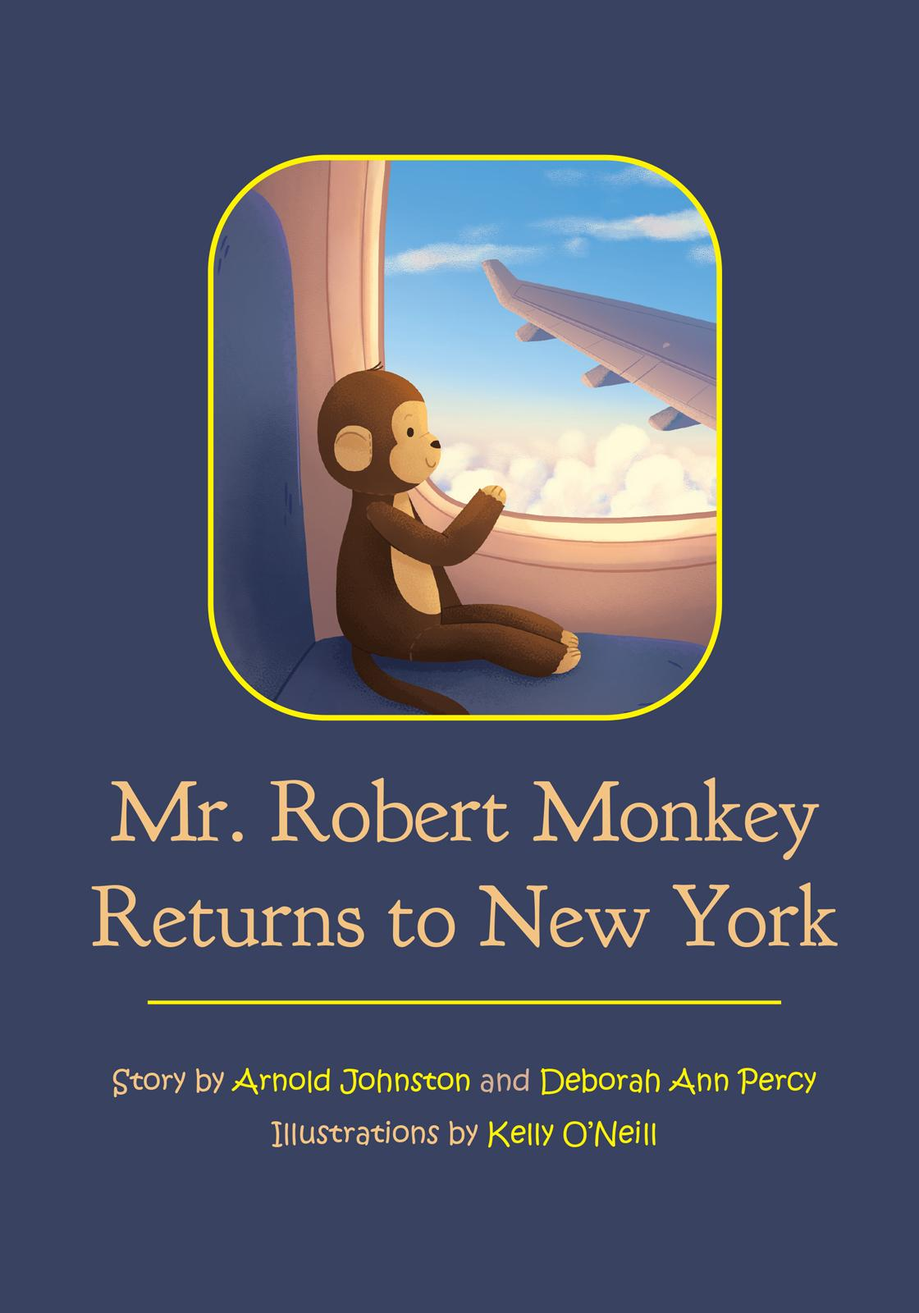

Mr. Robert Monkey and Bobby Penicki are the very best of friends. When Mr. Robert gets lost during a family move to New York City, Bobby is devastated. Meet new friends and travel by plane, truck, and backpack as Mr. Robert makes his brave journey home!

**About the Author**

Married writers [Deborah Ann Percy and Arnold Johnston](http://johnston-percy-writers.com/) live in Kalamazoo and South Haven, MI. Their individually and collaboratively written plays have won over two hundred productions, as well as numerous awards and publications across the country and internationally; and they’ve written, co-written, edited, or translated some twenty books. Debby earned the MFA in creative writing at Western Michigan University. After a distinguished administrative career in the Kalamazoo Public Schools, Debby is now a full-time writer, as is Arnie, who was chairman of the English Department (1997-2007) and taught for many years as co-founder of the creative writing program and founder of the playwriting program at Western Michigan University. They are members of the Dramatists Guild, the Associated Writing Programs, Poets & Writers, and the American Literary Translators Association.

**About the Illustrator**

[Kelly O’Neill](https://www.kellyoneillart.com/) loves to tell stories through cute, fun, and whimsical imagery. She earned a BFA in illustration from Syracuse University in 2017, and currently resides in Jenkintown, PA, where she works creating illustrations for children’s books.

**Interviews available upon request.**

[Belle Isle Books](http://www.belleislebooks.com/) is a proud imprint of [Brandylane Publishers, Inc.](https://brandylanepublishers.com/), an independent press located in Richmond, Virginia, that has published books since 1985.

_____

*Mr. Robert Monkey Returns to New York* (32 pages, hardback $22.95 / paperback $12.95) is available for pre-order through [Bookshop](https://bookshop.org/books/mr-robert-monkey-returns-to-new-york-9781953021090/9781953021083), [Amazon](https://www.amazon.com/Mr-Robert-Monkey-Returns-York/dp/1953021093/), [Barnes and Noble](https://www.barnesandnoble.com/w/mr-robert-monkey-returns-to-new-york-arnold-johnston/1139093661?ean=9781953021090), and other fine booksellers.